Hoshi
Hoshi is a user that settled in to Ayenee on January 12, 2018.
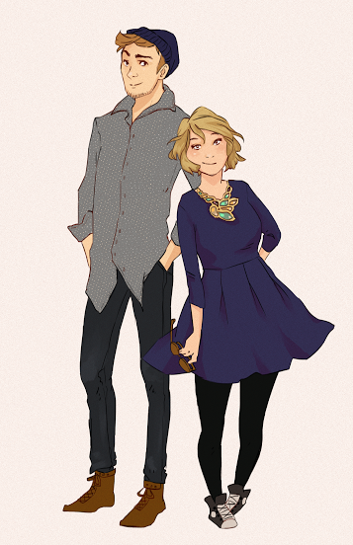
She is a girl that loves a lot of things like her husband, RPing with friends, and her dog!! She has a lot of big plans!

Characters
Her characters as of now are not all in the Ayenee universe, but here are some: Hoshi's Characters

Projects
- Tree City Of Introspection
- kusarigama
- Jade Dragon
- Character Template
- Spatial Bot
- Midnight Dragon
- Kaiyō Plot Plan
- Location Template
- Ayenee Tavern
- Outpost Liliath
- Ancient City Of Flux
- Flying Castle Of Hollowmoore
- Fight is Tight Magical Fight Club

Will
 If you wish to adopt this player's characters, plots, or setting elements, please ask Wes to email them for permissions. Hoshi's creations may not be changed or adopted without explicit permission.

OOC Notes
This page was originally created by Hoshi on Fri 12-01-18.

