Outpost Liliath
Outpost Liliath was built by the Phaerians as a small stronghold against invading ogra. It is now semi-abandoned save for squatters that never last the harsh winters here.
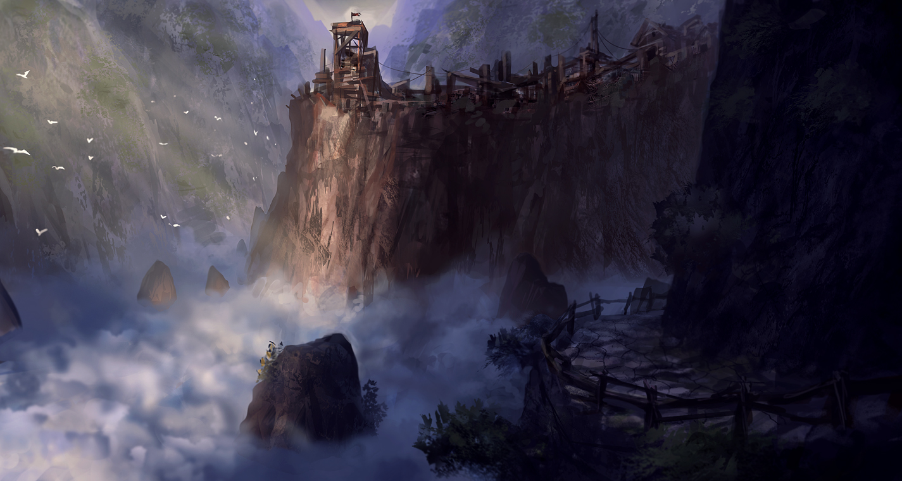

OOC Notes
This page was originally created by Hoshi on Mon 15-01-18.
Art by joakimolofsson.

