Em'zca Empire
Em'zca Empire, a part of Ayenee, was a distinct kingdom within the realms of Ayenee. Its governing body was formed up by a conglomeration of five distinct principalities within the Empire. The rulers and their consorts each took a place at the council table lead by a High King and Queen; who were rulers only of the capital city and its surrounding province.
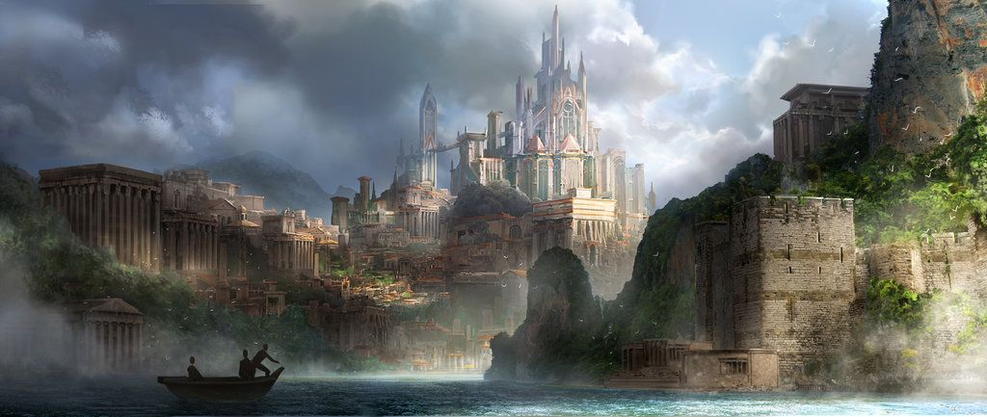
A nation formed from the peninsula and five surrounding of the continent Em'zca was broken into five surrounding principalities with the High King and Queen for all intent landless to avoid conflicts of interest. While the council had a controlling interest over individual aspects of their kingdoms and their votes were needed for matters of war or alliances the day-to-day running of the kingdom fell on the King and Queen with their advisors.
Their religion centered around two deities, Sremmos God of destruction, and Seria Goddess of Creation. The lore around Sremmos and Seria had them with multiple twin children that Sremmos reabsorbed in order to fight off other invading gods. Around them, the infrastructure of Em'zca's military and education was formed with the Deran Templars dedicated to the preservation of the royal line and through that the preservation of the bloodline of the gods.
The priests/ priestesses were the educators and formed the backbone of the safety net for Em'zcan citizens in the shape of hospitals, libraries, and aid programs. The theocracy and monarchy combined to work together in forming a cohesive environment with the intent of providing stability and limiting those in dire poverty.
Em'zcas rulers included:
Tenkou Joutenryu and spouse Sho Joutenryu
Amelia Joutenryu and spouse Slade Caizer

OOC Notes
This city was continued to be role-played after the fall of user rooms through Yahoo Groups under Em'zca Empire. Unfortunately, our archives and roleplays were lost when Yahoo Groups was removed from the internet as the group had been set to private so the archive servers were unable to retrieve the several years worth of additional roleplay.
Last editted by Lady_tenkou on 9/1/2022

