Capital Memorial City
Capital Memorial city is a “tech” city named in honor of those who died in the invasion of Ayenee Capital City. It is newer and smaller than Ayenee Capital City and is roughly 20 miles to the South.
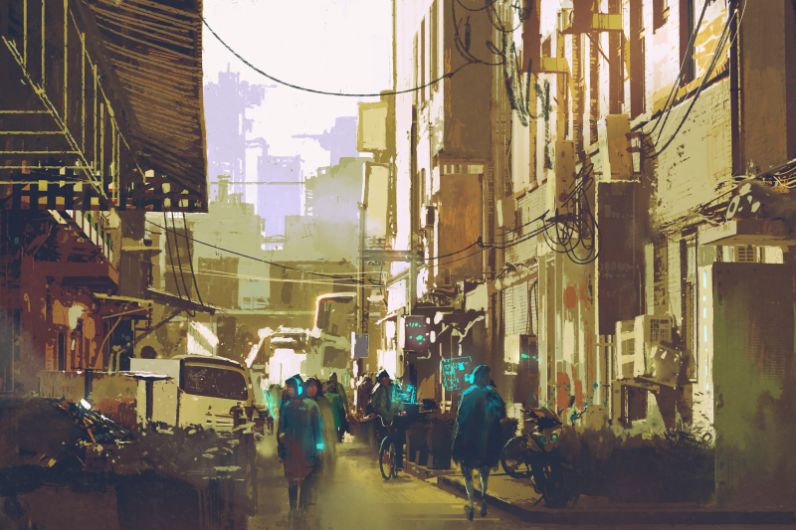
Fort Miller is located on the outskirts of Capital Memorial City.

Locations in Capital Memorial City
- Goodpint Bar1)
- Draken Club and Bar 2)

OOC Notes
This page was originally created by Wes on Thu 25-05-17.
City art purchased from Adobe Stock by Wes.

1)
2)

