Ayenee Space Coalition Exercise Uniform
The Ayenee Space Coalition uses an exercise uniform that consists of a white ringer T-shirt with red details, and red shorts in either a basketball (loose) or volleyball (tight) style. The shirt has the insignia of the Ayenee Space Coalition.
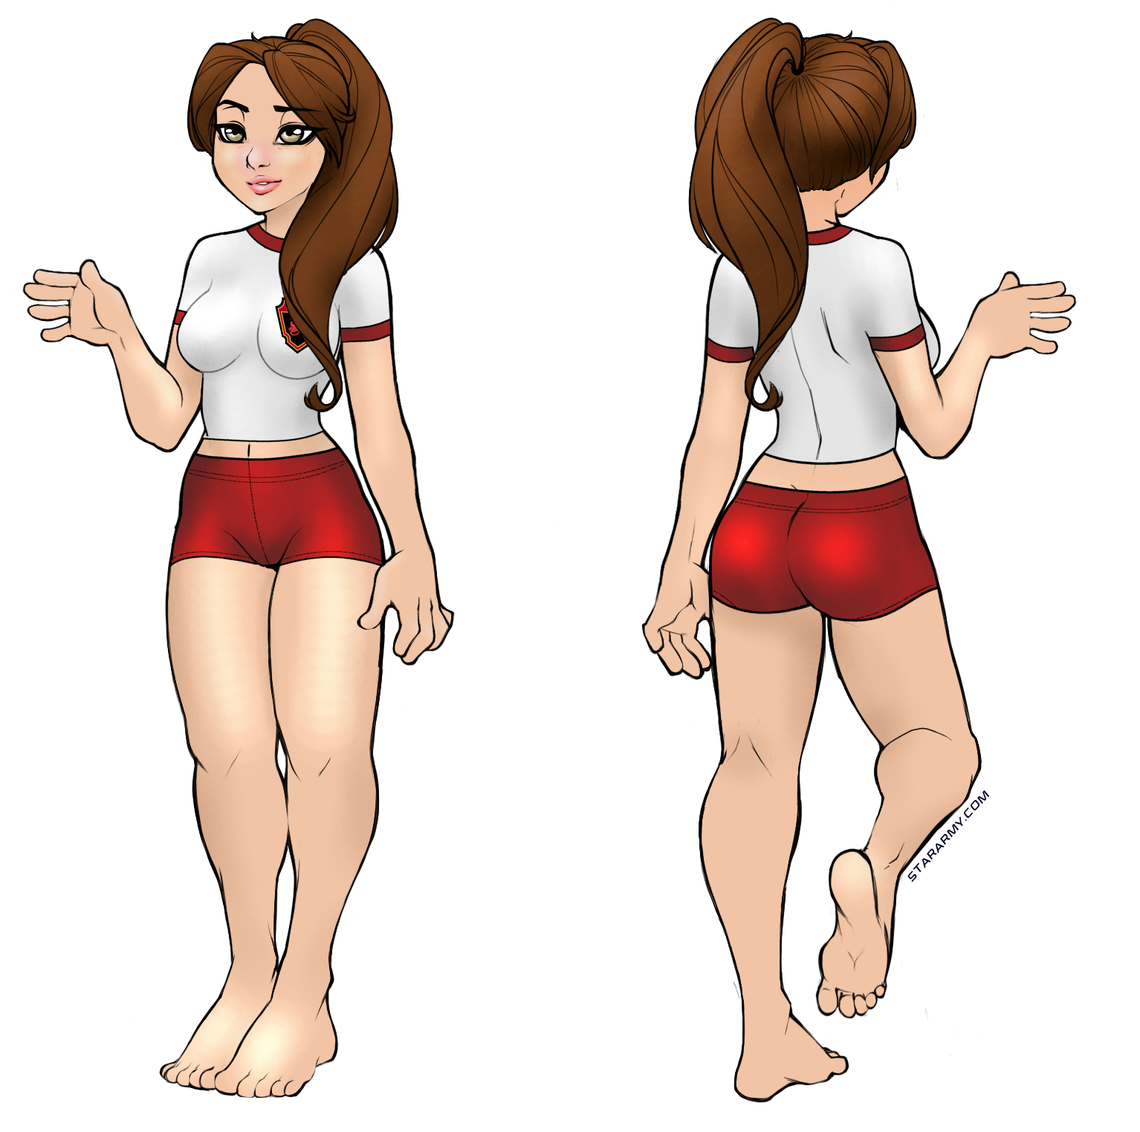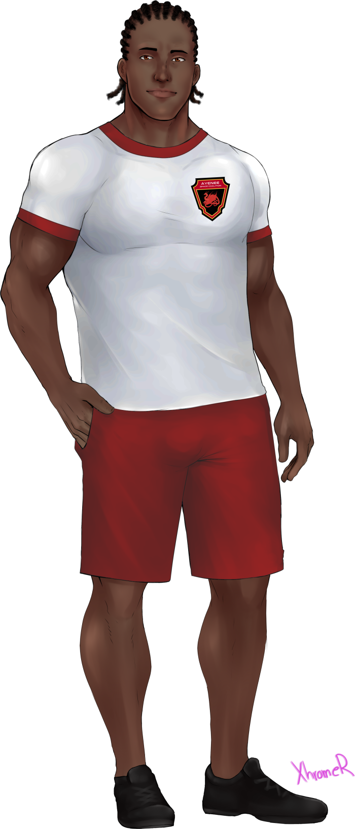

OOC Notes
This page was originally created by Wes on Sat 10-02-18.
Artwork (female) by Wes using the base by Waitress and by Xhromer (male character) commissioned by Wes.

