Vargas Argyris
Vargas is a PC played by Dadragon6 within the Arcadia Complex.
Vargas Argyris
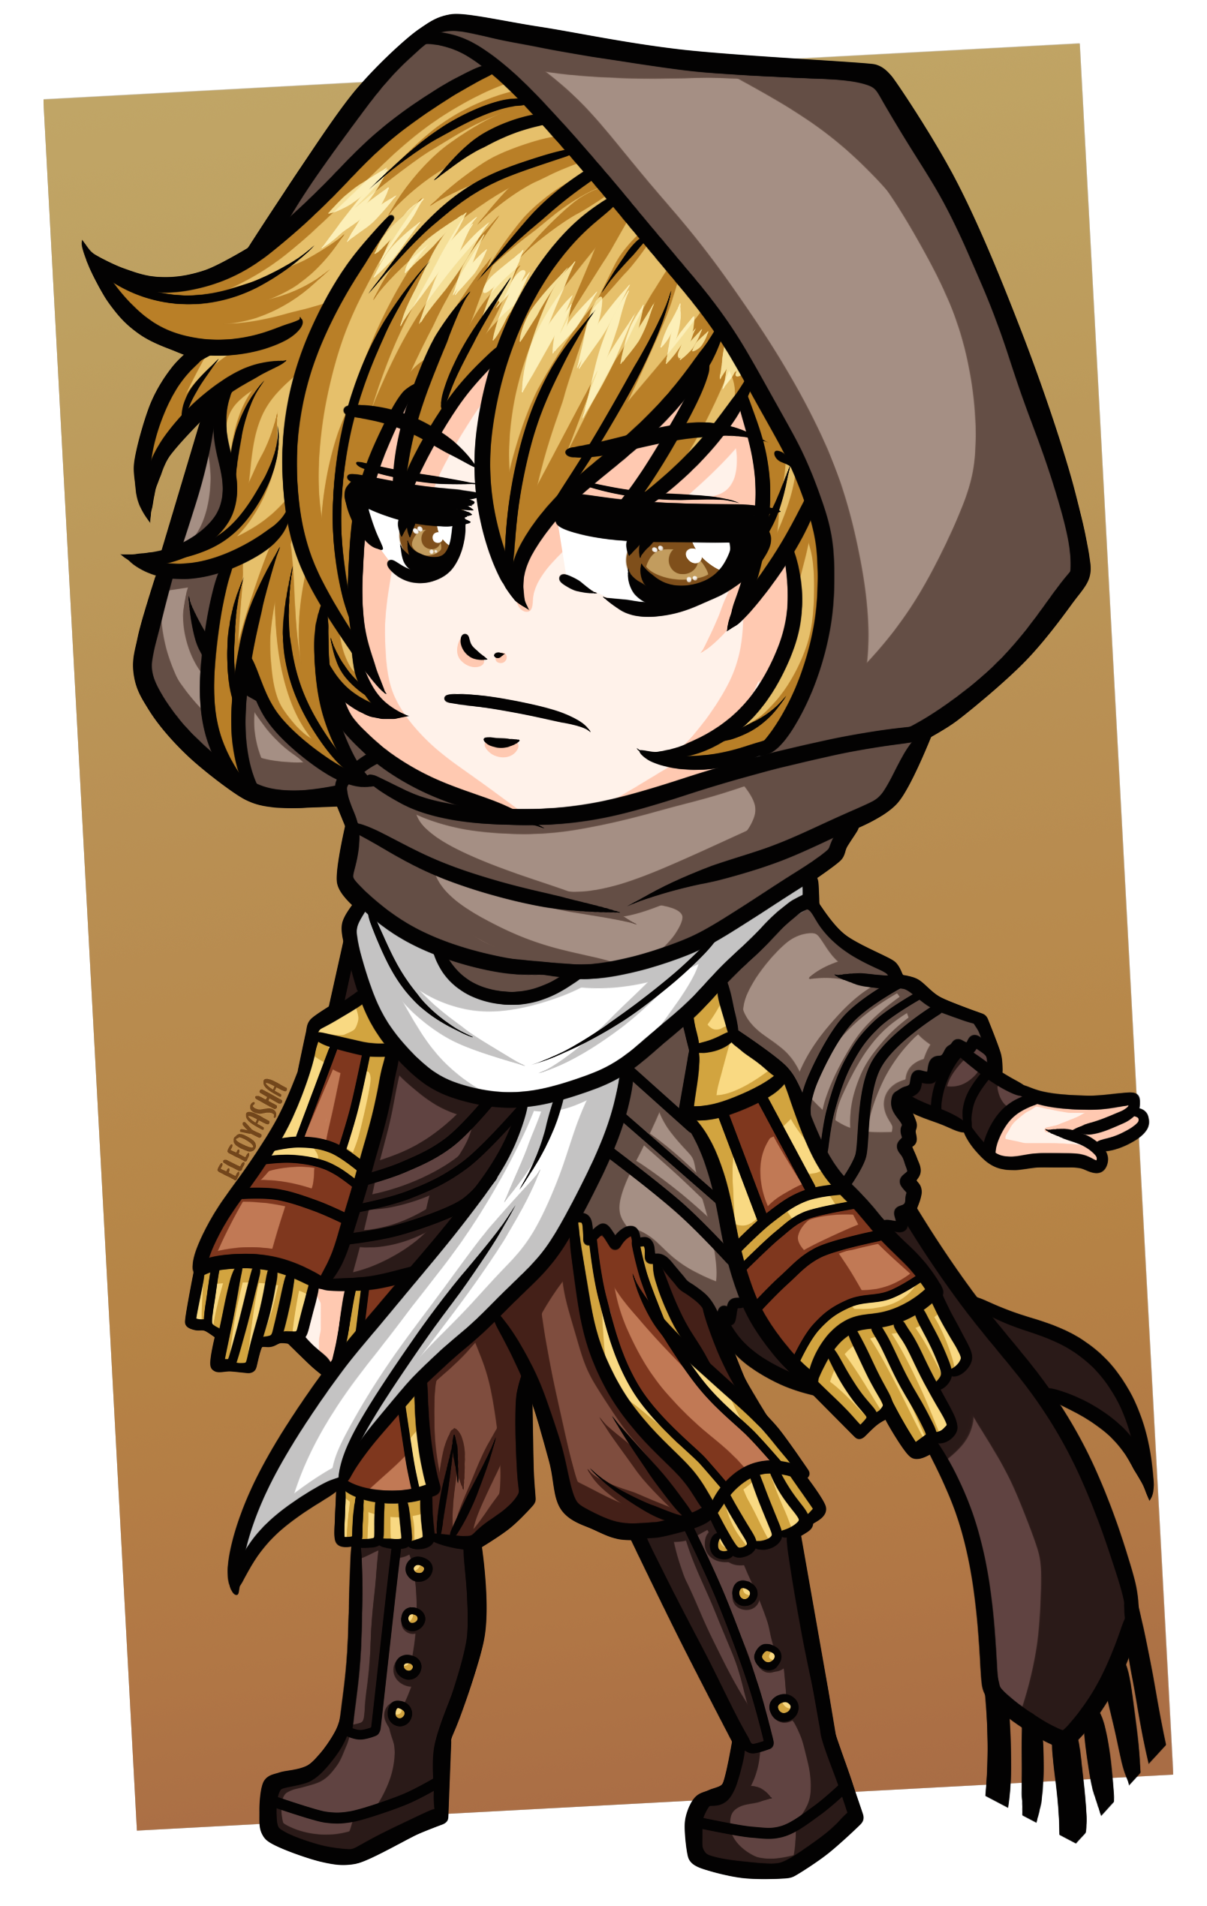
Gender: | Male
Race: | Human
Age: | 30
Faction: | Vigali Syndicate
Occupation: | Informant, ex-soldier
Nickname: | V

Physical Appearance
Vargas stands at a total of 5' 10“, or about 178 cm in the more widely accepted metric system. He has a mildly tanned skin as a result of spending so many years living in an arid climate, eyes the color of amber, and short wavy hair dyed a sandy blonde (though naturally dark gray). Thanks to military training regimen, Vargas is physically fit, as is the standard for any soldier.
Much preferring practicality over fashion, Vargas' usual attire consists of a mix and match of different pieces of clothing and equipment. The hood of his desert scarf often covers his head to both provide him concealment and protection from sunlight, but when not in use it can be found hanging loose from the back of his neck alongside his goggles on the opposite side. His beige travel poncho drapes to his left side, covering both his left arm and the holster on his hip where Vargas keeps his revolver. Underneath the poncho, he wears a bandolier on top of his old military-grade ballistic vest, and as a final layer of clothing he wears a loose-sleeved white shirt. On his left arm is a prototype cloaking device strapped to use as a bracer. Further down, Vargas' choice of trousers are a pair of plain brown cargo pants, tucked into his gum rubber boots; all of this gives him a distinct “desert wanderer” look.

Personality
[Placeholder]

OOC Notes
Speech is represented by the color code .
This page was originally created by Candle on Sat 31-07-21.

