Prince Zabulon Le Pontiantae
Zabulon Le Pontiantae
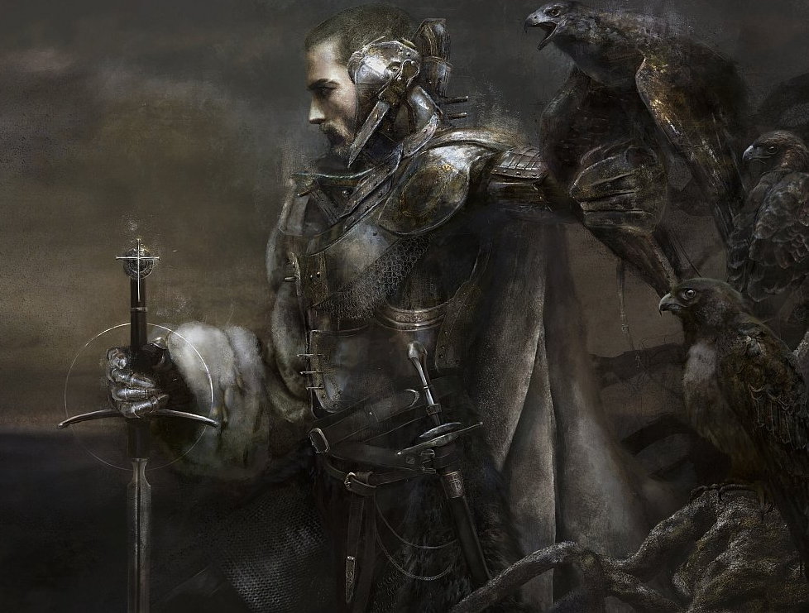
Titles: | Prince of Ayenee, The Black Prince
Gender: | Male
Races: | Human
Age: | 26
Occupation: | Prince
Faction/Kingdom: | Ayenee
Alignment: | Neutral Good
Status: | Alive
Relatives: | King Amorceas (deceased), Princess Amadour, Princess Malmora, Princess Shavasnia, Queen Beatrice (deceased)
Height:
Weight:
Eyes:
Hair:
Summary

Biography

Subsection

Subsection

Subsection

Subsection

Personality

Weapons,Relics, and Weakness

Abilities
ITEM:
ITEM:
ITEM:
ITEM:

External Links

Quotes

Trivia
Categories: NAME |NAME |NAME |NAME |NAME |
This page was originally created by J on Thu 22-06-17.

