Walter Hyde
Walter Joseph Hyde
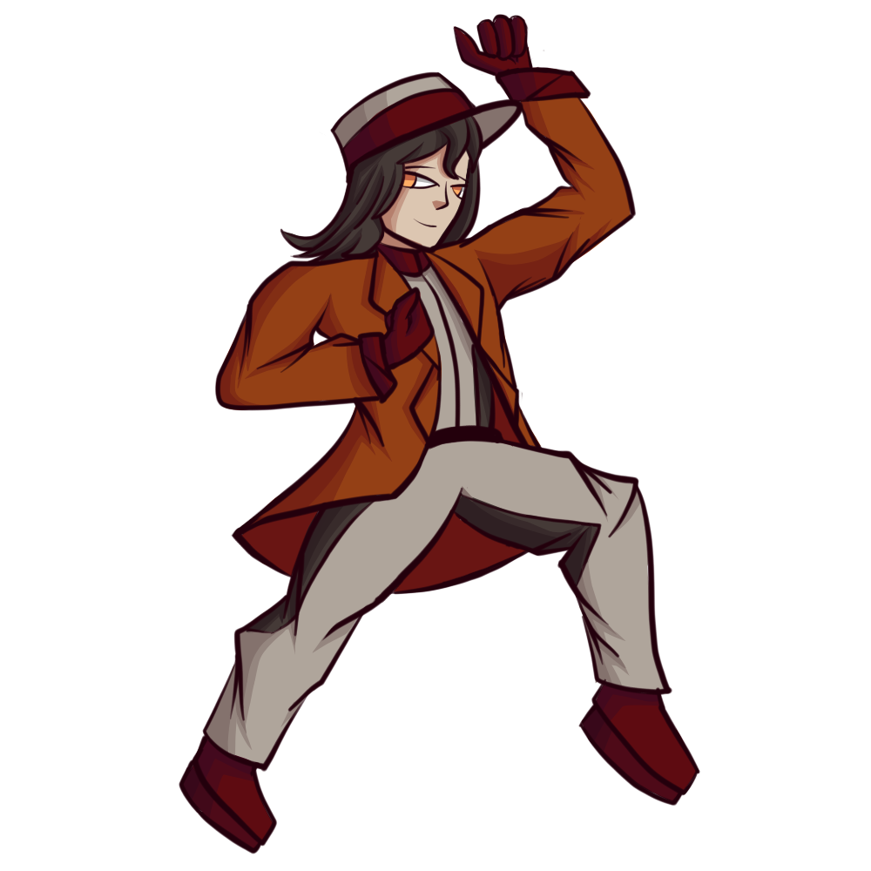
Gender | Male
Race: | NH-31 Minkan
Year of Birth: | YE 17 (Yamataian Calendar)
Organization: | Formerly Imperial Army of Yamatai
Occupation: | Engineer/Technician
Rank: | Nitô Hei

Physical Appearance
Walter Hyde is on the taller side of the height spectrum, being 6'5“ and all, and his dense muscles all the more give more weight to his stature.
The eyes are a bright orange akin to stars, and Walter's long hair is black like raven feathers. He brushes it to keep it flat and even, give it a day and it will curl up like weeds and vines. Walter also has elvish ears.
A unique characteristic is that he has a special biotech tattoo that is imprinted on his left pectoral muscle and shoulder. It is a orange shooting star, symbolized with a sun symbol and a brilliant comet trail that extends over the left shoulder and ending at the shoulder blade. It doesn't do much aside from glowing, although due to it being so close to the heart, it will glow brighter under certain conditions, namely in situations when he gets nervous.

Personality
Walter Hyde tends to act cold, tough, and unyielding whenever he feels cornered, due to his behavioral rehabilitation and the hostile environment he grew up in. Though the transition from Imperial Army to Star Army had softened Walter, and helped him become a little more trusting with others . The reason Walter hasn't progressed as a person would be due to the fact he hasn't taken interest in changing himself.
When he isn't at his worst, Walter is shown to be fun-loving, patient, humble, and loyal to those he serves with. He rarely flaunts about what he can do as a superior Minkan, preferring to lie low and look like he is only as strong as everyone else is.
Walter Hyde likes reading, dancing, roleplay, and fast food. What he doesn't like, however, is celery; Walter says that celery has a weird taste.

Biography

Pre RP
There is a battle technician who is called Walter Hyde. A smart and handsome Minkan from a sister dimension, serving the grand and overpowering Star Army of Yamatai as a clever soldier, and a determined techie.
This… Is not about that Walter Hyde. This is about another one, from a universe whom bred a evil empire so overwhelming that the very concept of failure didn't exist. The Imperial Army of Yamatai seemed to be filled with malicious, conniving, belligerent soldiers and officers in their ranks, and the empire thrived on the toxic culture “for consistent improvement in all fields”.
Walter Joseph Hyde, born to a cruel fanatic of a abusive, dominant mother, and a targeted, weaker mother who was worthless to her son and her spouse. The dominant one, Edwin Hyde, spun tales on how she charged the front lines, mowing them down with one Aether Sword in each hand, carving bodies into two. Walter had incredibly mixed feelings in the engrossing, and yet so horrid, stories of his mother's exploits. Of course, by the time Walter understood that those were supposed to be “happy stories”, he was also the same age to realize that inflicting pain and suffering is as unhealthy as it is to take the pain. The child didn't need to look no further than his parents dysfunctional relationship for a physical demonstration; his submissive mother, Belle Hyde, always had “unexplained accidents”, always changing bodies when she would get bruises.
In his teens, Walter was already sick of home, sick of Yamatai, sick of everything. His rebellious spirit had motivated him to take up dancing, getting his shooting star tattoo, doing a live action roleplay, and eating cheap market food. Despite his best efforts, Walter couldn't pull away; the idea of being in a part of mindless and efficient worldmongering was starting to grow onto him, with it being shoved in his face weekly on his homeworld in surplus.
Finally, Walter Hyde enlisted for service as a Engineer in early YE 39, where he learned the ropes of being a Imperial Soldier in Basic Training & Mental Reconfiguration. The training exercises were allowed to be as brutal as the instructors are willing to go, with some instructors going as far to finding ways to kill their trainees to offer more substantial lifelong lessons on warfare, as well as forcibly change the mentality of their trainees to be prolong the culture of the Imperial Army. His exceptional record across every test landed him a spot on a special ship: IYS 0071. A highly experimental ship designed to translocate itself to another universe. The moment Walter Hyde took up that position, he unwittingly made one of the most pivotal decisions in his life.
The end of YE 39 was fast approaching, and the IYS 0071 and her crew were ready to make their test run. It had two pilots, a scientist, and Walter Hyde; while everyone was in the cockpit, Walter stayed in the engineering bay of the ship. They initiate the transuniversal jump drive, and the moment the IYS 0071 jumped out of reality itself, it had already begun to fall apart. The hull was being sheared off with relentless force, the internal circuitry melted in the cockpit, and the Aether Generator couldn't produce any power, so the ship ran off of a few minutes of auxiliary before crashlanding into another dimension, uncontrollable.
Walter Hyde was the only survivor of the accident; the 0071's engineering bay protected him from being melted, while the power armor he wore protected him from the impact that followed afterwards.
The Minkan, whom came from another reality, whom is about as alone as he ever was, hesitantly enlisted as a trainee at Fort Miller. Walter willingly took up Basic Training once again, and was accepted as a Santo Hei. Despite his eagerness to start anew and find his place, Walter's complicated behavioral issues tend to make him stand out from the others, hence why he keeps to himself as he runs routine maintenance checks.
When Walter was free from his daily duties in Fort Miller, he goes out sightseeing, experiencing the planet firsthand.

RP
Much to Walter Hyde's misfortune, he had been transferred to the YSS Kaiyo II, a ship that had recently become a transuniversal explorer. The crewmates he was around were sharp, formidable, and had apparently met another version of himself before Walter came aboard. Any attempt the Minkan made to push attention away usually resulted in getting more attention directed to himself in the process, putting him on the brink of a number of anxiety attacks.

Abilities

Superior Minkan Body
Walter Hyde, coming from a universe that was as superior in technology as it was in vileness, also came in a Type NH-31 body that was superior to other NH-31s. On top of the perks that most NH-31s offered, it comes with the following:
- Superior Observation: Walter Hyde can process far more information within one moment than other Minkans, through sight, smell, taste, and touch, and hearing, which enables him to anticipate the moves of his target and counteract. This also designed to be affected by adrenaline rushes.
- Superior Muscle Tissue Lattice: His muscles tissue is meticulously layered to have a increased advantage on heavier loads, averaging around 250 kilograms of weight in 1G environments while in a dormant stage. When greatly agitated, the tissue lattice swells to provide an additional 150% strength boost.
- Advanced Cybernetic Defenses- The cybernetics involved with the design, while functionally alike to Minkans, are also protected with a strong defense matrix. The unique coding language involved makes it too hard to hacked. This anti-virus can spread to other technology, as long as they have the hardware to accept it.
- Electrical Transfer and Ground: The bones, which already have a increased bone strength, are also lined with biological cables that route to the feet and arms. The cables also increase the tensile strength of the bones themselves, however the boost is only a 15% increase. While this is claimed to be a design choice to resist electricity, the true purpose of the cables are to allow heavily damaged Mindy armor to remain relative functionality, while also keeping the soldiers overstimulated to prevent them from passing out.
-Increased Life Span- The body breaks down even slower with age, allowing Walter Hyde to live to around 343 years. He won't show signs of age until around 290 years, and will become unfit for service when Walter approaches 320 years old.
- Advanced Internal Chemistry: Walter's body is customized to have two small organs that function as chemical-storing organic capacitors. The Pheromone Subsystem allows Walter to emit phermones that arouse, but not force, feelings of fear or lust. The Adrenaline Subsystem functions as a harmful boost that stifles pain, increases ferocity, and overclocks strength and senses.

Yamatai Mindy Armor
The Mindy Armor that Walter came with, while vastly superior, had sustained critical damage. The engineers there couldn't fix it, or even recycle it, because it was the technology involved was beyond what they could work with. Thus, Walter Hyde was issued a underused Ke-M2-2D Series Power Armor; also known as “Mindy II”.
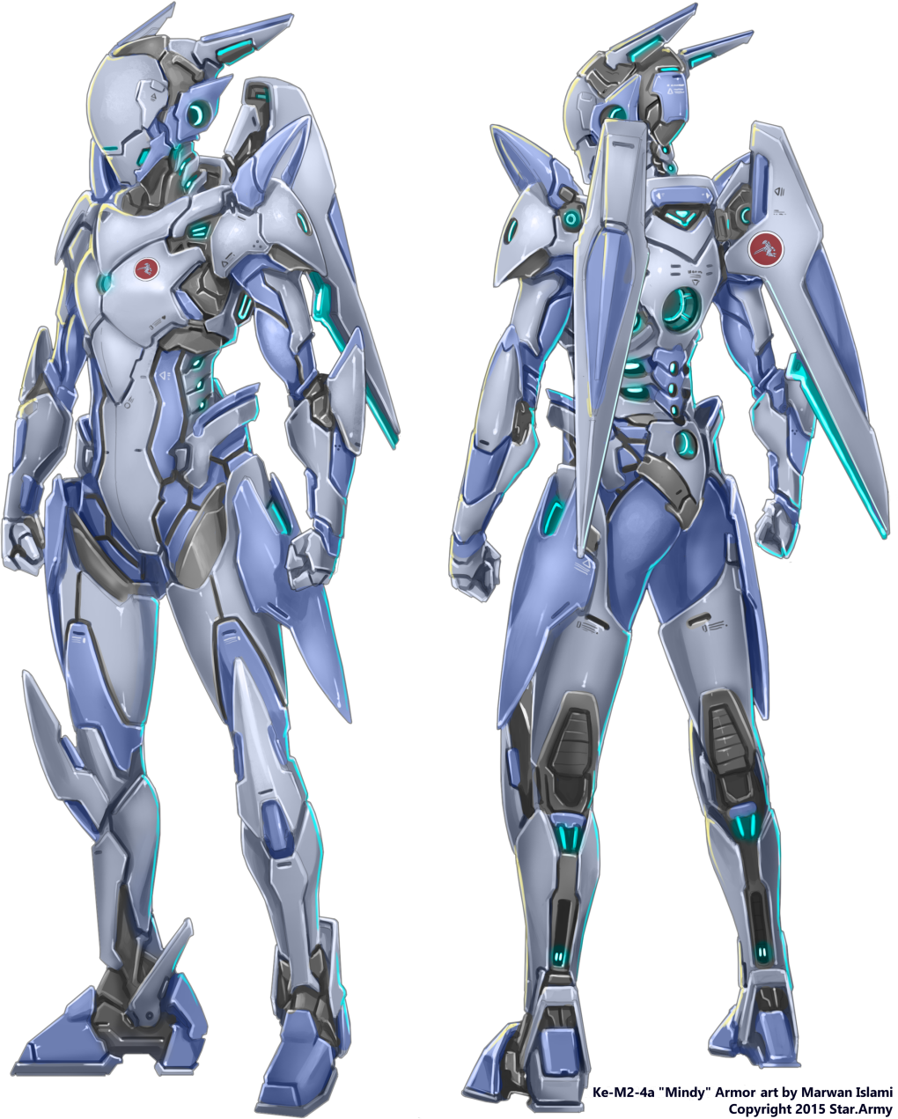
Left Shoulder | Dorsal | Right Shoulder
Type 35 Automatic Grenade Launcher | Ke-M2-G2902 Nodal Fabrication Module | Type 35 Automatic Grenade Launcher
Leg Pods | utility/cargo | Handheld
Ke-M2-W3002 Leg NSB Launchers | Large Ammo Belt (1700 AGL Ammo) x2 | Ke-M2-W3901 Aether Blade Nodachi
Left Waist | Wings / Tail | Right Waist
Blacksmith's Repair Kit | No/No | None

Skills
- Star Army Common Skills
- Repair and Maintenance - Walter Hyde, even with some improvised tools, could get just about any Yamatai technology fixed up in a timely fashion, if not faster. He struggles with technology he isn't aware of, namely technology of every other race.
- Entertainment - Walter knows a handful of dances, although only two moves are fast-paced. Practicing was a hobby that he picked up to distance himself from reality. His other hobby is acting; he lets loose and almost becomes a entirely new person when he plays a role. This had only happened when he did a live-action roleplay with friends, though that moment cemented his interest ever since.

Connections
- Alastair Belmont - Acquaintance
- Arete Surinus - Crush/acquaintance

Items
- Star Army Standard Issue Items
- Charred clothes that came from his home dimension.
- Blacksmith's Repair Kit
- A critically damaged Mindy IV, equipped with just a advanced Fabrication Module; also from his home dimension.
- Proper casual wear
- His uniform
- A nice collection of books
Walter Hyde currently has 2000 KS.

OOC Notes
This page was originally created by Burgmond on Sun 21-01-18.

