Dante Vernados Blackflame
Name
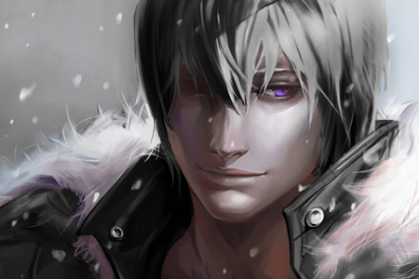
Titles: | Lord of Blackflame
Gender: | Male
Races: | Demon
Age: | Unknown
Occupation: | Clan Leader
Faction/Kingdom: | Blackflame
Alignment:
Status: | Missing
Relatives: | Lucien & Midori Blackflame
Height: | 6'0
Weight: | Variable
Eyes: | Violet
Hair: | Black
Summary

Biography
Dante's childhood was one of both learning and suffering. Born of an angel mother and one of the fiercest demons, he felt outcast from the entirety of his family, neither completely welcome in darkness or light. To make matters worse, his father decided to complete his training in the hell dimensions from which the Blackflames originated. The creature that came back to Ayenee several years later was not quite what his father had anticipated, however, and instead Dante chose to go his own separate way rather than continue persuing Damaris' twisted goals. Now much older and far more wise, he's realized that being an outcast in a family full of them is far from the worse fate one could receive.

Subsection

Subsection

Subsection

Subsection

Personality

Weapons,Relics, and Weakness

Abilities
ITEM:
ITEM:
ITEM:
ITEM:

External Links
http://www.houseofblackflame.com/

Quotes

Trivia
Categories: NAME |NAME |NAME |NAME |NAME |

OOC Notes
This page was originally created by Cyndi on Tue 14-11-17.

