Camaryn White
Camaryn “Cammy” White
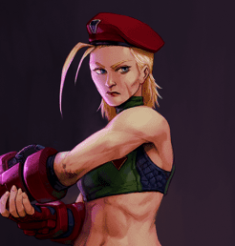
Titles: | CEO of Federated Technologies
Gender: | Female
Races: | Human Clone
Age: | 49
Occupation: | Chief Executive Officer
Faction/Kingdom: | Federated Technologies
Alignment: | Lawful Good
Status: | Active
Relatives: | None
Height: | 5'4“
Weight: | 134 lbs
Eyes: | Blue
Hair: | Blonde

Biography

The Killer Bee
Rather than being born to loving parents, Camaryn is a product of the Shadaloo criminal syndicate's cloning program. Specifically, she is a genetic clone of the insane, would-be dictator Master Bison.

Delta Red

Feisar Arms

The Future is Federated

Personality

Weapons and Relics

Special Abilities

Powers
Psionics:

Weaknesses
Camaryn has no special weaknesses inconsistent with human biology.

OOC Notes
This page was originally created by Alexis on Wed 08-02-23.

