Butterdemon
The Butterdemon is a unique species, often living on very hot planets in systems such as Thermius.
The cells in Butterdemons' bodies use special molecular bonds that allow them to be massively massively resistant to heat, though more vulnerable to the cold. This heat resistance allows them to walk through fire or lava unharmed. At normal room temperature, however, they tend to feel chilly. By instinct, they know how to use fire and heat magic, and can make it even more potent with training.
Butterdemons have a pair of butterfly wings on their back. These wings allow them to fly or hover, and are very maneuverable, but unlike bird-style wings their attachment points run all along their backs and they don't have additional joints apart from their attachment points to make them fold down and decrease their size. Their wings can be bent to some extent, but it's uncomfortable for them to bend them in sharp angles. They do reduce their back flexibility somewhat, but not majorly- it is, however, enough to give most Butterdemons a habit of waddling. Butterdemons are also capable of changing the color of their wings, and even making them glow with bioluminescence. Other types of Butterdemons have moth wings. These have the same attributes as the butterfly wing type Butterdemons, except they're capable of folding their wings up like a moth. Unlike butterfly wing types, they aren't capable of making their wings glow, though they can still change their color.
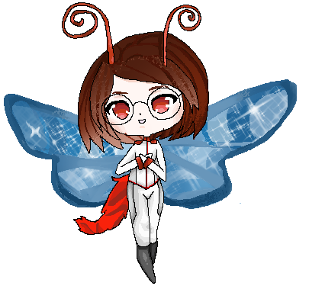
They have very long tails, with a length of about 5 feet. These tails are cat-like, covered in soft crimson red fur. They actually don't have any bones in them, making them extremely flexible and wriggly.
Some, but not all Butterdemons have an additional pair of limbs that resemble black insect legs on the sides of their torso between their arms and their legs. These can be folded to conceal them under a shirt or clothing. These limbs' main method of gripping is not a hand or a claw but instead tiny retractable bones that function like the hair-like structures that allow insects to climb walls. All Butterdemons have these tiny retractable bones on their hands and feet, which again, function in the same way the tiny hair-like structures do on bug feet and allow them to climb or stick to walls and ceilings.
They have two red colored insect antennae that are about 1 foot long and curl at the top. They tend to bobble due to their length and come out of the top of their head, protruding through their hair. Their antennae can pick up sounds, and are more sensitive than their ears, which can both help them and hurt them.
Butterdemons have fangs, and use them to drink blood. Blood is their primary food source, though they can get their nourishment from other things. While they can eat other foods, blood is particularly tasty and very tempting to them. They have some genetic similarities to cats which means they often enjoy what cats enjoy too. They have retractable sharp cat-like claws in place of fingernails and toenails on their hands and feet.
Their hair color varies widely. Their irises are almost always colored red. They tend to be very short, ranging from the 4 foot range to the lower 5 foot range in height on average, with no average height differences between males and females. The tallest Butterdemons don't even reach 6 feet in height.
The term Butterdemon was coined on account of their butterfly wings and insect-like features in addition to their extreme heat resistance and use of fire magic. Rumors have spread about Butterdemons that were seen using even hotter magic types than fire magic and transforming into different forms, such as what is described as a “demon-like form”, and more bizarrely, some have claimed seeing them change into the form of an ordinary butterfly. These claims are as of yet unverified.

OOC Notes
This page was originally created by Noodlewerfer on Thu 24-05-18.

