Arcadia Complex NPCs
“What's the point of creating a world if the characters inside it are not equally willing and able to bitch-slap a player character?”
- Pancakei
The plot of Arcadia Complex takes place in a world enriched by a multitude of major and minor Non-Player-Characters that frequently influence, back, or stand in the way of ISS Downrider Expedition as they travel the stars and beyond. This page serves as a roster for NPCs big and small, including information for characters and organizations who hold importance to the plot but do not have enough substance to warrant an entire page for themselves.

Core NPCs
Core NPCs are the driving force and heart of the plot of Arcadia Complex. They are usually members of the crew played by the GM, as well as frequently appearing adversaries. These NPCs are nearly guaranteed to be in, mentioned within, or influence the events of any episode of Arcadia Complex.

Dahlia Morgan
Main Article: Dahlia Morgan
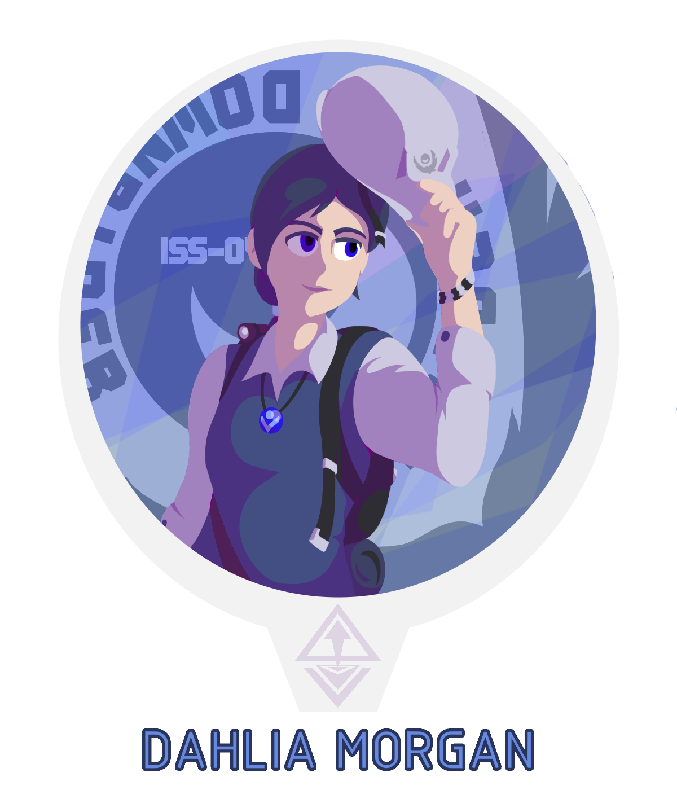
Dahlia Morgan is the young scholar who serves as the relatively inexperienced captain of the ISS Downrider. A young woman who has heard the elegends of Arcadia passed down through many generations, she is determined to uncover as much as she can about both the Arcadians and the many events surrounding their influence. Though she tries to be the best captain she can for her crew, her lack of experience as well as blunt pride can sometimes get the best of her.
She is a minor captain within the Vigali's ranks, frequently working with informants to help further her expedition- and pay off her debts.

OSC-01 / Tara

Main Article: OSC-01
Tara, former name OSC-01 is an unusual Overseer found in the densely irradiated forests of Loinia. Unlike traditional Overseers, servant models created by Oakland Heavy Industries, OSC-01 immediately showed signs of free will and particularly dangerous armaments. Although initially appearing as just one of many robots created as servants from an ancient time, more was revealed of OSC-01 as the crew continued working with her, eventually leading to many arguments and revelations. Tara served the New Incipere Courthouse at one time, serving as the personal guard for many important figures and friends in a begotten era. Left with a curse of immortality as she was unable to prevent the untimely deaths of several colleagues, she cast herself into exile.
While on shaky terms with the captain, Tara now serves as a guardian and guide for the ISS Downrider expedition, looking to make up for a lifetime of mistakes. Several of her former accomplices within the Servants Eternal are also active, though in differing states and opinions of her.

Bryce Arvero
Main Article: Bryce Arvero
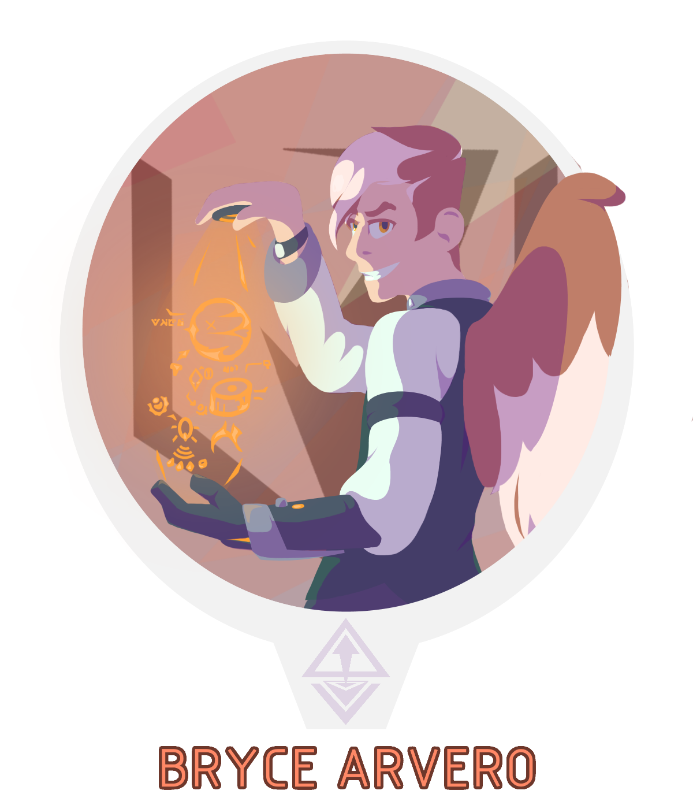
The frequent antagonist of the plot, Bryce Arvero is the self-proclaimed captain of the Arcandum Union. A supposedly smug and self-centered Arcadian born from disaster and molded by a childhood riddled with loss and injustice, Bryce is determined to do what he must to be on top. He has plans that will do such, and save the world from the destruction of the Schism in the process. He frequently flips sides with the Downriders, either seeing them as friends or mortal enemies as they cross paths.
As the captain of the Arcandum Union, he seems to oversee their operations directly and often strikes deals with other factions to get ahead. He puts up with the Downriders as a necessary evil to keep his heroic plans in line, though he has tried multiple times to get rid of them to no avail.

The Narrator
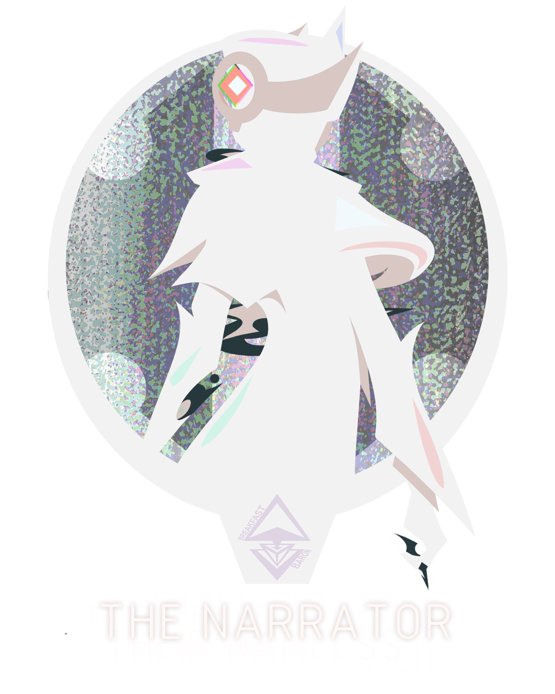
Main Article: The Narrator (Arcadia Complex)
The primary instigator and aptly, the narrator of the plots events. An incredibly powerful and undocumented being who exists far outside the way off the ISS Downrider. While they primarily serve as narration, their influence over the crew and their surroundings is strong. Strong enough so that they are responsible for the expedition's continued existence, bringing forth another iteration of the ISS Downrider Crew to carry their torch when the last one expires.
While not all meta text in the plot can be considered the word of the Narrator, their presence is usually noted by conspicuously italicized narration.

Major NPCs
Major NPCs are NPCs who hold some significance to the plot at large, but are not ubiquitous with it. These NPCs may appear with others or on their own, but their attendance or mention is usually not mandatory.

Alioth
Main Article: Alioth
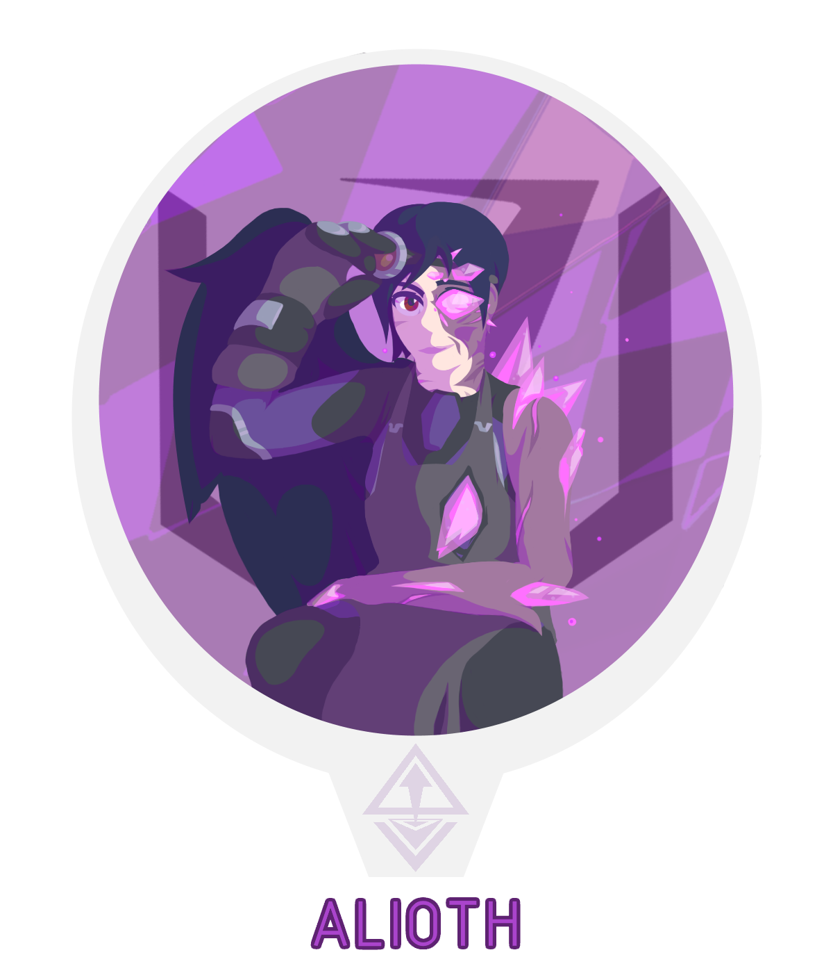
An artificer and field agent for the Arcandum Union, as well as Bryce Arvero's right hand partner in justice. An Arcadian ravaged by the Schism and left with no memory or name, ALioth is plagued with growths of raw echyllis and partial decay, living in a strange state between life and death. Because of this, she is an extremely powerful Syllic vested in telepathy, telekinesis, and echyllis manipulation.
A rather flat and easily annoyed individual, she leaves most of the theatrics of the Arcandum Union to Bryce, while she organizes dirty work and new leads. However, Alioth possesses (or at least claims) to be able to see the future, and knows that the end of the world is coming. She personally foresees the ISS Downrider expedition will be responsible for it, and as such is hesitant about working with them. She works with the Union in an attempt to make sense of the world she's found herself in, try and recall her past, and stop the Schism from coming agaim.

Satori
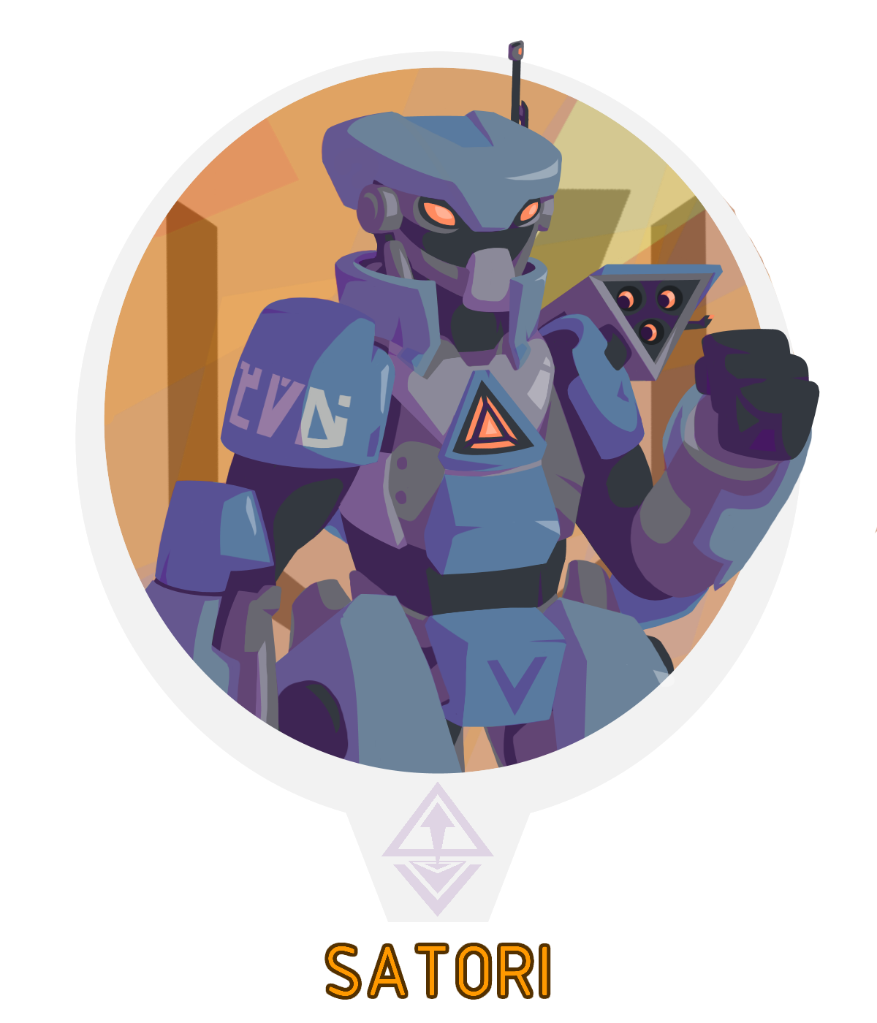
Bryce Arvero's robotic bodyguard, one half of a pairbonded Arcadian AI that has been split from its regulatory half. A last gift from his wayward mother, Satori acts as a guardian and information agent for Bryce. They specialize in cyber warfare, but their large frame means they excel in their own fair share of direct 'conflict resolution'. Their ATES-branded bodyguard body is strong and hard to take down, but is not their only place of residence.
Satori has access to a premium wealth of information through old Arcadian military and science channels (notably, SARCOM). They are also responsible for acting as a remote operating system for the Union's many shoddily made androids, which act as thin clients. Where Satori originated, the details of their creation, and the location of their missing half is unknown, nor do they seem troubled by it.

Clef
One of the three agents working for the Biechelon Collective Scouting Patrol A-13, and the patrol's scout. Quick to draw and even quicker to comment, Clef is capable of running his mouth and his opposition in circles at the same time. While not a particularly strong fighter, his ability to manipulate inertia and attain high speeds makes him hard to hit and capable of delivering high-speed kicks. Using the Overdrive key inserted into two leg-based drivers, Clef is capable of fast reflexes and solid air control, letting him ignore the effects gravity when running. When all else fails, machine pistols are a go-to defense.
A loud and foul-mouthed alien of thinned Nepherian blood, Clef serves as the scout and resident handyman of the A-13 Trio. He was born to a large family without much parental supervision, leading into his eventual induction into the Biechelon Collective as he searches his own path and history.

Gallo
One of the three agents working for the Biechelon Collective Scouting Patrol A-13, and the patrol's planner. A reserved and quiet man, Gallo prefers to bide his time when making attacks. Using a highly-experimental key known as 'Coalescence' in a helical drive, Gallo utilizes rifts for the purpose of evasion and laying traps to deal methodical bursts of destruction at the expense of no direct armor. Made up of multiple keys, the experimental key has unknown power channeled directly through a folding pole-arm. Without any armor, Gallo relies on dodging and redirection as well as a mesmer state to avoid attacks.
A reserved and mostly polite individual, Gallo often acts as the voice of reason for the A-13 Trio. Once upon a time he served as a technician in the Institute, never participating in the program directly but learning the mechanics behind it very well. When the Institute began to decline, Gallo was consumed by a lust for power and knowledge, stealing whatever documents and technologies he could muster along with his trade knowledge. Eventually, his experimentation caught the eye of the Biechelon Collective. With an organization to back his research, he constantly seeks new knowledge, experiences, and finds to fuel his curiosity- no matter the cost to others.

Agatha
One of the three agents working for the Biechelon Collective Scouting Patrol A-13, and the patrol's leader. Though she may appear old, Agatha is incredibly strong- even more so when under the effects of her driver. Manifesting in a bulky industrial suit, the Vulcan key slotted into an equally bulky driver allows her to manipulate earth and metal, super-heating the environment in the process. She quickly becomes a hardy opponent that cannot be knocked down feasibly, bringing a great deal of offensive and defensive power at the cost of range and longevity.
The hardiest yet oldest of the trio, Agatha is a zealot to her bones. She does not take lightly to those who stand in her way, often making spiteful remarks against her opponents and sometimes falling victim to her own hubris. Once upon a time, Agatha was a preacher for a small church, with a loving collective beneath her wing. The tides of Ayenee's endless power struggle eventually ravaged the area, burning the church to the ground and killing many in its wake. Pushed past the deep end by loss, Agatha swore to take vengeance against those who wronged her. Looking to gain enough strength to end the struggle once and for all, Agatha was swept up in the Biechelon Collectives teachings, becoming enthralled in it.

OSC-02 / Avani

OSC-01's sister unit, another specialty Overseer of extremely similar model. Given the span of time between their creation, OSC-02 is marginally more refined on a physical level than OSC-01, possessing greater combat flexibility and a more durable reactor.
When Tara chose to defect from New Incipere following the raid on the New Incipere Courthouse leaving several dead, Avani and Ferrus followed albeit somewhat reluctantly. The more emotional and hostile of the two, Avani took this out on Tara and the two left on poor terms as the gateway to Arcadia- and New Incipere by extension- collapsed. In the modern era, Avani awoke before Ferrus, and quickly fell into the same problems OSC-01 did upon wake. This left multiple expeditionist of the Grumman Adventure Corp dead or maimed, and Avani in shock. Their whereabouts since the incident are completely unknown.

BTC-03 / Ferrus

A specialty 'Breaker-Type' unit, in the same line of servants as OSC-01 and 02. A hulking war machine with a heart of gold, Ferrus was designed to be the ultimate siege machine should Arcadia attempt to rise again. With twin reactors and several tons of armor, Ferrus is not an opponent that can be easily brought down without some kind of dirty trick.
When Tara chose to defect from New Incipere following the raid on the New Incipere Courthouse leaving several dead, Avani and Ferrus followed albeit somewhat reluctantly. Having also experienced the failure, Ferrus obliged with more reason than his soon-to-be wife. When the two retired and entered slumber, Ferrus was the second to wake only after Avani's rampage. After reconciling the situation, Ferrus reluctantly agreed that Avani needed time to sort things out. Years later when the Arcandum Union and the ISS Downrider came knocking, Ferrus was rudely awoken to a firefight where he had little time to catch up before being hacked by Satori.
His location is unknown, but he is still under the possession of the Arcandum Union.

Minor NPCs
Minor NPCs are the lesser backbone of the plot, background characters that serve to fill the void in the world and offer dialogue and influence events from a distance. Usually, Minor NPCs only appear within their respective episodes or simply do not appear with enough importance to be considered a Major NPC.

Mervius Talamon-Beauford
Mervius Talaomon-Beauford is the aged and quaint owner of the Downrider Inn, and one of the two primary financiers of the expedition which came to take his Inn's name. An balding man with a broad build and bushy eyebrows, Mervius is an avid collector and enthusiast of the weird and wacky. He works full-time as the manager and oftentimes barkeep of the Downrider Inn, located on the outer limits of Ayenee's Capital City. A warmhearted if hard-to-understand man, he has in the past acted as a bit of a parental figure to Dahlia Morgan. His favorite color is brown.

Douglass Vigant
Douglass Vigant is the founder of the Vigali Syndicate, as well as the retired figurehead for its cover operation of Vigali Enterprises. An old and harsh man, Douglass has mostly delegated his responsibilities to other parties in his old age, though he still holds his agents liable against the core competencies that founded the Vigali Syndicate to begin with. Despite his age and importance in founding the organization, he has no children and therefor no heirs.

Bismarck Urane
Bismarck Urane is the head of the Biechelon Collective, serving both as a form of commander and a religious figurehead for the cult. There is very little known about them at the time, as their name has only been mentioned in passing by the A-13 Patrol. Form what can be gathered, they are exceptionally powerful, wielding an extremely powerful version of echyllis-fueled weapon-projection devices known as Drivers, and pose great risk to the system at large if left unchecked. They are interested in tracking down Romulus Aurum, no doubt due to his involvement in the downfall of the Amperia Institute as well as past grievances.

Historical Figures
Historical Figures are NPCs who serve to further the world-building of Arcadia Complex and the many factions at play surrounding them. These NPCs are almost exclusively unplayed outside of records or other forms of preserved media, and serve primarily to provide backstory to the plot's many events. There may be exceptions to this rule in the future, however.

Adila Marheart

Born in Arcadia with a forbidden mix of Nepherian and Arcadian bloodlines, and a member of the least desirable subspecies no less, Adila was not long for the world. She spent only a small amount of time in her homeland before being stolen away by her father to Nepheros through the most stringent customs in the universe. As an adult, Adila would serve a great role in the downfall of her homeland, though through no violence. A versed scribe gifted in tongues, Adila became a valuable asset on any matter of communication or moral dispute in the melting pot of Nepheros, as well as being the one to write warning calling for evacuation to the citizens of Avisten before its downfall.
When Arcadia fell, the state of New Incipere rose from its radiation-bitten ashes. When it came time for legislation to be crafted, Adila and her lover Richter were chosen to fulfill the need. Together they wrote a fair and just system for law to be conducted and positions in government to be filled based on transparency and a lack of discrimination. For a brief time, Adila (now Marheart) served as New Inciperes first judge, though her interim term was cut short by her own will.
In early retirement, Adila and Richter worked together on their final project, nicknamed the Codex. It was to be a single, comprehensive timeline and vast library cataloguing information the earliest known traces of society on the river Aper to the downfall of Arcadia and beyond. Unfortunately, Adila never lived to see the project to completion. Her involvement in the war, however peaceful, was enough to make her the target of rebellious scraps left over by the toppled nation. In a nightly raid, her woven blood had been spilled over the courthouse floor. Her untimely death was one of the reasons Tara cast themselves and the rest of the servants into exile.

Richter Marheart
Richter Marheart was a reporter of terran descent, who worked for a reporting collective that was often bogged down with conspiracy theories and given a bad reputation among its peers. He aspired to work for a real network, but could never seem to find escape. Richter's big break was a case pertaining to the existence of Arcadia, and their influence on the planet Dredgen Vix. The story and photographs gained him fame- and a target on his back. Quickly finding himself under Arcadia's scythe, he was saved by a jumper squad of Nepherian rogues, dragging him away for their own questioning.
After release, Richter stayed in Nepheros and served as a valuable informant, his wide-spanning theories and first-hand experience with ATES proving him a surprisingly valuable asset. It was there he met his future wife Adila, eventually becoming a low-ranking officer in the New Nepherian Order, helping in overthrowing the Grand Republic of Avisten. He documented and photographed the events of the war exceptinally well, serving to fuel the propoganda driving it to it's completion. After Arcadia fell, Richter and Adila were tasked with creating a fair and just system of law for the new nation, New Incipere.
In early retirement, Richter and Adila worked together on their final project, nicknamed the Codex. It was to be a single, comprehensive timeline and vast library cataloguing information the earliest known traces of society on the river Aper to the downfall of Arcadia and beyond. Unfortunately, Adila never lived to see the project to completion. After a raid conducted by a group of Arcadian dissidents took her life, Richter was left behind in a pit of grievance and depression. When Tara cast the servants away into exile, Richter was offered a chance to escape but refused. What came of him after the incident is unknown.

Amelia Athes

Amelia Athes was an Arcadian Avecris born into military royalty in Avisten, Arcadia. The great granddaughter of the Derelict Athes II, Amelia Athes became the family figurehead of ATES- Arcadia's premier military service which operated both in and out of their home dimension. Though a familial figurehead, Amelia was trained as any other service member, eventually becoming a high-ranking commander in the Syllic division. At some point in her career, she had a child which she kept hidden away from both the public and her overseers. Amelia served several decades both as a commander and a member of the defense council leading up to Arcadia's final years in power, becoming a known image to fear.
Amelia foresaw the downfall of Arcadia ahead of time, trying to pursuade the defense council to back down their aggression over humanity before it was too late. When all else failed, she worked with several sympathizers within the Upper Gardens of Avisten to stage her leave, taking a wealth of information and striking a destabilizing blow against ATES in the process. The consequences of her actions came around quickly as the more faithful of ATES tracked down and killed her child, cementing her defection from the nation.
Amelia traveled to Nepheros to quote “face the demons she could not pacify.” Whether she meant the Nepherians or her homeland, no one was sure. Although Amelia's defection was welcomed by the warmongers in the New Nepherian Order, she was not a very popular figure among the actual Nepherian troops- no doubt due to hersupervision of ATES while on the defense council. In the end, she was a pivotal figure in the turnaround of the war against her Arcadia, her stolen good and insider knowledge proving critical for destabilizing the enemy in ways they had not prepared for. Despite her presence almost single-handedly assuring Nepheros victory, Amelia chose to stay out of the foundation of New Incipere, merely living out the rest of her life away from the action.

The Faceless Baron
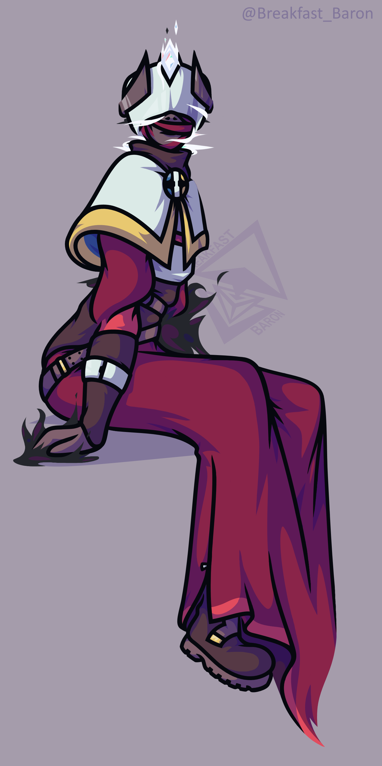
The Faceless Baron, also known as the Good Baron and Their Facelessness was the first leader of New Incipere. Prior to its foundation, they served as a field officer in the New Nepherian Order. When the raid against Avisten first seemed like a victory but soon gave way to the Schism, it is believed the Baron was there to help put an end to it. Sealing away the Folly that ravaged the city, they vanished in the process- as did many in the area. While initially thought lost, they resurfaced from the Great Nothing days later, many others soon following. Despite their brief disappearance, they came back a completely different person than they had entered. Older, wiser, stronger, and with a body warped by their travels, they came back with great plans to establish a new land from the destruction. Having been disfigured form their travels, the being rejected their former name, becoming henceforth known as the Faceless Baron.
During the reign of the Faceless Baron, New Incipere flourished. The city on the coast rose into a nation, casting away their past debts to forge a new path and new law for the foresaken land. The Faceless Baron was often cited in contradictory ways, some claiming them as a loud and charismatic leaders while others would cite them as being a shut-in planner. The Baron was no doubt a strange person, many of their ideas supposedly coming from 'dreams' or visions, many of which they deemed absolutely critical to the nations success. This behavior came down to the most intricate detail, even going so far as to reject water fountains to fit their plans.
The Faceless Baron worked closely with the higher ups of Oakland Heavy Industries, one of the conglomerates of engineers that rose to help restore materials from the desecrated site of Avisten with their new autonomous servant. In their older age they formed a secret project known as the Servants Eternal, tasking the engineers with creating a perfect cabinet to continue their setup plans until New Incipere could be considered self-sufficient. In the end the project was a success, with one such ascended unit, Tara, serving as their own personal guard. The Faceless Baron eventually passed by natural causes, leaving their nation and servants behind with a grand mission to fulfill, and an even grander one yet to come.

Conrad Waywrit, the Duke
Conrad Waywrit, known informally as the Duke of the Burg, was New Incipere's last leader heading into its dark age. A cult of personality, the leader was either loved or hated among their citizens. With New Incipere being on the brink of destabilization due to rising tension in political culture, the Duke was seen as a weak leader who rejected the Baron name to his citizens- and an even easier target to his enemies. In a nightly raid against the New Incipere Courthouse, dissidents of Arcadia broke in while the guards were distracted quelling the mob outside. The raid resulted in the death of the Duke as well as New Incipere's first judge, Adila Marheart. The event was the tipping point that caused the Servants Eternal to disband, and New Incipere to enter a dark age as the gateway to and from the nation collapsed.

NPC Factions
NPC Factions are independent groups whose actions are directly facilitated by the GM and NPCs, either in support of, against, or completely indifferent of the Downrider Expedition itself.

Vigali Syndicate
The Vigali Syndicate is an interplanetary organized syndicate spanning several sectors and systems. It was founded a few decades ago by Douglass Vigant, who has since retired into a more laid back administrative role. Initially, the Vigali Syndicate was founded as a free federation that sought to establish market operation among the stars, free from the everchanging tyranny of their home planet and the implications it put on space travel. Ever since Ayenee established further space travel and competitors have shown up, the Vigali have expanded their operations to… maximize potential dominance.
The organization is split into a bright front end, and a more morally ambiguous back end, with their cover known as Vigali Enterprises entitling them to perfect cover and corporate law. On the lighter end, Vigali Enterprises deals in cargo and transportation, known for an impressive fleet of freighters and a dedication to ensuring material is moved as fast as possible- no matter how light or dark the cargo may be. With a high prioritization on information management, the Vigali have an entire network of ever-vigilant informants and spies, always looking for the next big haul or the next contract to seal.
On its less publicized back end, the Vigali Syndicate deals with matters of arms dealing, illegal cargo shipment, debt collection, human trafficking, and money laundering. Those who cannot pay their debts are rarely have blood spilt, the Vigali know better than to waste it. They are, however, sent to work for the Vigali's ever growing arrangement of asteroid mining and logistical warehouses until their debts are due. What drives their interest in Arcadians is not disclosed, but they are willing to support the ISS Downrider within reason. As their overseers and partial financiers, the Vigali frequently handles the contacting and sale of the expeditions finds.

Arcandum Union
The Arcandum Union is one of the many political parties at play under the New Incipere Courthouse, founded by a woman named Rust. To say they were downtrodden and forgotten would be an understatement, as they never reached the limelight to begin with. The party was founded on the belief that The Faceless Baron was a flawed leader who lied their way into power, accusing him of murder, theft, and the disbelief that the Schism was stopped. While not an initial trait, the group eventually formed the belief that Schism would strike again, no thanks to the Facless Baron's many other interests. While the party did receive power once, they hardly achieved anything with it. The party was at large marked as fools or cultists, often ignored at events they did attend.
In the modern era, Bryce Arvero came across the Arcandum Union and began to shape it to fit his master plans. With a bodacious persona and a fondness for finding old 'heritage' sites, Arvero helped turn the Union around into a more pleasant and outwardly growing organization. This was furthered by the joining of Alioth, who could only confirm the Union's fears of the Schism returning. Now the Union travels from place to place, restoring old world sites with the help of local, autonomous, and traveling workforces. While their intentions may seem pure, these acts could be considered a cover for defamation, often found altering or even destroying history that does not fall within Arvero's grand vision of the group- and himself.

Biechelon Collective

The Amperia Institute

New Incipere Courthouse

OOC Notes
This page was originally created by Pancakei on Fri 03-09-21.

