Mithrandirxx
Well I started in Ayenee in April of 98 I believe. My first character creation was Mithrandirxx, yet there were quite a few characters I created over the years. At the time I was a Freshmen in high school, and preferred to build my character through each interaction I had in the wild chatrooms of Yahoo. I continued to roleplay actively in chatrooms nightly and on the weekends. Most of my characters were hardly ever seen consistently because they all had their draws and I prefered to play each different character depending upon my mood and the story line I was involved with at the time. A quick run down of my Characters were Mithrandirxx, Nick Dragonsblood, NightmareSoul, Narcromancer28, Tecna_True, Leif_Mimar_Stormcrow, Nicotine_The_Good_Black_MnM, Mormegil_The_BlackSwordIC, Ancolagan_The_great Niverm_Lashaw, Dakkon_Sammael_Olorii, Shen_Ithri,. until the destruction of the User Rooms of Yahoo in 2001 thanks to Pepsi Cola, who threw a fit because their adverts were being displayed on “Older men for little girl” rooms. In an attempt to retain some of the joy I had I joined the AMBC (Ayenee Message Board Community) and became a highly active member. I started as a general moderator for the Assassins board, and then the Techboard. From there I worked with Muutwon and SinDefiesar as a mod under their administration until the Forums located at Ayenee.org died. I moved to rectify the problem as best I could by gathering people at Ayenee.org's rival site Ayenee.com and preparing a temporary board community. From there there were movements to rebuild Ayenee.org however the domain had been picked up by someone else and Ceros picked up the Domain NewAyenee.org. I was happy to sit back and have no responsibility, but I was not given that option, and was placed in charge. So from the members of the Temp Boards we compiled a list of site rules and Moderator conduct rules as the AMBC and Ayenee.org was often refereed to as Rule and Grammar Nazis and I wished to end that view of moderators for AMBC/.Org/TempOrg/NewAyenee. I think thats enough about the journey that brought me here at the moment.
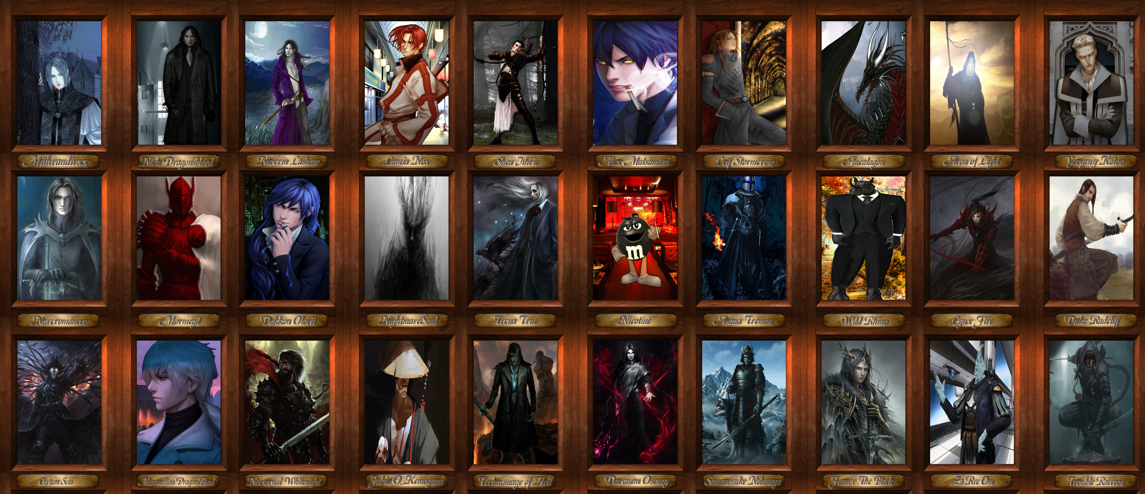
Formatting syntax is linked in the text above the editing window.

OOC Notes
This page was originally created by Todd Antonson on Tue 23-01-18.

