Tree City Of Introspection
Magically, you cannot talk in this city. It is a beautifully crafted place of densely forested homes created in Yamataian Calendar YE 40 by long-dormant race of half-dragons. They live here while thei ancestors, full dragons, live in the higher mountain peaks above the city. It was created to give the half-dragons somewhere to settle themselves down, since the area is affected by a magical, binding, and strict speech barrier.
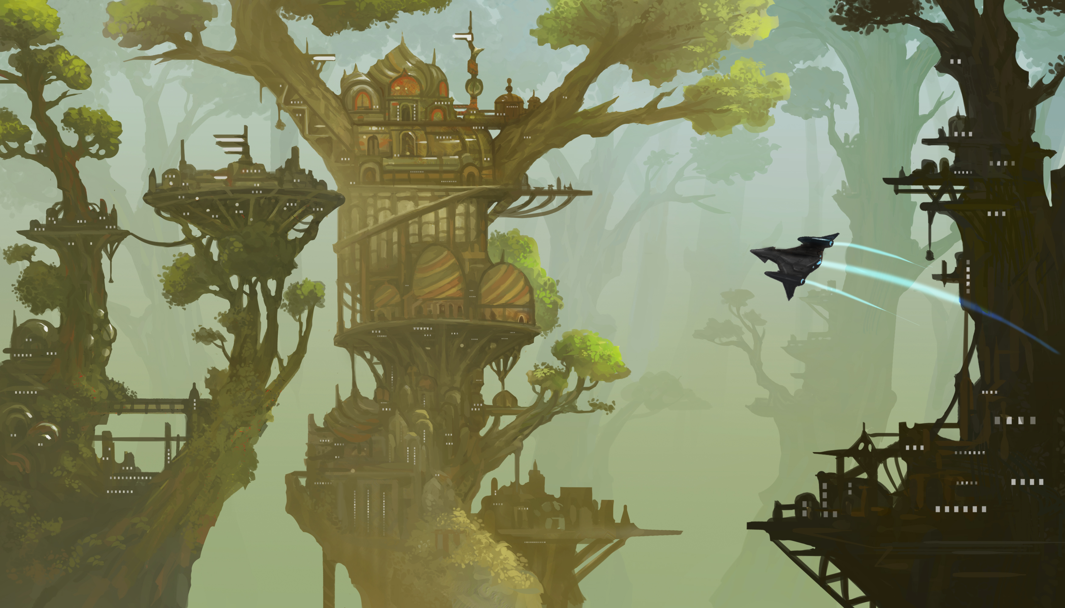

OOC Notes
This page was originally created by Hoshi on Sat 13-01-18.
Artwork by Banzz

