The Southern Republic
The Southern Republic
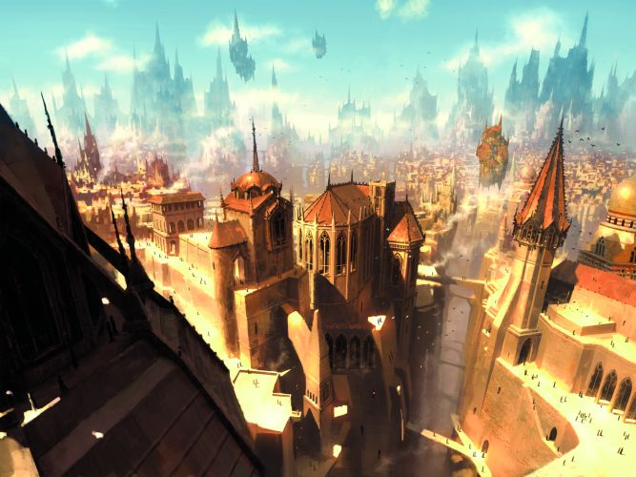 |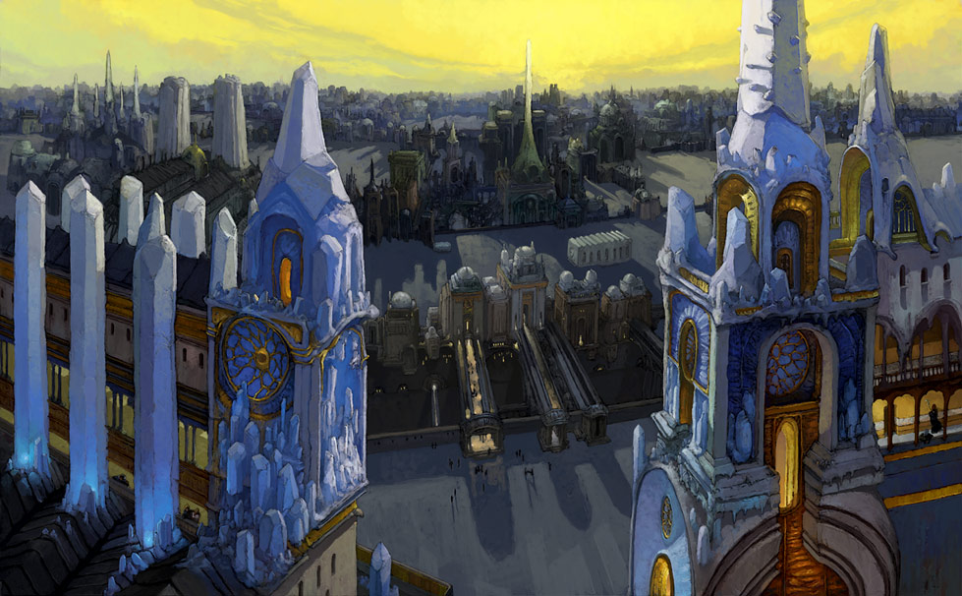 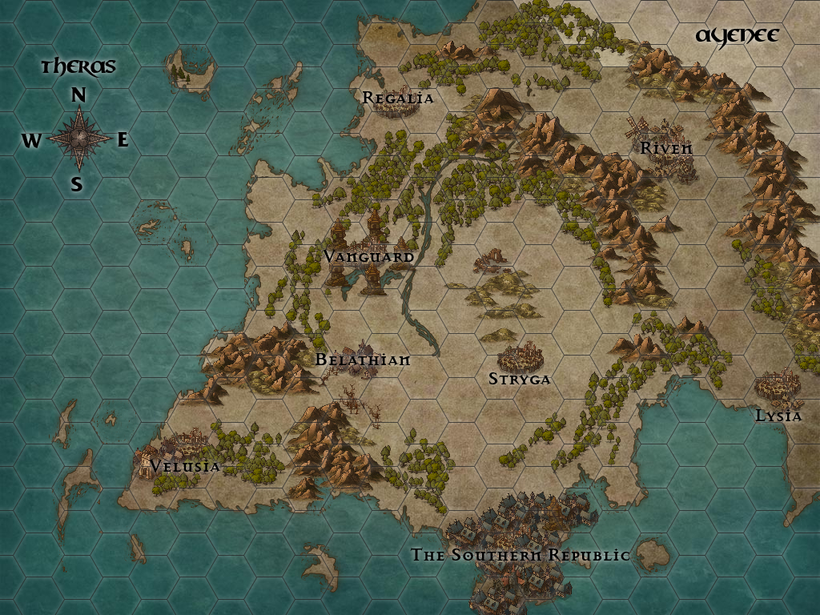
The Southern Republic is a large kingdom in the south of the Thera provinces; this includes Velusia, Lysia, Riven, Stryga, Regalia, Belathian, and Vanguard. The Southern Republic is the largest of these kingdoms, a cityscape of towers, buildings, temples, and apartments, floating above the city are buildings on levitating land masses, below the city are a network of caverns and underground temples and cities. There is very little undeveloped land in the Southern Republic, making it a giant maze of buildings to outsiders. One can find any manner of craftsmen or other service in the Southern Republic, one just need look.The city is a mixing pot of various races and half-breeds. Almost every major religious faith is found in the Republic.

The Emblem of the Republic
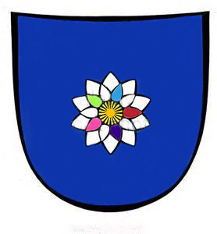
The Mana Lotus, is a flower that grows in the marshes of the Southern Republic. It is a highly valued commodity due to its ability to enhance enchantments, spells, and replenish a magic user who is fatigued. It does have a very high addictive nature and is also used in the production of the drug “fairie dust” also called pixie powder, fae dust, sandman, stardust, and a variety of other interesting names. Though the name makes it sound harmless, it is anything but that. It causes hallucinations, euphoria, and a deep slumber, mixed with its addictive nature the drug can take over ones life.
The mana lotus is only known to grow within the borders of the republic. It has petals that come in a variety of colors all on one flower, which also makes it a very sought after for garnishment and landscaping. The smell of the lotus is different to everyone, some say it smells like sugar cookies, others like childhood memories. It is believed the flower simply produces a pleasing smell to whatever creature smells it as an method of attraction.

History
It is said that a tribe of humans first settled the lands that would become the republic. These humans were not as xenophobic or racists as much of the human race seems to be. Over time goblins, elves, dwarves, minotaurs, satyr, centaur, changelings, gnomes, half demons, half angels, and the list goes on. The kingdom was flooded over the years by waves of refugees from distant wars, from disasters. The republic always took them in, and the republic evolved with each new group of immigrants. The Republic was never one to side with anyone in a war, and so became a place of neutral ground. Other kingdoms would sometimes hash out new terms in the republic's borders where they had no influence, not even over the assassins. It was during the great war against the armies of Darkthornes and their allies that the republic was forced to take a side. It was also the first time a leader had been elected for the people rather than the guilds.

The Guilds and Orders
The person that calls them self leader of the republic is not truly the leader. The republic is run by the different shady and non-shady groups.
The Slavers Guild: Slavery is legal in some of the sections of the cityscape. In those sections people of lower birth are placed into slavery, slaves take care of the day to day needs of the city, such as repair, preparing food, and other menial labor. Tradesmen still live in these sections and use slave labor to produce a higher quantity of products. Slaves are forced to fight in the arena, and they are severely punished for disobedience to the point of death and mutilation. They are usually packed in ships and sent off to far off slave auctions. The slaver's guild has dealings with the other guilds that allows for victims to wander or be found in the wrong sections of the city and sold into slavery.
There are three slave guilds, each with their own colors and locations. An example of one is that of Marakyte Al Kahn and his den of devils as they are called. Marakyte is a minotaur and has gold covered horns, white fur over pale flesh, two colorless eyes, and a scar across his chest. He had even boasted of selling previous rulers into slavery when they fell out of favor with the guilds.
The Vice Guild: In certain sections of the city there are numerous bordellos servicing both men and women in any sort of pleasure they seek. The vice guild has dealings with all the other guilds and are therefore at times, under the mercy of levees. They pry secrets from government officials, other guild guilds, there is no secret they can not somehow discover. There are many spies in the city that are in service of the vice guilds. There are at current times only a handful of vice guilds, each places a brand on its members for identification.
An example of one of these guilds is Miss Ella Riel's bordello the Queen of Hearts. Ella has a thick accent, long blonde curly hair, emerald green eyes, pale skin, and a heart tattoo on the left side of her. No one knows how she found the capitol to become a madam, but it is a closely guarded secret of hers.
The Drug Cartels: On any given day numerous drugs flow through the city, sometimes there are more demands for one than the other. The cartels have managed to corner markets on certain ones as well as manufacturing. Everything from spice, dust, elixirs, or the banzo leafs. Each cartels has its own hold over which they control and often times disputes will rage between rival cartels, turning the streets red with bloodshed. The drug cartels also act as a sort of thieves guild as well.
An example of one is Biggalo Bogswaggle's cartel if clowns, the wicked grin. Biggalo calls his minions buggalos, they wear clown face, dress in bright colors, and color their hair in bright unnatural colors. His cartel consists mostly of goblins, satyrs, and ogres. Biggalo himself is a goblin, a grinning skull tattoo covers his face, he is blind in one eye and wears a eye patch with a smiley face on it. His cartel controls the banzo leaf trade. His lair is deep beneath the city streets, only accessible through the sewers.
Assassin's Guild: It is said you can have anyone killed in the republic, but foreign dignitaries are off limits. It is also a rule that no assassin take a contract on another assassin. There are many safe houses for hired killers around the city, and many secret tunnels and passages for them to move around in order to get close to their target. About 30 years ago, the ruler of the republic suddenly stopped taking bribes from the guilds, he began a campaign to clean the city streets. They say the amount of assassins hired that day, emptied the guild halls and half the streets. That ruler Harper Peshang, was found poisoned, stabbed, and had numerous arrows in his body.
An example would be the silent sisters, an guild of female assassins that are able to kill using looks and skill. They are currently the top ranking guild on the killer boards. Every assassin with high kill counts is a member of the silent sisters. The kill board hangs in the noose, a bar located under the city in one of the many tunnels. The noose is a place where killers from all the assassin guilds come for a drink and some fun. People looking for someone to kill without conscious and for a price come here, to find assassins. It is not uncommon to see servants from noble houses here, as well as some of the more shadier types. The silent sisters are headed by Abigaile a female faun, she is said to have black fur, amber eyes, and long raven black tresses, her tongue was cut out by her master when she was a slave, and so she uses sign language to speak. All of the silent sisters have learned this sign language and use it talk to one another, since only they know its secrets, no one can listen in.
The Ivory Tower: A tower rises into the city sky, a tower as white as snow, it gleams in the sunlight. This is the home of the matrons, an order of paladins, all female, that carry out a crusade of retribution against evil doers. Skilled in combat with weapons as well as using the power of the light, they also carry geas collars. These collars when placed around the neck of an evil doer, compel them to do good, until the collar senses a change in their personality it can not be removed. Matrons take in orphan girls and give them education, shelter, food, and train them to be the next generation of matrons. It is said that if you have a matron hunting you, then there is no place on this earth that is safe. Once a matron has marked her quarry, she can determine the direction they are located until the mark is removed by holy magic, or the marked one dies.
Dhalia is the matron mother of the ivory towers that dot the republics landscape, but ivory towers exist outside the republic as well. Matrons from those outside ivory towers make pilgrimages to the republic to be blessed by the matron mother. Sometimes they come to consult her about certain issues. The ivory tower serves the light of goodness, it holds the goddess Palladiam Mar as one of its approved goddesses for worship. A statue of Palladiam stands at a fountain at the base of each tower, she holds the scales of justice before her. Her face is blindfolded, for her eyes were burned away when she looked into the heart of the Effigy and witness the depth-less evil within.
The Sacred Heart: The priests and knights of the sacred heart believe that magic is a sin, it is a vile plague that is slowly eating away at the world and its citizens. They often times proselytize in the streets or hold pogroms in the streets against magic users. Any time someone with magic is at fault for something bad, they claim this is proof of what they believe. They believe in the god, Algaram whose light shone so bright that it pushed away the darkness that enshrouded the world. His light gave hope to the people and forever burns in the hearts of the faithful. The knights that follow this order can be found in the streets on their sacred crusade against the darker side of magic. They bring in donations from people, and carry out various charitable work through the republic.
High Priest Tyson Stonehaven a dwarf, leads the faithful through the streets carrying a incense burner and blessing the hearts of those who claim magic to be evil. They constantly end their parade at the gates of the magic quarter, where mage towers, libraries, and schools are protected by guard. They cast insults and decrees at the walls, throwing filth and rocks at the walls, before parading back to the holy temple of the sacred heart. The temple is decorated with lapis lazuli and white marble in the floors, with cut white marble stones making up the walls. Stained glass windows line the walls, fountains full of koi dot the rich gardens. In the morning the sun cascades through the stain glass at the back of the temple throwing colorful light over the pews and altar. Every seventh day the faithful gather here to sing and give praise.
The Bounty Hunter Guild: In a dark cantina near the eastern gate, one can find a board with various petitions and quests. This is also where the bounty hunter guild operates. They are sell purse mercenaries left over from various different wars outside the kingdom. When their side lost and their armies were sundered, they fled to the republic. They put their skills to the test fighting beasts that threatened the farmlands, hunting down vampires or other creatures of the night that stalk the streets, or simply hunting down wanted felons. After a while someone put up a board and people began to put notices up there. A quick word of caution, when it comes to the Eastern Cantina, one should never reach for a weapon. The bounty hunters inside are often known to fire first and ask questions later. And more often to not care if someone is killed as long as it doesn't disturb their drink.
Boris Maul is currently one of the top bounty hunters, often times making appearances in the street and signing autographs these days. Boris retired after loosing his right arm in a fight with an assassin. Unable to wield a sword, Boris picked up a pen, and a mug. He has been trying to change various ancient laws that keep the guilds hold over the city and its people, becoming a politician. He has a group of loyal friends that usually follow his every move keeping him safe. He owes his career to the bounty hunter guild, and often times frequents the cantina.
The Peace Keepers: All around the republic's land borders is the a huge wall called the divide. Peace Keepers began as an order of warriors and rangers that patrolled the wall, but they soon began to be employees in the city streets as well. The Peace Keepers were the last great move of the last great leader, some say. They receive the funds for training and supplies from taxes that every section pays. They are lodged in the apartments along the divide and they owe allegiance to no one except the republic. It is their duty to protect the city streets, and the divide. Some consider them a police force, and many citizen think in an honor to serve as a keeper.
Keepers are also given citizenship upon the completion of their service, meaning they are allowed to own land, have more than one child, move freely between sections of the city, and hold titles. Citizenship is a very important and sought after perk of the republic. Most can only achieve it by either applying for it, which you must have a valued skill in order to qualify, or you simply buy citizenship which the equivalent of 100,000 republican crowns, the equal price of 100 pounds of gold (about 2 million in us currency). Or you can be born of a noble house, or be of the merchant guild which are granted citizenship. Anyone can live in the city, but one can only live in places that are rent-able, you can not own land, unless you are a citizen, then you can become a landlord by buying land, building housing on it, or business.
Dolan Scarsgard is the leader a the keepers and can be found in their recruiting offices during daytime hours. He has long curly black hair, a weathered face, black beady eyes, and often wears blue and white, the colors of the keepers. They also wear a blue tabard with a golden eye on it.
The Mage School: Magic has played a huge part in the landscape of the republic. Many of its buildings would not be if it were not for magic. Constantly shielding the republic from outside threats when the time comes and providing an army for times of war. The mages leave in center city, a walled city all its own inside the republic. They have their own set of laws and groups within their walls. One can find summoners, golem lords, necromancers, blood mages, wizards, psionists, witches, arcanists, alchemists, artificers and enchanters behind the walls. Vast gardens with plants no one has ever seen before grow there, marvels line the streets, fountains of water that act like waterspout caught in a pools. Brooms sweeping on their own, books floating in the libraries, glowing neon lights at night, strange devices. There are two schools and four libraries behind the wall and then mages tower.
The council of magi, rule this section of town and do not submit to the guilds. The guilds leave the mages alone since they don't want their wrath raining down on them. The mages leave the guilds alone, because there are more important things in the world, than the transitory suffering we all endure while alive. The mages conjure food, drink, and supplies, they teleport to and fro, they have no need of the rest of the republic.

Places to Visit
- The Walk of Destiny (road links one end of the republic to the other, starts at the divide, end at the south docks.)
- Market Block (four city sections filled with shops and various vendors)
- Black Mart Bazaar (found in the underbelly, tunnels beneath the city)
- High Town (built along the ridge, where upper class live)
- Mid Town (for those in-between)
- Low Town (slums covers nearly half the republic)
- Center City (where the mages live)
- Sea Side (port where fresh sea food is brought, an sea side fair)
- Mid Town Zoo (creatures from all over the world)
- Sacred Heart Temple (low town, huge temple)
- The Magic Quarter (if allowed in, very pleasant place compared to anywhere else in republic)
- The Arena (gladiators, slaves, and thrill seekers, beasts and over worldly beings fight here)
- The Hot Springs(limestone pools of warm water heated beneath the earth, bubble up here)
- Imperium Bank (half a block long bank, takes care of the nations money)
- Ivory Tower (so bright, can't see)
- The Divide (huge wall, its very big, wonderful wonderful wall, just lovely)

Events
- The Great Race (each section of the city has its own colors, they select a runner to wear their colors and out run bulls. Show pride for your city section and wear the colors. The bulls run a course to the market every year, many people die or are injured during this celebration. The streets are usually packed with spectators.)
- The Day of Death (goblin custom, people paint their faces, leave out some sort of treat for the spirits at night. It is tradition to leave a piece of quartz behind, if you take a treat, to ward off spirits. The higher class usually have masquerade balls around this time of year in celebration.)
- The Winter Wicker (a huge straw horse is constructed in the center of the republic on the Olran plains, a small circle of untouched land, about 700 square miles. People dress as the winter saint in red and white, others dress as the winter sinner guise of a demon. Celebration is loud, and full of festive loud music. At the end of the night, the demons throw torches to light the wicker horse. Dancing and music, along with a feast)
- The Wine Festival (wine and beer actually, Olran plains are decked out with tables for citizens and lottery winners, sampling of all the vineyards and breweries along with a feast. A smaller sampling and feast is set up for non citizens. Everyone leaves drunk and full, good times.)

OOC Notes
Kingdom created by Julian Milam, his character Xelilo Peshang was once elected the new ruler of the republic. Xelilo nearly died to assassins, his friend and bodyguard Lone helped him survive as well as the cat person Lynx. Xelilo lost favor with the guilds the instant he ran, because he was for the people and anti-corruption. His father had died for those ideals. Xelilo lost the reelection and now resides in the magic quarter.
As far as roleplay locations go this place is a perfect setting for a host of rps.
This page was originally created by J on Sat 13-05-17.

