The Forgotten Eclipse Tavern & Inn
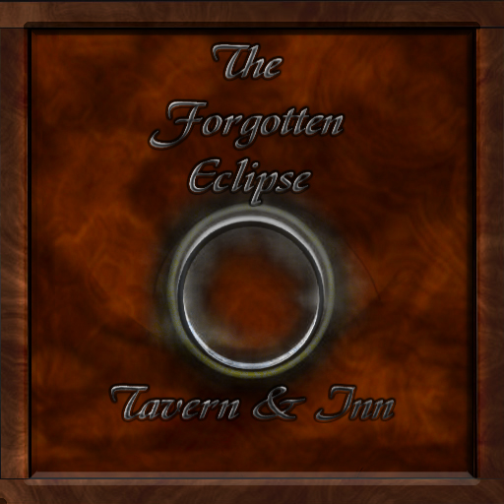
The Forgotten Eclipse Tavern & Inn is the Ayenee tavern operated by Mithrandirxx.
Smoking is allowed in the tavern1).
The original Forgotten Eclipse had the assistance of Veta2), who owned and operated the The Blackbird Tavern & Inn.

Location
The Forgotten Eclipse Tavern happened to be a few separate taverns all owned and operated by Mithrandir Olorii Stormcrow. The original Forgotten Eclipse Tavern was established nearly four hundred and nineteen leagues South by South east of Tesla City within the bounds of the New Fangorn Forest. The Second Tavern was Established nearer the heart of Ayenee about 43 leagues north west of Ayenee Capitol City. The third Forgotten Eclipse Tavern was established in in a settlement in the wilds of Ayenee named “The Town”.
The Forgotten Eclipse Tavern, was now being built anew in a new location. That made three locations but this was the only one in a town. It was strange that Mithrandir had never considered building in a town before but it always seemed in Ayenee that towns were a bit of a problem, especially when it came to humans being afraid of demi-human creatures as they were often called. Mithrandir knew full well he would do well in this town having a monopoly on the tavern industry thus far. This town had been established nearly a year and a half ago, while the construction had started Mithrandir worked on getting approval for his business to be the first tavern in the town, sadly it took a while longer to get the paperwork out of the way and begin on breaking ground.
It had taken nearly a year since then to get his tavern built properly and up to code. It was a miracle that the tavern was able to be built so quickly with out the use of Magic, but in Miths opinion magic used for the simple fact of avoiding hard labor was always a misuse of Magic. Thankfully the main hall and offices of the Eclipse were finished now all he had to worry about was the future addition of a second floor to the main tavern hall, and the completion of the three floors of the inn3).

Description
Standing behind the counter he smiled as he looked over the Interior of his newest Eclipse, it was a mirror image of the other two, but still it seemed different. From the polished hard oak floors to the ceder doors. Even the dyed blue marble counter top, and the light blue cushions of the bar stools. Sliding his hand under the counter he grasped an ashtray and set it upon the counter the evening would be coming soon, and he hoped perhaps with it the first customer to the newest Forgotten Eclipse , and maybe even a few employees to help shoulder the load.
Below is the Presently most accurate map of the interior of the Tavern

Menu
Welcome To The Forgotten Eclipse Tavern and Inn I am Mithrandirxx Owner of This establishment. Our establishment should have what ever your heart desires but if it doesn't, please inform me of your idea and I shall see if I can add it to make it an even better place . Please No Fighting inside the tavern, kill each other outside it's so hard to get blood out of the carpet.

Menu

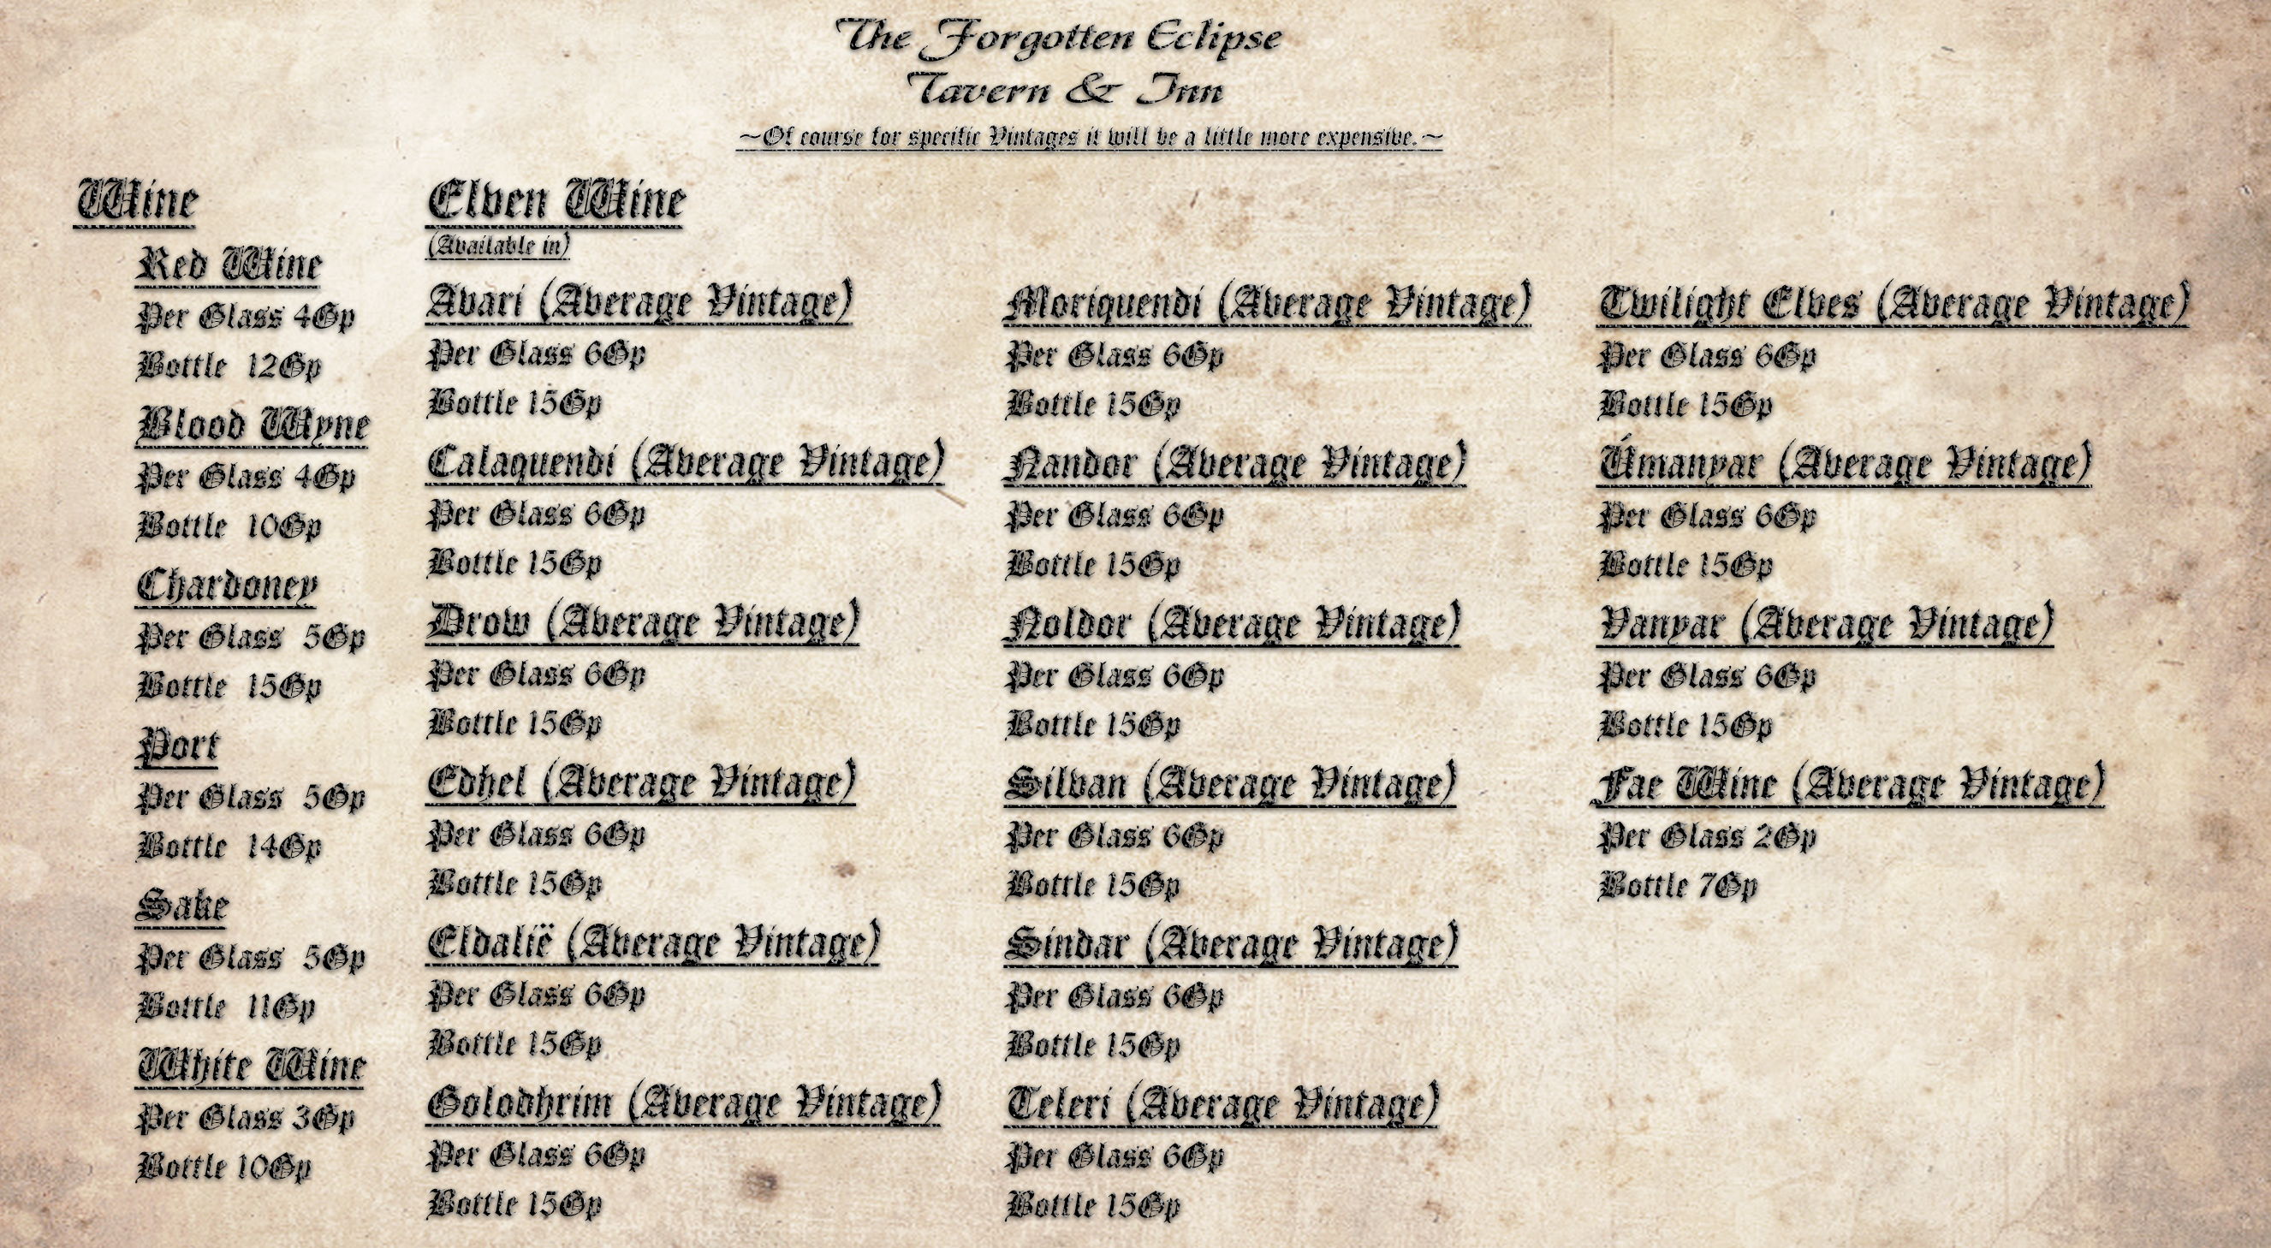

Wine
Red Wine
- Per Glass 4Gp
- Bottle 12Gp
Chardoney
- Per Glass 5Gp
- Bottle 15Gp
Blood Wyne
- Per Glass 4Gp
- Bottle 10Gp
Sake
- Per Glass 5Gp
- Bottle 11Gp
White Wine
- Per Glass 3Gp
- Bottle 10Gp

Elven Wine
(Available in)
Avari (Average Vintage)
- Per Glass 6Gp
- Bottle 15Gp
Calaquendi (Average Vintage)
- Per Glass 6Gp
- Bottle 15Gp
Drow (Average Vintage)
- Per Glass 6Gp
- Bottle 15Gp
Edhel (Average Vintage)
- Per Glass 6Gp
- Bottle 15Gp
Eldalië (Average Vintage)
- Per Glass 6Gp
- Bottle 15Gp
Golodhrim (Average Vintage)
- Per Glass 6Gp
- Bottle 15Gp
Moriquendi (Average Vintage)
- Per Glass 6Gp
- Bottle 15Gp
Nandor (Average Vintage)
- Per Glass 6Gp
- Bottle 15Gp
Noldor (Average Vintage)
- Per Glass 6Gp
- Bottle 15Gp
Silvan (Average Vintage)
- Per Glass 6Gp
- Bottle 15Gp
Sindar (Average Vintage)
- Per Glass 6Gp
- Bottle 15Gp
Teleri (Average Vintage)
- Per Glass 6Gp
- Bottle 15Gp
Twilight Elves (Average Vintage)
- Per Glass 6Gp
- Bottle 15Gp
Úmanyar (Average Vintage)
- Per Glass 6Gp
- Bottle 15Gp
Vanyar (Average Vintage)
- Per Glass 6Gp
- Bottle 15Gp
Fae Wine (Average Vintage)
- Per Glass 2Gp
- Bottle 7Gp
~Of course for specific years it will be a little more expensive.~

Hard Liquor
American Grog 3Gp per glass
After Shock 5Gp per glass
Black Gold 4Gp per glass
Black Russian 4Gp per glass
Blazing Brandy 2Gp per glass
Bloody Mary 5Gp per glass
Blue Blazer 4Gp per glass
Boston Caribbean Coffee 3Gp per glass
Brandy
Armagnac 8Gp per glass
Cognac 9Gp per glass
Fruit Brandy 5Gp per glass
Metaxa 4Gp per glass
Pomance Brandy: 5Gp per glass Chocolate Coffee Kiss 6Gp per glass
Daiquiris 5Gp per glass
Demons Red 10Gp per glass
Doublemint 5Gp per glass
Ellen's Earl 3Gp per glass
Ever Clear 2Gp per glass
Hot Brandy Alexander 2Gp per glass
Hot Cinnamon Apple 5Gp per glass
Hot Minty Kiss 2Gp per glass
Hot Sex 4Gp per glass
Hot Toddy 3Gp per glass
Irish Coffee 4Gp per glass
Irish Car Bomb 6Gp per glass
Long Island Ice Tea 9Gp per glass
Margarita 5Gp per glass
Mexitaly Coffee 4Gp per glass
Midori 3Gp per glass
Mulled Red Wine 7Gp per glass
Rum 3Gp per glass
Rum & Coke 6Gp per glass
Schnapps 2Gp per glass
Scotch 2Gp per glass
Screw Driver 3Gp per glass
Seagrams 7 5Gp per glass
Sex on the Beach 8 Gp per glass
Snow Bunny 5Gp per glass

Tequila
Añejo 3Gp per glass
Blanco 8Gp per glass
Joven 2Gp per glass
Reposado 6Gp per glass

Whiskey
Bonded Whiskey 5Gp per glass
Bourbon 5Gp per glass
Canadian Whiskey 4Gp per glass
Corn Whiskey 3Gp per glass
Irish Whiskey 3Gp per glass
Jack Daniels 3Gp per glass
Rye Whiskey 3Gp per glass
Sour Mash Whiskey 2Gp per glass
Tennessee Whiskey 3Gp per glass
White Russian 7 Gp per glass

Vodka
Kubanskaya 6Gp per glass
Limonnaya 4Gp per glass
Okhotnichya 7Gp per glass
Pertsovka 9Gp per glass
Starka 5Gp per glass
Zubrovka 4Gp per glass
~If its not listed we may have it please ask the tender. ~

1)
2)
3)

