Nightwalker Station
Nightwalker station is a Nepleslian colony It is currently under construction. It includes a small garrison of SAoY personnel as well as Democratic Imperium forces.
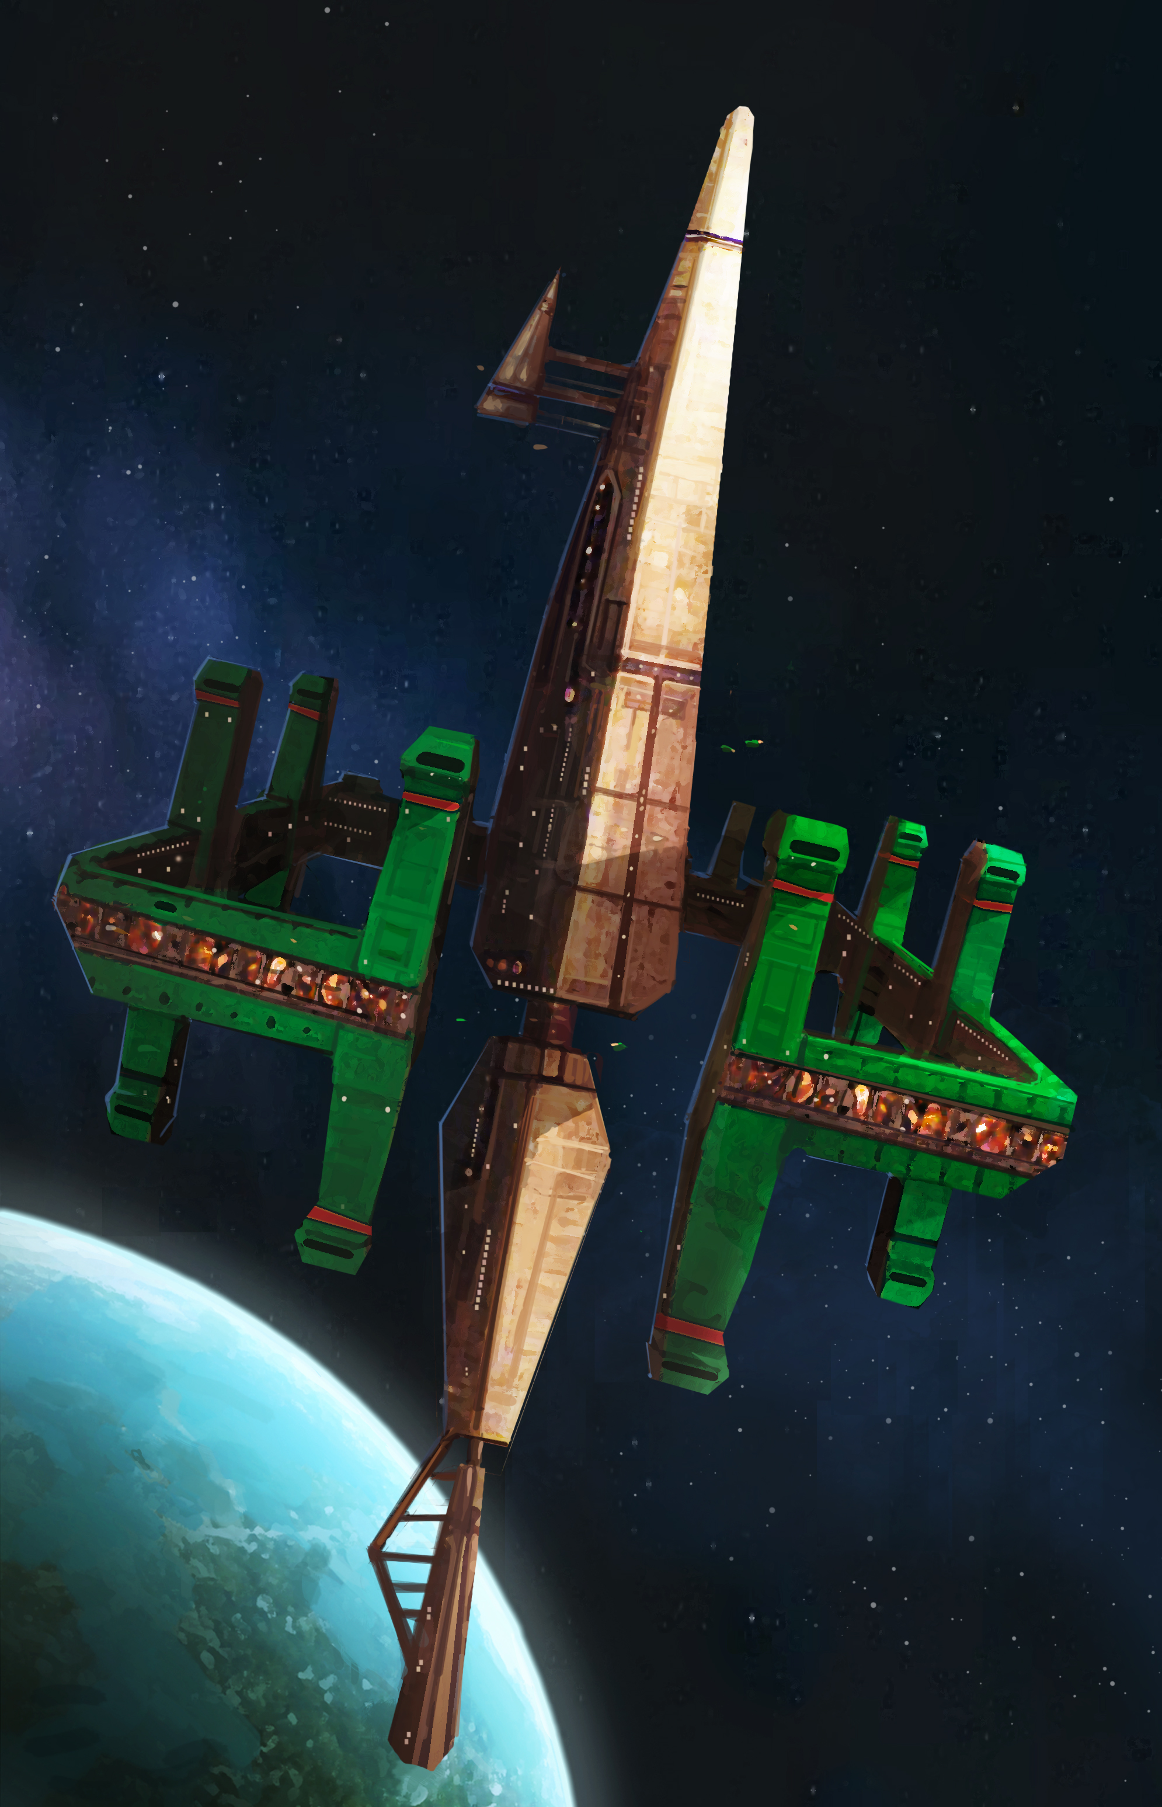

Appearance
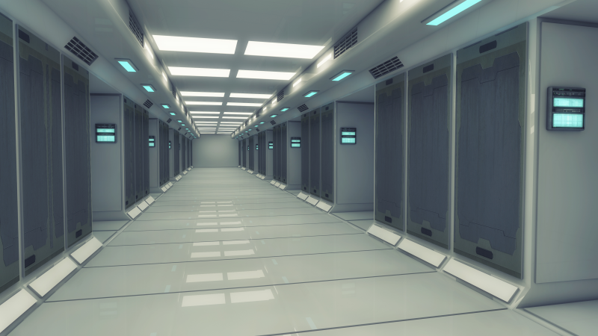
It has a multi-part appearance that has a central elongated diamond shape and then around the center of that mass and far from them -somewhat like rings around a planet- circle around the diamond shaped central piece. All of the structure is quite massive and is painted gold in the middle and the outer rings are green.

Interiors
The interiors of the ship are sectioned off according to military branch, faction involved (Yamatai and/or Nepleslia), and if it for civilians, manufacturing, good and services, or other.
The “ring” of the station is where most of the military sections are. It is lined with barracks, drydocks, weapons platforms, and hangars. The central hub of the station is a mix of Civilian as well as Military command.
The lower portions of the station are for civilian use. The civilian habitat sector is floor to ceiling apartment complexes. The lower portion of the station also contains multiple hydroponics centers to provide food and breathable air for the entire station. Not only that, but the engineering and fabrication sections of the station are also located there. The Entertainment district has several shops ranging from restaurants and cafes to armor and gun shops.
Towards the center of the station is the Combat Information Center or CIC and the station's bridge. Both the bridge and CIC are the most protected sections of the station.

Weaponry
The Nightwalker station is armed to the teeth from top to bottom. The outer ring contains the majority of the station's offensive and defensive capabilities.
The ring is lined with electromagnetic railgun batteries which function as both offensive and defensive purpose, due to the fact that the rail gun can change it's ammunition mid fight. The ammo loadouts include:
- Basic Rods, for everyday use.
- Shatter Rods, used to create a literal wall of shrapnel to stop incoming missiles dead in their tracks.
- Penetrator Rods, designed for the purpose of penetrating ship armor before delivering an explosive payload inside the hull.
- EMP Rods, munitions containing a strong energy charge to overload a ships shields
As well as railguns, the station has a number of missile batteries. The missile batteries have several types of missiles that can be loaded, however they take longer to load than the railguns do
- Standard Missile, everyday ordinary missile.
- Cluster Missile, A missile that contains x20 micro missiles inside its frame. Used for saturation attacks.
- Electromagnetic Missile, the frame contains a larger EMP payload for overloading a ships shield.
- Aether Missile, the most destructive missile that the station has. On impact the missile will detonate with enough explosive force to create a brief singularity.

OOC Notes
This page was originally created by Hoshi on Sat 13-01-18.

