Vampire Tavern of Memorial City
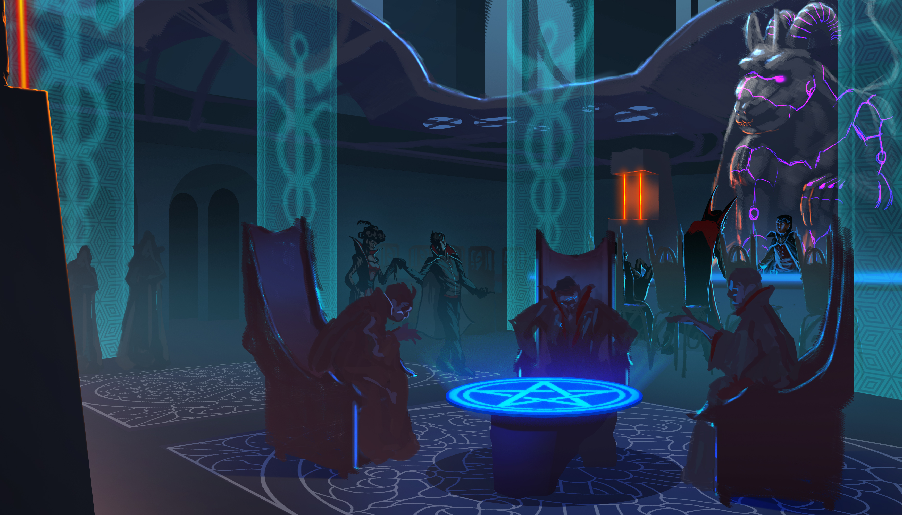
This vampire tavern is frequented by those that live for the blood of the body. They are served what they crave here in such quantities that rarely are innocent non-vampires preyed upon. The vampires of the tavern range from quite docile to extremely polite to all those in the tavern. It is not a safe place for those without manners and an air of refinement, but is tasteful and able to put on airs. Many non-vampires have found their way here and find the act of walking on eggshells to be more enjoyable. The interior is beautifully intricate with glowing see-through partitions and half-walls, a large and very demonic statue behind the lower bar. More to come.

OOC Notes
This page was originally created by Hoshi on Mon 15-01-18.
Artwork by Banzz

