Capital Memorial City
Capital Memorial city is a “tech” city named in honor of those who died in the invasion of Ayenee Capital City. It is newer and smaller than Ayenee Capital City and is roughly 40 miles1) to the South.
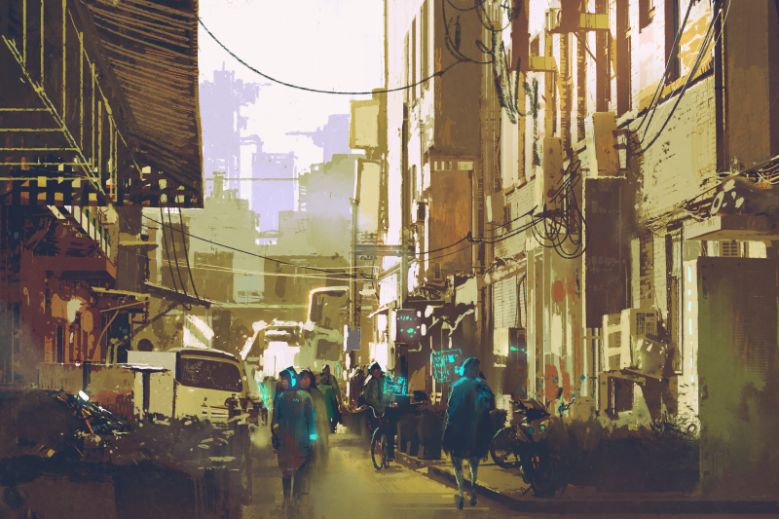
Fort Miller is located on the outskirts of Capital Memorial City.

Locations in Capital Memorial City
- Goodpint Bar2)
- Draken Club and Bar 3)
- Federated Technologies Legacy Support Division

OOC Notes
This page was originally created by Wes on Thu 25-05-17.
City art purchased from Adobe Stock by Wes.

1)
2)
3)

