Brimstone Castle
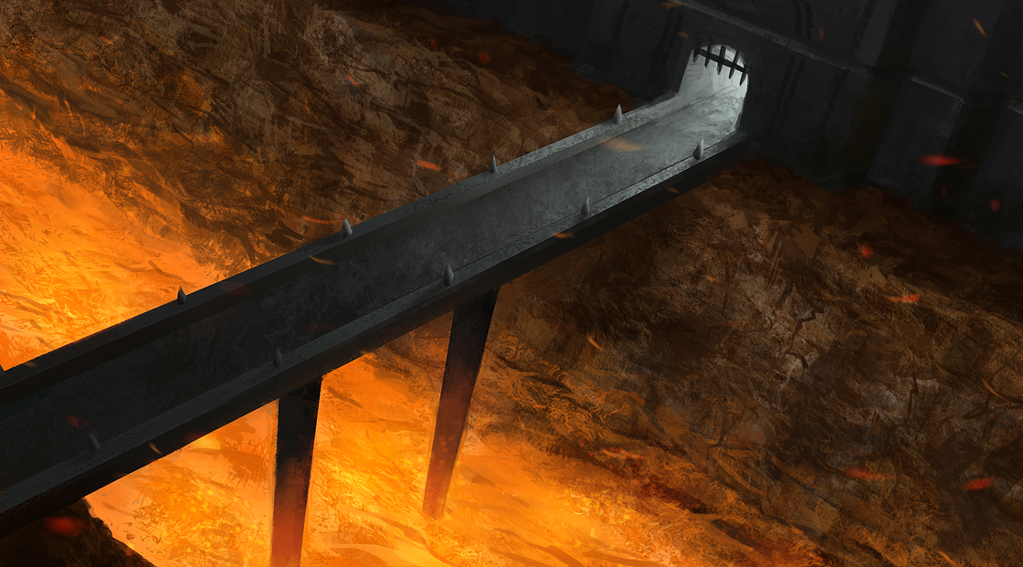
The fortress known as Brimstone castle sits in the remains of an ancient volcano. The castle walls are jet black from being covered in soot and ash. The volcano might be ancient, however hot lava continues to flow through the natural channels that were carved out over thousands of years. This made for a convenient moat around the castle.

OOC Notes
This page was originally created by Gunhand on Tue 16-01-18.
Art by joakimolofsson.

