Ayenee Space Coalition
The Ayenee Space Coalition consists of several groups working towards the same goal of protecting Ayenee and the territories around Ayenee.
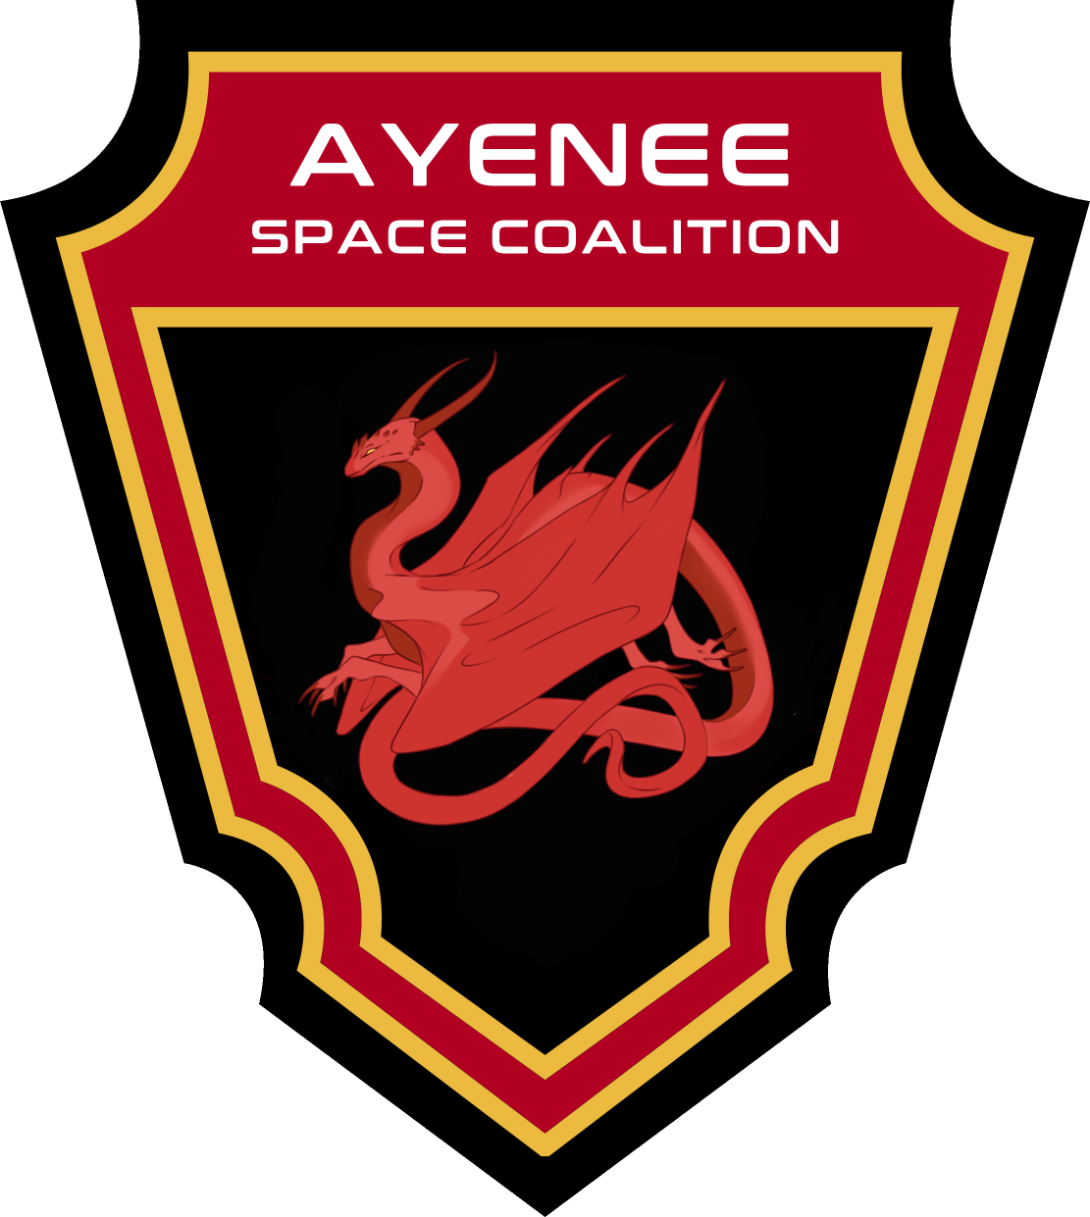

Groups in the Coalition
Below are the groups within the Coalition:
- Star Army of Yamatai.
- Nepleslian Space Marine Corps
- Ayenee Mobile Space Command
- Other allied factions

History
In 2018 the Ayenee Space Coalition was created and made into something that could protect the space and territories around Ayenee.

Notable Members
- Transuniversal Explorer Kaiyō

Uniforms
- Ayenee Space Coalition Uniform
- Ayenee Space Coalition Exercise Uniform

OOC Notes
This page was originally created by Hoshi on Fri 26-01-18.

