Vargas Argyris
Vargas is a PC played by Dadragon6 within the Arcadia Complex.
Vargas Argyris
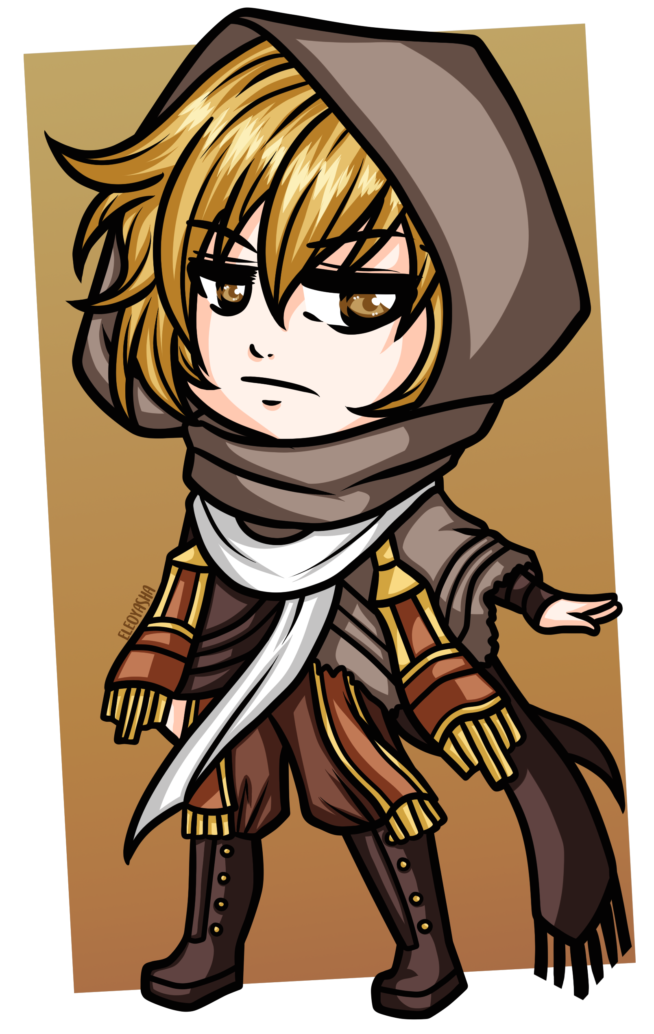
Gender: | Male
Race: | Human
Age: | 30
Faction: | Vigali Syndicate
Occupation: | Informant, ex-soldier
Nickname: | V

Physical Appearance
Vargas stands at a total of 5' 10“, or about 178 cm in the more widely accepted metric system. He has a mildly tanned skin as a result of spending so many years living in an arid climate, eyes the color of amber, and short wavy hair dyed a sandy blonde (though naturally dark gray). Thanks to military training regimen, Vargas is physically fit, as is the standard for any soldier.
Much preferring practicality over fashion, Vargas' usual attire consists of a mix and match of different pieces of clothing and equipment. The hood of his desert scarf often covers his head to both provide him concealment and protection from sunlight, but when not in use it can be found hanging loose from the back of his neck alongside his goggles on the opposite side. His beige travel poncho drapes to his left side, covering both his left arm and the holster on his hip where Vargas keeps his revolver. Underneath the poncho, he wears a bandolier on top of his old military-grade ballistic vest, and as a final layer of clothing he wears a loose-sleeved white shirt. On his left arm is a prototype cloaking device strapped to use as a bracer. Further down, Vargas' choice of trousers are a pair of plain brown cargo pants, tucked into his gum rubber boots; all of this gives him a distinct “desert wanderer” look.

Personality
[Placeholder]

Inventory
- Magnum Revolver: modified to fire heavy blasts of concentrated thermoelectric energy—these can shock and will melt through flesh and robotics both. The triangular cylinder is itself a generator, providing “ammunition” to the weapon by the transformation of kinematic momentum and static electricity.
- Sniper rifle (silenced): holds ten rounds per magazine. After some black market modifications, accepts anaesthetic darts in addition to standard high-explosive incendiary/armor-piercing (HEIAP) shells. Is stabilized for hip fire in a pinch.
- Survival knife: more for utility than actual close-quarters combat. A knife is an applicable tool to many situations, and even more so with enough clever thinking.
- Grenades: two of each stored on his bandolier.
  - Electromagnetic pulse (EMP): 2/2
  - Flash grenade: 2/2
  - Fragmentation: 2/2
  - High-explosive (HE): 2/2
  - Smoke grenade: 2/2
- Explosives: small-scale for general demolition work, and usually disarmed while not in use. Stored in his utility belt alongside blasting caps and a remote detonator.
- Ballistic vest: old and worn, but still has its uses. No soldier would be complete without one of these.
- Goggles: can switch between night vision and infrared settings.
- Cloaking device: strapped to his left arm as a bracer. User becomes transparent when active. Functions through use of a light refraction field, controlling the electromagnetic radiation around the user to shield them from view.
- A hollow, defunct Overseer's skull. Obtained within Alipier Observatory during Episode 2: Union.
- A small bag of blue dust, smelling of ozone and possessing electric properties. Vacuumed from the floor of the Oakland Heavy Wayfarer during Episode 3: Defile.
- Four laser diodes of Arcadian make, possibly still functional. Extracted from an underground mining rig during Episode 3: Defile.

Skills
- Unarmed combat: military training regimen does wonders for your physique, and it's especially useful when it comes to hand-to-hand combat. Vargas is able to effectively disarm and subdue a humanoid opponent at close range, and knock them unconscious if necessary.
- Marksmanship: Vargas is a gunslinging expert with his revolver, and can accurately hit priority targets with his sniper rifle long before they reach engagement range.
- Demolition expertise: in many ways, Vargas was born to be a soldier. While his extensive and life-long training prepared him for a diversity of situations out in the field, and gave him the necessary proficiency to efficiently utilize his entire arsenal, his primary role was that of a breach specialist.
- Stealth: in contrast to his lack of proficiency at it while acting with his squadron, Vargas learned the art of stealth after his desertion due to pure necessity of avoiding bounty hunters and military police. His gum rubber boots assist in muffling his footsteps, while his cloaking device turns him transparent—though the distortion of light caused by this can be noticed by the more perceptive individuals.

OOC Notes
Speech is represented by the color code .
This page was originally created by Candle on Sat 31-07-21.

