Trilis
Trilis
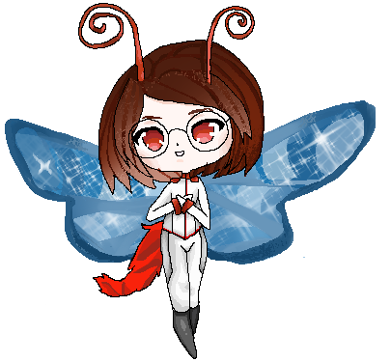
Gender: | Female
Race: | Butterdemon
Age: | 20
Year of Birth: | YE 19 (Yamataian Calendar)
Organization: | Star Army of Yamatai
Occupation: | Soldier
Rank: | Santo Hei

Physical Appeareance
Trilis stands at a height of 4'8, with relatively large blue butterfly wings on her back. She has two bright red butterfly antennae on her head that are one foot long each, and a 5 foot long cat-like tail with bright red fur. Her hair is brown colored and straight at a medium length. She has a white complexion and crimson irises, however her eyes almost always have a pair of black-rimmed glasses on them with thick lenses as she has very poor eyesight. Her glasses have a tiny computer built in them which practically can't be seen, but it generates a HUD for accessing information and scanning. She has human-like hands, but rather than fingernails she has the retractable claws of a cat. In addition, she has fangs. Her species' primary diet consists of blood, but this is not the only thing they are capable of eating. On her hands and feet are very tiny retractable hair-like bones to allow her to climb walls and ceilings like an insect. She hates the cold and loves the heat. She is very light, under 90 lbs.

Biography
Trilis spent a significant amount of her life studying and learning. She loved to learn, though, did not get much social experience. While she is a friendly person, her shyness got in the way of her really making any true friends. While it wasn't that she liked being alone, she was content with studying. More recently her parents suggested she look for a job, partially in hopes that she would meet some friends. She became interested in joining the A-Files team, wanting to explore and collect data with them.

Personality
Trilis is shy, though, friendly once she gets to know people. She can easily be described as a nerd, knowing a large amount of knowledge and often enjoying a textbook or two. She has very poor vision without her glasses, and as such almost always keeps them on or at least nearby. She's slightly shy about sharing her knowledge, it's not uncommon for her to stop herself before saying what she was about to comment. Sometimes, though, she may go off on a ramble not realizing whether or not the other person actually understands what she's talking about. She is not particularly self-confident.

Abilities/Skills
- Fire magic: Trilis has access to fire magic, enabling her to throw fireballs and create fire.
- Heat magic: In addition to fire magic, Trilis also has heat magic, which enables her to increase the temperature of areas or objects without using fire.
- Heat resistance: Trilis' species is extremely resistant to heat, even capable of walking into fire without getting burnt. This stops her fire magic from harming her as well.
- Intelligence: Trilis is very smart, having studied a significant amount on several topics.
- Wall climbing: Because of the tiny retractable insect bones in her hands and feet, Trilis is capable of climbing and sticking to walls and ceilings.

Items
- Computer glasses
- Clothes (Most notably, long black elastic pants and a stretchable green sweater with slits in the back for her wings.)
- Basic hygiene items
- Textbooks
- Datapad
- Money

OOC Notes
This page was originally created by Chlorate on Thu 25-01-18.

