Tenkou Joutenryu
Tenkou Joutenryu
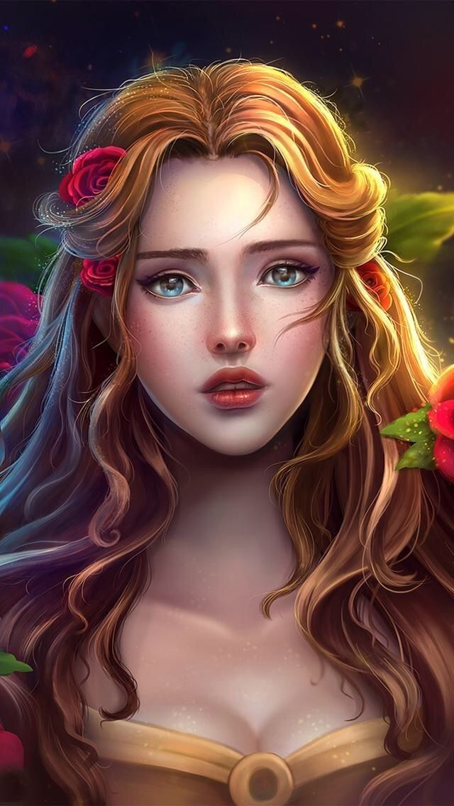
Gender: | Female
Race: | Dragon-shifter / Deran
Faction: | Em'zcan
Occupation: | Royalty / Healer
Rank: | Queen / Queen Dowager

Physical Appeareance
She appeared delicate at first glance, a small woman standing at just over 5 feet tall. Her hair was worn long and often braided so the red hints in her auburn hair were first noticeable. Dark blue eyes were the true windows to her soul showing both the sorrow and resolve she had lived through. She was beautiful in the way of her mother Seria Van Deras and held within her an innate grace that came with the confidence of owning herself.
In dragon form, she is a sleek silver beast. Her blue eyes carried over and along her right side, she bears four thick dark scars where the scales overlap in discord from an old wound. The wing on that same side also bears thick scarring along the leading edge making her less agile in flight. The horns that crest is shaped around her eyes and sweep back to protect the back of her head. She is a smaller dragon and reaches maybe 20 feet long.

Biography
Tenkou Joutenryu was born Princess of Em'zca before the empire fell to an invasion. During the attack one of the Deran templars was able to escape with the gravely wounded princess. At this time it was not known that the infertile High Queen had begged their goddess Seria for a child and in return had been granted the incarnation of her final daughter. With her memory lost Tenkou managed to survive and grow to maturity.
Through her adventures, she managed to grow into her healing powers while suppressing the side that allowed her to change into what many considered her true form. In these adventures, she bumbled into Sho Joutenryu and La'Tanya (spelling?), and together they started gathering the forces to take back their homelands. In this quest, they also met Jack Van Deras, her twin brother younger by only moments, and started to learn the truth of who she truly was. Through
Tenkou regained the throne of Em'zca but also fell in love with Sho. They were married and both crowned rulers of Em'zca. Their relationship was an easy one, with both often in agreement. Sho Joutenryu became Tenkou's world and in many ways he was her strength to continue. They had several children together. Three sons and their eldest daughter. Of all the children only one child would survive to adulthood- Amelia their daughter.
When Sho was slain in battle Tenkou felt it immediately. When official word had reached her that he was gone, she was beyond devastated. Her depression lasted for months and when she finally emerged again Tenkou was an empty shell of herself. In that battle not only had she lost her soulmate but also her eldest living son Kayin. Her goal soon became to preserve and strengthen her empire long enough for Amelia to mature and take her place on the throne.
In the end Tenkou abdicated the throne in favor of her daughter. Sremmos was gone from their realms, her brother Jack no longer reachable, and with Sho deceased she had no true support group or will to continue. Instead, she dedicated her remaining years tending the shrines to her fallen mate and two deceased sons. When a flu-like plague struck the Empire she was among the first to fall; with her formerly indomitable will to live seemingly gone.

Personality
Gracious was the first thing that came into mind when dealing with Tenkou. She was gentle and soft-spoken. Her words were measured and thoughtful but also bent towards kindness. What few saw was the fierceness in the woman and her dedication to her lands and her family. In a way Tenkou was chaotic good. SHe would choose the good of all over the good of one no matter the personal cost.
She was also loyal to friends and family. A loving mother, daughter, and wife Tenkou cared about those around her. A true healer at heart she was the last to pick up a blad and the first to set it down to start repairing the damage.

Abilities
Healing - she was a strong healer both innate and further as she trained. The magic was taxing but she mastered it in accordance with her heritage.
Shifter - Tenkou had two forms that she could shift to at will, her silver dragon self and human self, while she counted her human appearance as her true self she was at ease with her dragon body as well.
Nature Magic - bound to Em'zcan soil Tenkou was strong in her homelands able to call upon nature to aid her. Here she could use the land's own magic to her causes. Off Em'zcan soil, she would be weakened and eventually, the drain from her body trying to maintain the bond would kill her.

Items
Crown of Em'zca: A silver crown of two dragons tangled upon each other. Their wings lifted to curve above her head and were studded with tiny sapphires and moonstones. The heads of the dragons dipped down to rest on her forehead and between them was a large teardrop sapphire that symbolized the binding magic of the crown.

