Sir Churchill
Sir Churchill
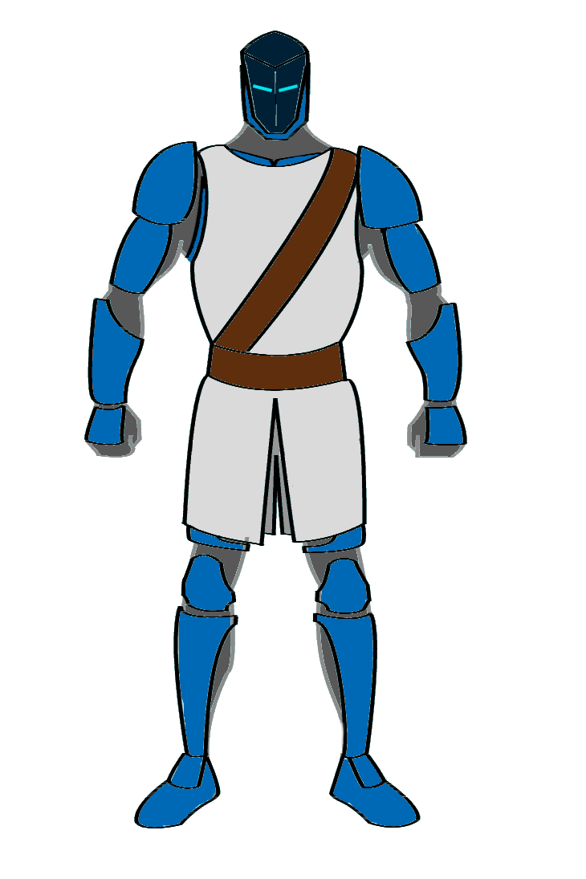
Species & Gender: | Human male
Real Name: | Ethan Miller
Date of Birth: | January 18, 1997 (Earth Years)
Age: | 22 (Biologically), 39 (Chronologically)
Affiliation: | Order Of Terra
Occupation: | Mercenary

Appearance
Miller stands at an imposing 6'2“ and weighs a hefty 210 lbs. His skin is fair from so much time spent in his suit, with a squared jaw, dark brown eyes, and dark brown hair shaved into an undercut that parts at his left temple. His body is bulky and muscular.

Personality
After so much carnage, Miller is a seasoned combatant, always willing to be the first one in and the last one out. Though sometimes he may seem heartless and detached, one will find that he's still very passionate about fighting “the good fight”, and occasionally the young boy he once was will show through his battle-hardened exterior. He believes very passionately in the Order's Code of Chivalry, and lives it fully in all moments. He values loyalty and camaraderie above all else.

History
(See the “History” section of the Order of Terra page for references to the following events.)
Ethan Miller, aka Sir Churchill, was a normal college kid from Nebraska. His day to day life included energy drink-fuelled study sessions, fraternity parties, being eternally broke, and fighting tooth and nail for internships. All of that changed when Earth was attacked by extraterrestrials. Ethan, eager to find glory and adventure outside of his mundane life as a business major, enlisted in the newly-created United Nations Army to defeat the alien threat. It was there that he found his first taste of combat, against much more advanced combatants. Somehow, through sheer luck, he managed to survive. This experience was a real eye-opener for the boy, who began to wonder if the “glorious” life of the hero was really all it was cracked up to be.
After Earth was saved by the Collective, Ethan was given a chance to volunteer for the empire's super-soldier program. Against his better judgement, he accepted. The next decade saw him taking part in the Collective's shock and awe campaign across the galaxy. Each new fight further desensitized him to the horrors of warfare, and further increased his skills as a combatant.
When the news broke that the Collective had been behind the attack on earth all those years back, along with many others, Miller and a few of his fellow knights fought their way out of the military installation where they'd been stationed, commandeering a ship to take them back to Earth. It was there that he and his fellow knights formed the Order of Terra, and along with several other species, rebelled against the Collective. Miller was responsible for the assassination of several Collective leaders, and the eventual death of Poseidon at the Battle of Olympus. The rebellion had been won, and Miller finally knew peace. Though now, after so much fighting, he knew that he could never go back to his old life as an underachieving undergrad. He was at a loss.
When the Order was disbanded, and its members exiled to Ayenee's universe, Miller found himself wandering aimlessly as a mercenary to keep a roof over his head and food in his stomach. If the cause is right, and the price is high enough, he'll stay by your side until Hell itself freezes over.

Gear
- Mk. V "Crusader" Battle Suit
- Mk. II "Lionheart" Plasma Revolver
- Longsword
- Shield
- Plasma Shotgun (pistol grip, pump-action, attached bayonet)

Abilities
- Enhanced abilities & healing
- Flight
- Excellent fighter
- College-level education (whatever good that'll do him)

