Sioh Coelacanth
A PC used by Primitive Polygon for the Arcadia Complex plot.
Spooky Fridge Eel
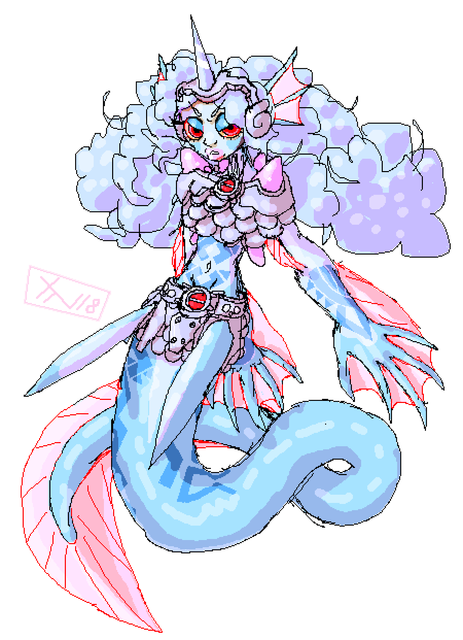
Gender | Female
Race: | Magically Fabricated Bio-Weapon
Age: | Unknown
Faction: | Unknown
Occupation: | Mercenary / Ice Witch / Sea Vagrant
Rank: | N/A
Theme Music
♫MMZ2 - Cool Water♫

Physical Appearance
A weirdly shaped rubbery blob of mixed fishy traits, Sioh generally stands at about five foot tall, with light blue skin and a generally mermaid-esk appearance. That said, their long ropey fan-like tail is more like that of an eel, and they have distinctly unfriendly webbed claws for hands. The overall frame is lithe, but dense with sinewy muscle where is counts.
Their face is quite rounded and has large red eyes with yellow sclera, and they have wide fan-like fin-ears. An extremely dense mass of curly purple-white hair absolutely dwarfs their head otherwise, a cloud-shaped and uncontrollable lump which grows very quickly. A single conical horn sticks directly out of the top of this, made from a glossy tooth-like substance, but sharp enough to scratch metal.
Lastly, their skin is covered around the torso and both forearms by jagged blue patterns, noticeably colder to the touch, and indeed where their ice-based powers emanate from.
They mostly stick to the clothes that they were created with, a tattered and ancient breastplate and scale mail skirt. Not just because it contains apparatus for breathing on land, but because their abilities tend to destroy any other clothes touching them even in the best cases.

Biography
Not born but designed as a sentient weapon system in ages long past, Sioh is technically a marvel of nearly god-like magi-tech… But was frozen in an inactive state for so long that their mind, and large parts of their equipment, are completely shot. Deployed automatically to confront the crew of the ISS Downrider when they investigated an underwater colony, Sioh awoke knowing that they were supposed to protect something, just not sure what. Given that they couldn't exactly survive long term, and knowing nothing of their own culture, never mind anyone else's, it was perhaps a given that they ended up just clinging to the crew for a while.

Personality
Shady, arcane and a little self-serving, Sioh understands the concept of 'friendship' poorly and doesn't trust any agreement without a price tag attached. They understand modern languages only with difficulty and are much too impatient to learn them properly, despite a certain hidden intelligence and cunning. This means that they can generally get by understanding others, but are prone to wheezing or muttering back simple one-word answers, often leaving their own motives a mystery.
They are always acting on instinct, and sometimes refuse to agree with surface-worlder facts, just because they'd prefer to physically fight someone. Conversely, however, they also don't particularly like the effects of their own powers, and will sometimes seek to steal another's body heat in order to get comfortable.

Abilities/Skills
- Frost Array: Sioh's body is covered in blue dermal mesh embedded shapes that project fields of intense cold. They can freeze the very water in the air around them in order to create large slabs of ice, as well as rapidly dissipating heat from things like thermal weapons and lasers. They can even hurl sharp ice shards, or use their breath on metal objects to make them brittle. The downside is that Sioh is -not- actually immune to the inverse effects of this, merely resistant. They can accidentally freeze themselves or even give themselves hypothermia if their power is overused.
- Spiky Bits: Their claws, teeth and horn seem to naturally remain super sharp, lacerating flesh and things like leather with ease. Combined with their long muscular tail and the ability to freeze things, crushing enemies and objects is also not out of the question. Biting someone and freezing their blood is something reserved for people they really hate. The significant downside to this, however, is that they can't really hold any other weapons easily, or even wear humanoid armour; Even a modified torso piece would freeze itself to their skin.
- Air Breathing: The pink crystals attached to their back and gills can mysteriously absorb about a days worth of water, allowing Sioh to breath on land for that long. This also stops them from choking on ice when they freeze the water around them.
- Regeneration: Can fully regrow any lost appendage within two weeks. It's likely that this is how their body was originally fabricated. Brain or organ damage would still result in the same effect as you would expect, though, since they wouldn't be able to survive long enough to regenerate those things.
- Agility: Has an innate ability to rapidly slide around and squeeze through small spaces, and is generally built for inflicting maiming injuries. Unsurprisingly, they are also a fantastically good swimmer, able to reach speeds of 55km/h underwater. Not exactly as quick on land, but they can still sidewind, dodge and weave like a snake plenty well enough.

Items
- Their ancient armour. It allows them to breath on land for twenty four ours after submerging it in water, and is made from an unknown, highly durable metal. If you look at it closely, though, it's actually falling apart due to age, and probably used to cover a much larger area of the body.
- A large bathtub.
- Various fish tank accessories… Apparently it makes their room feel more like home?…

OOC Notes
This page was originally created by Primitive Polygon on Thu 14-06-18.

