Rebecca Blackthorne
Rebecca Blackthorne
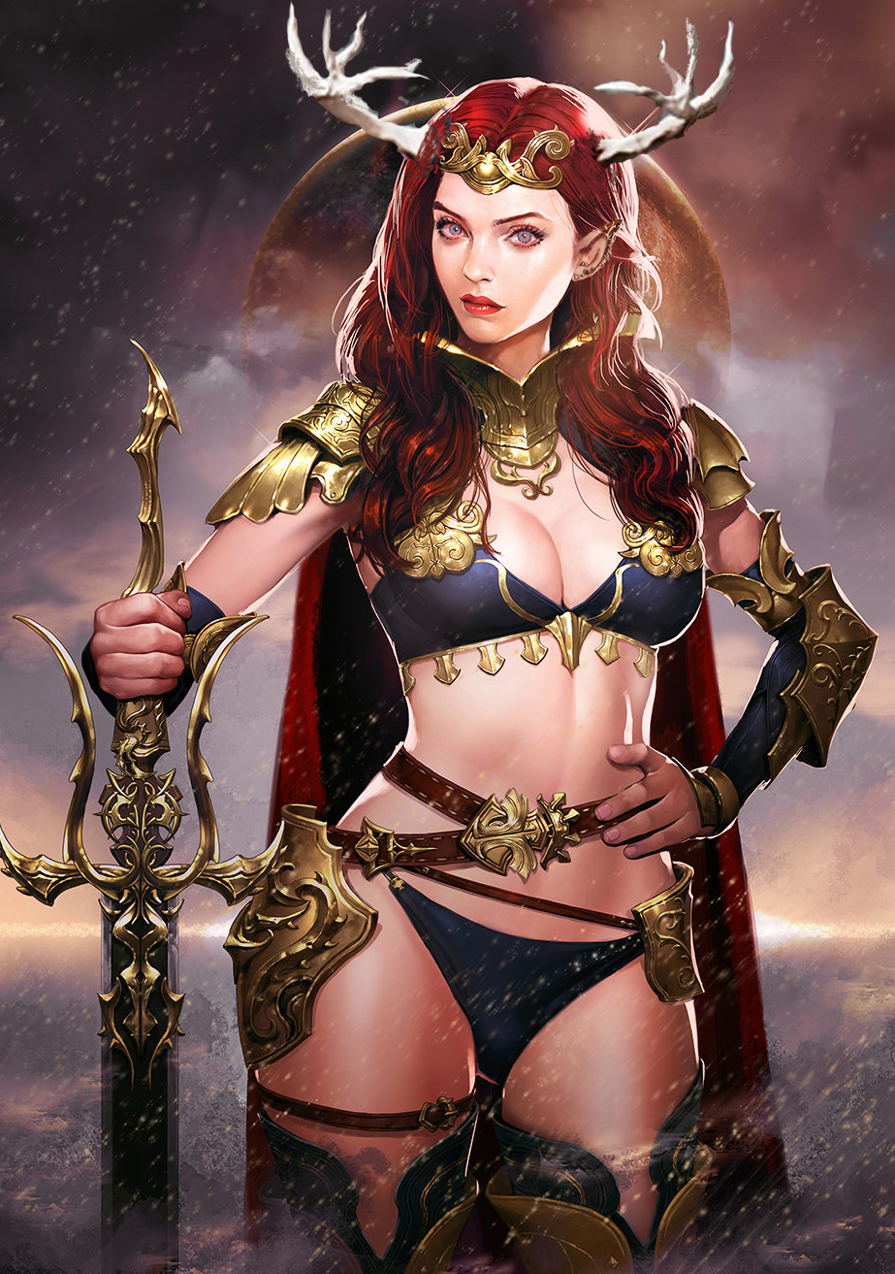
Titles: | Queen
Gender: | Female
Races: | Tuatha De Dannan/Elf (fey)
Age: | 358 years old, equivalent to a middle age human
Occupation:
Faction/Kingdom: | Blackthorne/Velusia
Status: | Deceased
Relatives: | Desmond(deceased,brother),Rebecca(deceased,twin sister),Vincent(deceased,brother),Orianna(sister), Adrian(half-brother), Cebrese(half-brother,deceased),Mason (son)
Height: | 5'9“
Weight: | 170lbs
Eyes: | Blue
Hair: | Red

OOC Notes
This page was originally created by J on Sun 14-05-17.

