Mithrandir Stormcrow Olorii
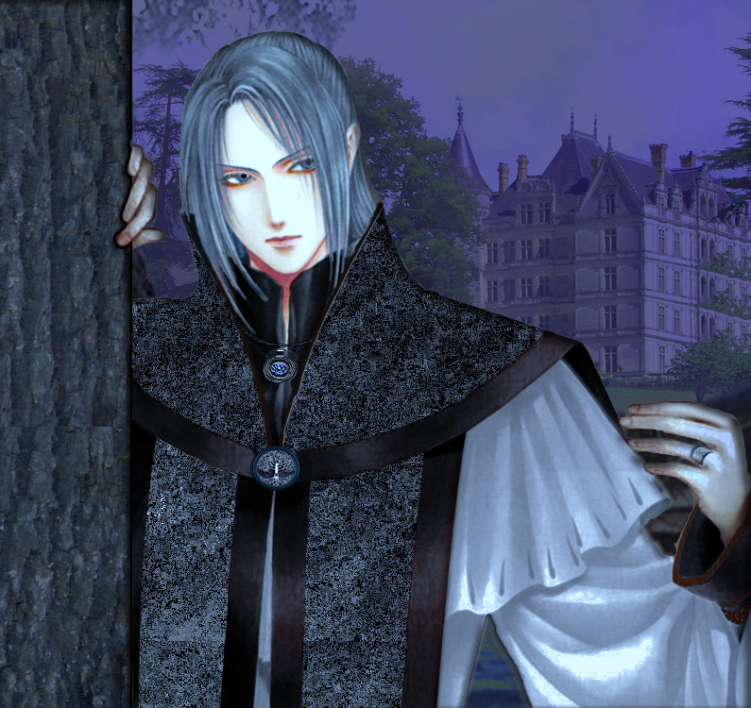 img
Gender: | Male
Race: | Istari, Vampire
Alias: | Mithrandir, Olorin, Gandalf, Incanus, Tharkun
Occupation: | Bartender/Sage
Place of Origin: | Middle Earth, Valinor

Physical Appeareance
Height: | 6'2“
Hair Color: | Grey
Eye Color: | Silver
Complexion: | Caucasian

Biography

Personality

Abilities

Items
Description of the page goes here.
Formatting syntax is linked in the text above the editing window.

OOC Notes
This page was originally created by Todd Antonson on Wed 22-08-18.

