Lone Ashtir
Lone Ashtir
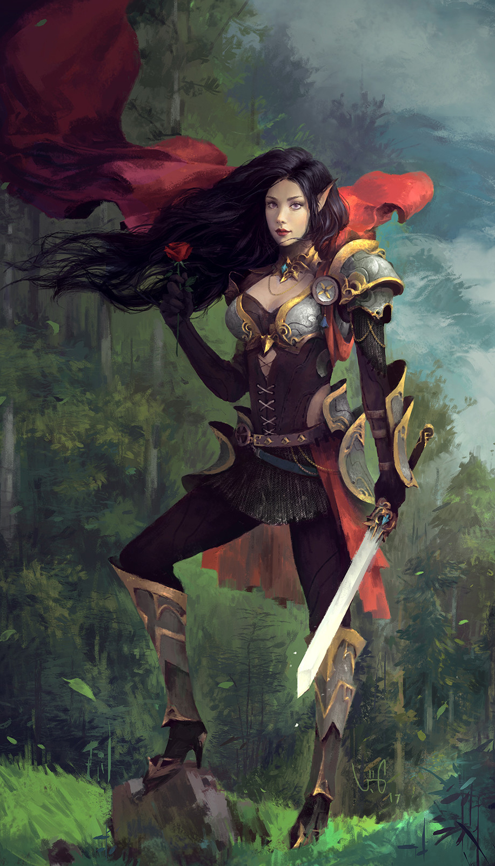
Titles: | Guardian of the Southern Republic
Gender: | Female
Races: | High Elf/Moon Elf
Age: | 117
Occupation: | Bodyguard
Faction/Kingdom: | Southern Republic
Alignment: | Lawful Good
Status: | Deceased
Relatives: | Orphan
Height: | 5'9“
Weight: | 119
Eyes: | Vermillion
Hair: | Black
Lone is described as having graceful beauty and deadly skills. She was orphaned at a young age on the streets of the Southern Republic. Lone is loyal to Xelilo, it was his family that took her in. She followed him all across Ayenee, guarding him with her life. Eventually, she dies at the hands of an assassin.

Biography
Lone was raised by a drunken father and a prostitute mother. They were always beating her any time they were angry or if she made a sound. After her father lost his job, Lone was lead by her parents into the furthest parts of the kingdom where she was abandoned on the street. Lone survived on the streets for some time. One day she picked the pocket of a wealthy looking man. The man chased her down through the streets. She fought the man and injured him, but was taken prisoner. It turned out he was Zion Peshang, the soon to be elected ruler of the Southern Republic. He saw something in her, potential, he took her in and had her trained in school, in fighting, and in how to let go of her bad memories. She grew up next to his son Xelilo who was about her age. The two became fast friends and inseparable.

The Dark Underbelly
Xelilo's father made a point to try and purge the corruption of the Republic's many guilds. A summit was to be held between the guilds and Zion. The summit escalated into violence as the guilds began to fight amongst one another. Zion was slain in the fray. Now that the patriarch of the Peshang family was dead, his enemies descended upon his house. Xelilo's mother died protecting Xelilo and Lone. Lone killed a goblin attacker that came after them. It was the first life she had ever taken and it made her freeze up. Xelilo quickly broke her from her trauma and they two fled.

Life on the Run
During a prison riot, Kaivo managed to escape and was greeted by one of the guilds. They sought to employee him to hunt down the last of the Peshang family line. Kaivo had an ability to control the minds of others, as well as other low level psychic abilities. Kaivo however had a huge ego and this was normally his undoing. He tracked the pair down to the library in High Town. He attacked them by having Xelilo and those in the library attack Lone. It was then that he revealed himself to be her father. He used his psychic ability to force himself into her mind and urged her to join him. He was impressed by her skills fighting off his puppets.
She told him that she would never join him. She begged him to leave Xelilo alone and just tell his employers that he was dead. Kaivo refused and commanded Xelilo to cut his own throat. Xelilo began to look for something sharp to comply. It was then that Lone felt herself reaching taking her father's psychic presence and stripping it. Kaivo pulled away in pain as Lone sent a blast of concussive energy knocking Xelilo against a wall where he fell unconscious. She then lifted up her father with her new found psychic abilities. Her psychic force constricted about his neck and as he begged for his life, she said, you never showed me mercy. She then snapped his neck with a quick nod of her head.
She ran over to Xelilo checking to find he was alright. Over the next few months she feared her new found powers. She was afraid she would become as callous as her father, that she would kill without remorse. Xelilo continued to study magic and suggested they could remove her powers if she wished. She agreed to the removal. They found they could not remove them, they could however bind them. Xelilo worked some magic and chained her powers within her. She felt somewhat better, but she continued to struggle with her conscious.

The Fall of Luxor
Xelilo and Lone made their way to the Luxor Kingdom where they spent years in hiding. The two trained and plotted on how they pursue their future path. Xelilo began to tutor under Lynx Darkpaw, a cat-person mage, Lone trained under Reese Blackthorne who worked nearby at a tavern. He taught her all he could about martial and melee arts. He sent her to train with Alex Frost a knight and Dresden an assassin.
The two taught her very different styles of fighting. One was meant to protect and the other was meant to kill. After she learned all she could from them, Reese introduced her to Nicholas a monk. He taught her how to center her inner turmoil, how to purify her mind and soul. After this, she challenged Reese once more and nearly beat him. Reese explained in the years he had watched her train, she showed an aptitude he'd never seen.
Lone and Xelilo had improved much over the many years they spent in Luxor. It was then that Luxor suffered a civil war that split the kingdom in two. Then to make matters worse, a massive army of gnolls attacked Luxor. The land was in flames, chaos everywhere. Lone and Xelilo managed to escape Luxor, they made their way back to the Southern Republic, after staying with Xelilo's friend Celine Jules for a few months.

Return to the South and the Great War
After returning to the Southern Republic, the rebels managed to instigate a vote. An election was held and Xelilo managed to beat the current elected leader by a small margarine. The Southern Republic had been suffering since his father's death. Xelilo quickly began to repair the damage he could, installing new walls enhanced with magical defenses. He reopened the mage schools and freed the slaves and gave out pardons. It apparently was just in time, as Xelilo met with the new council, he received news that he was summoned to Ayenee Capital City. Xelilo and Lone traveled to Ayenee Capital and spent the days joined up with Celine Jules and Corbain Saezar, along with a diplomat from Stryga.
It took days before everyone had arrived from all corners of Ayenee. After everyone had gathered, they were called into a summit. It was determined that a large army was forming across four nations. This army was of great power and size, enough that every kingdom should be afraid. It was then announced that even worse, this army had joined forces with the deposed tyrant Varsinax and his allies. Many of the kingdoms agreed to help, some re-framed from joining, declaring the threat to be nothing to worry about. Xelilo and Love traveled back to the Southern Republic and began to put together a force to aid in the war effort.
During their part in the event, the Republic managed to thwart an attack by the Merrow Lord of the Deep, Nash'tan and his naga and fish folk allies. The skirmish took a lot of casualties from the Southern Republic, but they managed to protect their ships, though some of the vast cityscape kingdom was destroyed in the attack when a Leviathan sent a wave of water onto the city.
Xelilo and Lone sailed with the Armada up the coast eastward to aid Celine Jules and the Dhooms of Stryga. They arrived at a massive naval battle but managed to turn the tide at the coast of their flagship. Xelilo was knocked out and Lone swan to shore with him in her arms. She gave him mouth to mouth and realized she had very strong feelings for Xelilo, ones that were different than before.
The two were rescued from cannibals by Lynx Darkpaw and the group managed to make their way back to the Capital. They arrived after the city had already fallen to the Dark Alliance. They had to stay low and travel at night till they were far enough away that they could safely open a portal to home. Upon arriving back, Xelilo and Lone were attacked by a stranger to the realm. The man called himself Clowd Meredith and he attempted to use his powers to destroy the entire kingdom. It was a plot by the Darkthornes or perhaps one of the Guilds, he was accompanied by another man named Sai. Lone and Xelilo managed to thwart their attempt to destroy the land kingdom, but Lone suffered a fatal blow and died in Xelilo's arms. Xelilo put his hand to the crystal matrix he had constructed and infused it with his will-power, he banished the two assassins from the realm, preventing their energy/spiritual signatures from ever stepping foot in the Southern Republic again.
Xelilo was distraught by Lone's loss and disappeared from the political scene.

The Clones
Xelilo in his despair used magic to clone Lone. The first clone awoke and her mind shattered. She attacked Xelilo and was disfigured in an exploding mana crystal. The clone fled his residence and was never seen again. This didn't stop Xelilo, who was so lost to his grief that he attempted it a second time. The second clone remains in a deep stasis within a magical suspension chamber. Xelilo is afraid to awaken her for fear of losing her again. The mere presence of the clone helps Xelilo get by. He imprinted the clone's mind with all of Lone's memories and gave the clone the same frequency as the original Lone.

Weapons,Relics, and Weakness
Lone's Gladius: The blade was crafted for her by Reese Blackthorne after she completed her training. He had her take the blade to a friend of his. The friend turned out to be a paladin who brought the blade to his order hall where it was blessed with the powers of law itself. The blade glows a brilliant white, it is filled with white magic, holy magic.
Bond: Lone's weakness is her bond to Xelilo, she is willing to sacrifice her life for his. She is willing to put herself in danger to protect him. Perhaps it is her connection with Xelilo or a feeling that she owes his father for saving her? It has proving to be her undoing once already.

Abilities
Psychic Awareness: Lone has the ability to use various different psychic talents and traits. She can summon shields, scry other's minds, read someone's emotions, sense auras power, and alignment. She can construct invisible barriers to absorb and disperse energy attacks and block physical attacks. She can restrain others and command others with her will. Her mind is shielded from intrusion and scrying. She can heal wounds and levitate, as well as send out concussive force towards her foes. The limits of her powers have never been tested, nor has the source of her powers been revealed.
Martial and Melee Training: Lone was lucky enough to be trained by some talented individuals. She has expanded upon that training, adapting what they taught her to her own style. She is very capable with her weapon of choice and in hand to hand she can quickly dispatch a foe.

External Links

Quotes
- “I have a bad feeling about this…” Lone replied at the sound of drums emanating from the jungle depths.
- “Xelilo always keep a place in your heart for me. I was never destined to deserve happiness.” Lone to Xelilo before she died.

Trivia
- Lone and Xelilo, as well as the Southern Republic, were created in the last days of user chat on Yahoo.
- Lone never confessed her feelings for Xelilo.
- Lone's mother died during the tidal wave of the great war.
Categories: The Southern Republic |Southern Ayenee |The Eyanee Veil |Xelilo Peshang|
This page was originally created by J on Thu 22-06-17.

