Kaithorn Aikanaro
Kaithorn Aikanaro
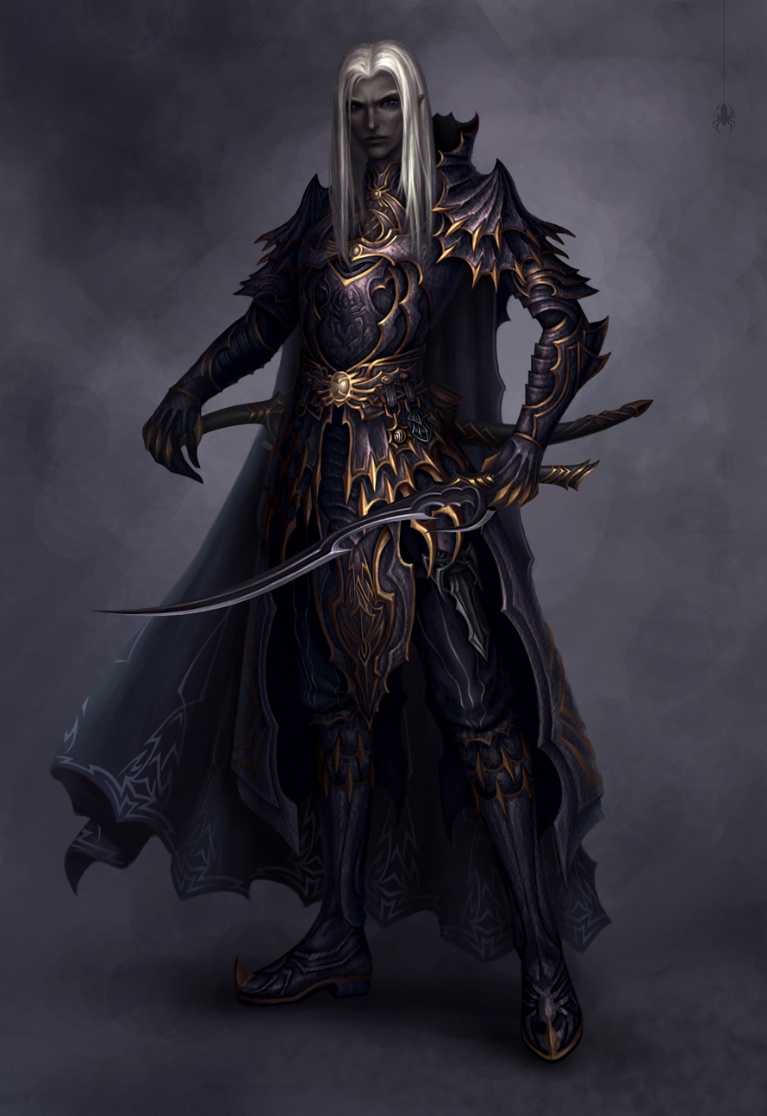
Titles: | The Beast
Gender: | Male
Races: | Drow (cursed: lycanthropy)
Age: | 123
Occupation: | Sorcerer, Warrior
Faction/Kingdom: | Aikanaro/Underdark
Alignment: | Neutral Evil
Status: | Alive
Relatives: | Kaitlis (brother), Vhaerun (father,deceased)
Height:
Weight:
Eyes:
Hair:
A powerful sorcerer and swordfighter, he combines cunning and brute strength. He is an opportunist and will ally himself with anyone who can help him further his own goals. He is notable in particular for his ruthlessness and pragmatism. His manipulative and deceptive nature has earned him many enemies in his long life. His rise to notoriety began when he left the only place he had ever known as home. As a drow, he lived most of his life with his younger brother and his tribe in the deep underground passages beneath the earth.

Biography
Kaithorn and his tribe were unlike the other drow, they believed in equality. At first, they wanted to bring peace and unity to all the elven tribes, not just the drow. They wanted to unite all elven races underneath the sky and ground as one tribe. His tribe was seen as a cult, a divergent group that believed in a leader, Vhaerun, Kaithorn's father. Vhaerun believed that he was a god and that he was here in this world to break the shackles of difference and bring harmony, unity. Vhaerun intended to have one of his sons become his champion, Kaithorn had been selected for this. Kaithorn underwent experimentation becoming altered through alchemical mutations, his soul was inscribed with powerful magic tattoos. The process was painful and nearly drove him mad.

The False Prophet
Kaithorn lay in his cell as the sounds of battle stirred him from his restless slumber. The cult of Vhaerun had become such a nuisance that an army was sent to slay every member of the cult and their leader. Kaithorn's brother Kaitlis opened the door and urged his brother to come with him. Their father had been slain, they had to flee from the Underdark. Kaithorn and his brother Kaitlis made their way into the Iron back mountains. The mountains were considered cursed. It didn't take long for them to find out why as night fell. Shrouded in the dark cloak of night, howls echoed throughout the peaks and cliffs.

The Cursed Mountains
He and his brother became hunted again. This time the hunters were fierce werewolves, the iron fang. They were considered the most feared of all the werewolves. They lived here among the inhospitable peaks, none ventured here. This meant the werewolves were some of the oldest in the world. Hunters would not enter the mountains either no matter what the reward was. Kaithorn was bitten by one of the iron fangs in a battle. He and his brother managed to escape by falling down among some large stone, they found a cave here.

The Dark Curse
Over the next few days, as they descended the mountain, Kaithorn began to experience strange dreams. He would awake in sweats and one night he awoke to find his skin covered in a strange white fur. Kaitlis understood what was happening to his brother. His brother was changing, what was worse, there was a blood moon rising on the morrow. As the blood moon rose Kaithorn changed, becoming a werewolf covered in white fur. He began to hunt his own brother having lost control of himself. Kaitlis led his brother away from the mountain and managed to survive the night.

The Gauntlet of Salvation
Kaitlis, at his brother's insistence, bound him to a tree the next night. As Kaithorn changed, he began to fight with his new bestial nature. Perhaps due to the mutations or the magical inscriptions on his soul, he was able to gain some control. It would not be enough, but he could keep himself from attacking his brother after he changed. The two traveled to Velusia, where a silver gauntlet was made for Kaithorn by a surface drow. Kaitlis enchanted the gauntlet to allow Kaithorn to control himself completely and to be able to change at will rather than at the whim of the moon.

Vengeance Rising
Kaithorn then turned his anger on those that first sent him into this spiral of depression. He went back to the Underdark and began to hunt the drow in the dark tunnels. He inflicted the lycanthropy curse on numerous drow, letting them infected and infiltrate the cities of the Underdark. His father's teaching still echoed in the back of his mind, but those teachings did nothing to save his father. He spent many years waging his own personal war against his fellow drow.

Weapons,Relics, and Weakness
Twin blades of Vhaerun: Kaithorn uses the twin drow blades of his father, given to him when he was selected to be his champion. The blades are enchanted so that wounds received from them are slower to heal.
Silver Injection: If silver is directly entered into his body, bloodstream through a wound, it effects him the same way that silver effects changelings, or iron effects Tuatha De Dannan.

Abilities
Mystokinesis: User has access to magic, a skill only limited by one's own power level, skill, and imagination. Essentially the user has an unlimited possibility to what they can do and create. The power to summon real the concepts created through imagination and imagery. Magic can pull from other realms to access powers. Mystokinesis is the hybrid of magic and psionic, a draw back of this ability is that electrical devices glitch and short out around the user. The user can also cause large amounts of static energy to shoot from themselves when using this ability. An ability granted to Kaithorn from the soul enhancement and mutations.
Alchemy: User has the ability to use mystic science to create a wide range of effects and potions. Everything from creating life, to animating objects, physiology mutations, explosives and acids, to potions that protect one from death itself. Kaithorn studied alchemy his brother studied enchantment.
Nether Manipulation: The ability to manipulate the very element that flows through the realm of the living and dead. The very source of entropy and destruction, the soul severing element of death and decay. An ability given to Kaithorn through his soul enhancement.
Lycanthropy: User has the ability to turn into a wolf, or anthropomorphic wolf like creature. They can do this either at will or due to a curse and the circumstances of these curses vary. Suffering from this state, they are attributed with werewolf physiology, meaning they share the abilities of a werewolf as well as the weaknesses, such as silver and wolfsbane. A curse given to Kaithorn in the Ironback Mountains.
Sword Master: The user knows their weapon of choice with such absolute mastery they are dangerous and a force of nature when wielding the weapon. Kaithorn trained in the darkness for years, many times training for a total of 15 hours a day with a sword. He challenged all those around him in the effort to hone his skills.
Adoptive Muscle Memory: User has the ability to replicate an action after seeing it performed once. This is an ability granted to Kaithorn through chemical mutation.

External Links

Quotes

Trivia
Categories: NAME |NAME |NAME |NAME |NAME |
This page was originally created by J on Fri 26-05-17.

