Elk 44
A PC used by Primitive Polygon for the Aether Files "A-Files" plot.
Electronic Liaisons Knight No.44
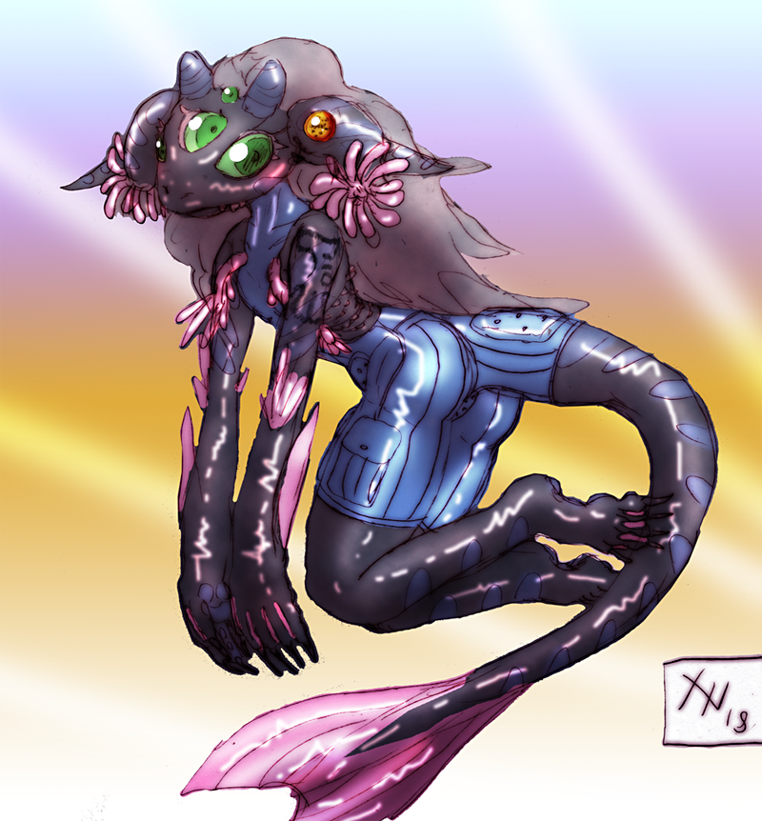
Race: | Robot
Age: | 4
Faction: | Independent
Occupation: | Mercenary
Rank: | N/A

Physical Appearance
A large vaguely humanoid white robot with many embedded red crystals. It has a very boxy utilitarian design with large hips and a thin waist, though the head is a more stubby dear-like affair with large glass eyes and curved prehensile 'horns'.
It has an intimidating stature of six foot seven, and it's crystalline parts tend to pulse and glow brightly whenever it is moving or talking.

Biography
The city of Isomer is well known for it's bizarre ancient runs of a high technical standard. The creatures that emerge from the depths are sometimes very large and fearsome, a fact which lead the company 'Steinroter' to begin hastily developing defensive robots using scavenged tech. Elk was not one of these robots, but instead an amiable public relations machine, designed to promote general trust among human investors in the project.
Unfortunately, many of these components were poorly understood at the time, leading to things like magical crystals to be integrated into many units simply because 'It stopped working otherwise'. Those that didn't mysteriously explode one day were instead prone to sudden and drastic personality changes without rhyme or reason.
Elk remained remarkably stable and faithful no matter what. As the years went by they were restyled as a knight mascot for a publicity stunt, though Elk themselves had no idea that this was a falsehood and meant no actual increase in combat effectiveness. Eventually, however, faith in the project was lost when a Steinroter mecha-dragon went wild and killed an important cooperate backer. The firm went bankrupt and newer companies began to buy off the remaining combat units as recyclable materials, or worse, target practice for the more advanced next-gen mechanoid tests.
A rich investor named Hilda bought Elk as a security guard-come-party piece, but basically forgot about the robot when the novelty wore off. Not really understanding the minutia of all this and still concerned with their pre-programmed notions of universal peace and love, the robot soon wondered off without anybody noticing.
Upgrading themselves and completing bounties as a matter of trial-and-error, the machine then began to apply their saturday morning cartoon morality to the real world with a newfound intensity and gusto.

Personality
The robot was only ever really designed to talk to people, and thus comes across as incredibly naive and trusting towards others. They are always happy to help, but are prone to misunderstanding a lot of things about humans to a nearly childlike degree.

Abilities/Skills
- Made Of Metal: Elk's body is a composite of highly advanced magi-tech crystals and servos, smushed hodge-podge into a particularly cheap and boxy common-metal shell. This means they are only about as tough as a regular suit of armour, yet are still highly resistant to heat, cold, water, air deprivation, and any form of mind control or magical effects which might disrupt an organic being's soul.
- Rainbow Crash: The machine can and does use magical weapons. When they use anything melee related, it creates the illusion of streaking rainbows and causes raw magical damage. Nobody really knows why. They generally use this to carry out rather fanciful and ridiculous sparkly finishing moves.
- Stellar Trance: Elk doesn't have enough processing power to use their main sensory systems and actually walk around at the same time. Crossing their legs and entering a trance-like state, however, they can detect things like radiation, magnetism, radio waves, vibrations, and magical sources up to a mile away.

OOC Notes
This page was originally created by Primitive Polygon on Tue 05-06-18.

