Diago Darkthorne
Diago Darkthorne
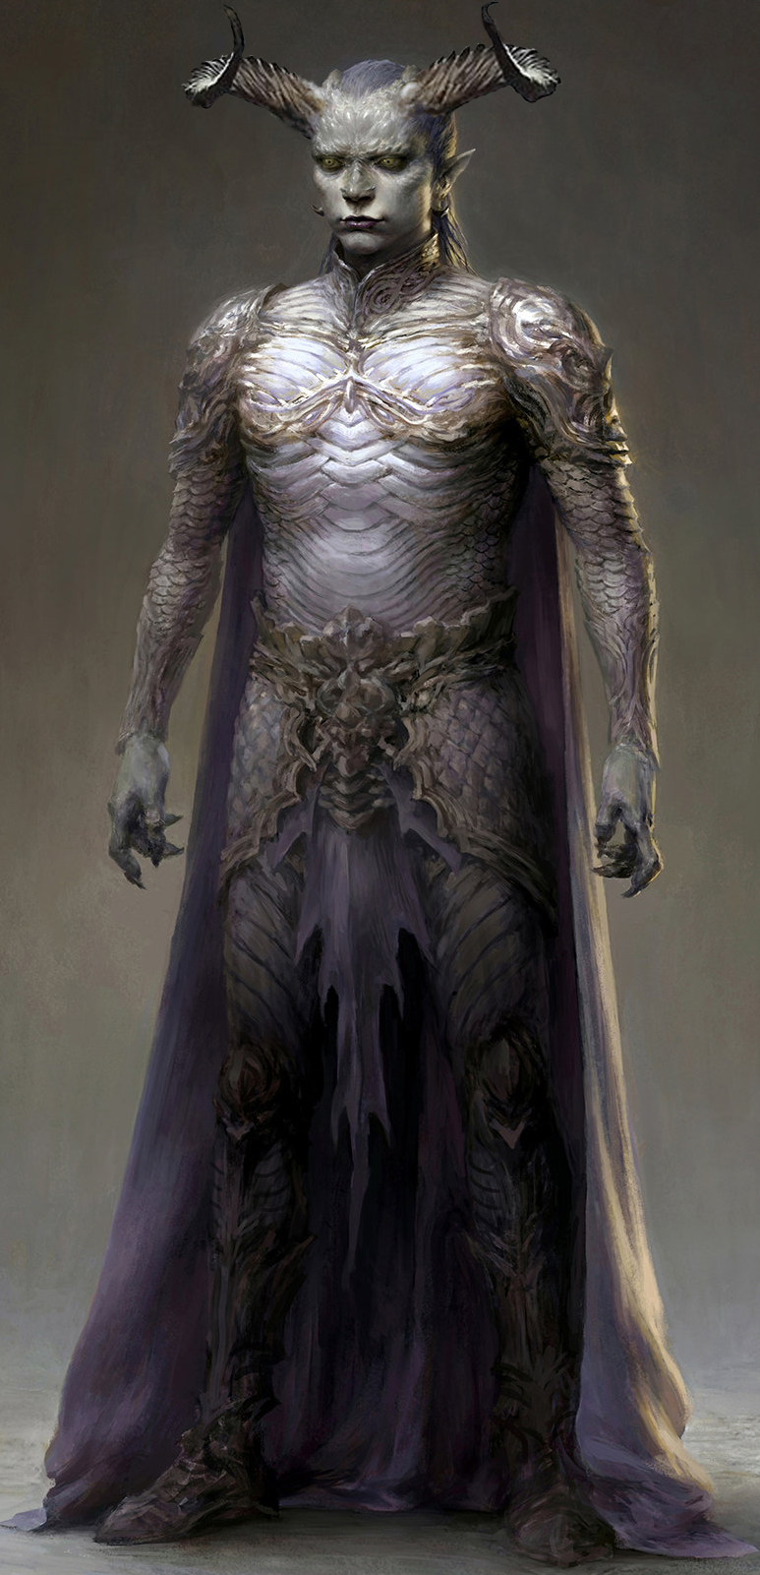
Titles: | King, The Serpent of the Garden, The Tyrant
Gender: | Male
Races: | Tuatha De Danann, Vampire (fey)
Age: | 233 years old, equivalent to a young adult human
Occupation: | Hell Knight
Faction/Kingdom: | Belathian
Status: | Banished
Relatives: | Bohan(deceased,father),Eru(deceased,mother)
Height: | 6'1“
Weight: | 197lbs
Eyes: | yellow
Hair: | silver
Diago Darkthorne the son of the heroic Bohan Daellyn Ath Cortha of the green thorne clan. They protected the forests of Velusia from enemies from outside and within. Diago was found by the Darkthorne king Manece and made into one of the dark. He eventually killed Manece and took his place as ruler of the Darkthornes. He began a campaign of recruiting new thornes to the dark. These were called the young bloods, the previous generation of Darkthornes had been the last full blood tuatha. All those under Diago's command were half bloods like him.

Biography
Bohan and his fellow wildthorns had some called them, hunted down a den of higher vampires that threatened the land. The vampires had become lost to a blood lust and seemed to be on a binge. The battle with the den nearly wiped out both sides and took many years to end. The remaining higher vampires were not crazed with bloodlust and begged for mercy. They simply wanted to live in peace and to not be hunted into extinction. Bohan who was still young, in his seventies could understand. Many of the younglings had died in senseless wars and the tuatha that remained were well into their two hundreds, unable to have any offspring. He was the last along with a handful in his band of rangers. The leader of the higher vamps admitted the same of his kind, except for his daughter. He suggested she marry Bohan to create a union between the two races. Eru met with Bohan and the two actually got along quite well. They agreed to the deal, and within the next few years gave birth to Diago. His birth was not an easy one, because no one was sure about the mingling of the two races. The fact the last five younglings were all male made the decision. Bohan would never have thought to spawn with an outside race, but in order to carry on, they had to.
The wildthornes were not to survive the age of dust, Manece killed all of them except Diago. He forced Diago to drink from a goblet filled with Manece's corrupted blood. After which Diago's body began to change, becoming tainted, his eyes changed color, his skin steamed and bubbled. The effects of the corrupted thorne blood on the half breed were unexpected even by Manece. Diago was stronger and faster, his teeth had become razor sharp fangs able to drain a victim of their blood or sever their spine. He began to be groomed as a hell knight, a special type of fighter given the powers of a sacrificed demon, and whose own soul is then transferred into a weapon, making them soulless killing machines. Diago proved himself in battle by killing over 100 prisoners in the Darkthorne pits. Manece promoted Diago into his personal vanguard and was challenged by Diago the next day. Diago defeated Manece before the other young blood like himself. He kept Manece alive for days drinking his blood and torturing him before finally boiling him alive in oil.

All Hail the King

Toil and Trouble

Thrown to the Pits

The Curse Ends

Personality

Weapons,Relics, and Weakness
Miotal Spéir:
The Eye of Athul-Mun:
Iron: Iron is deadly to Tuatha, it can poison the blood, something only a blood transfusion can fix. It can also make a wound become infected or not heal right. Tuatha are basically allergic to Iron, it is an item not found in their blood or anywhere in their bodies like it is in humans. As such this has caused such rivalries between the humans and dwarves with their dealings with the Tuatha. Humans use iron in so many things that Tuatha can be offended by the most minute object offered them by a human. The dwarves spend their time mining iron and smelting it more than even the humans and some of the runoff from their smelting camps has polluted streams that run through Tuatha lands. Iron also weakens Tuatha in such a way that their regenerative abilities are disabled for a few days from receiving a wound with iron.

External Links
Julian's Roleplay Bio This page was originally created by J on Fri 12-05-17.

