Bryce Arvero
Bryce Arvero is an NPC played by Pancakei within Arcadia Complex, serving as the frequent antagonist of the plot.
Bryce Arvero
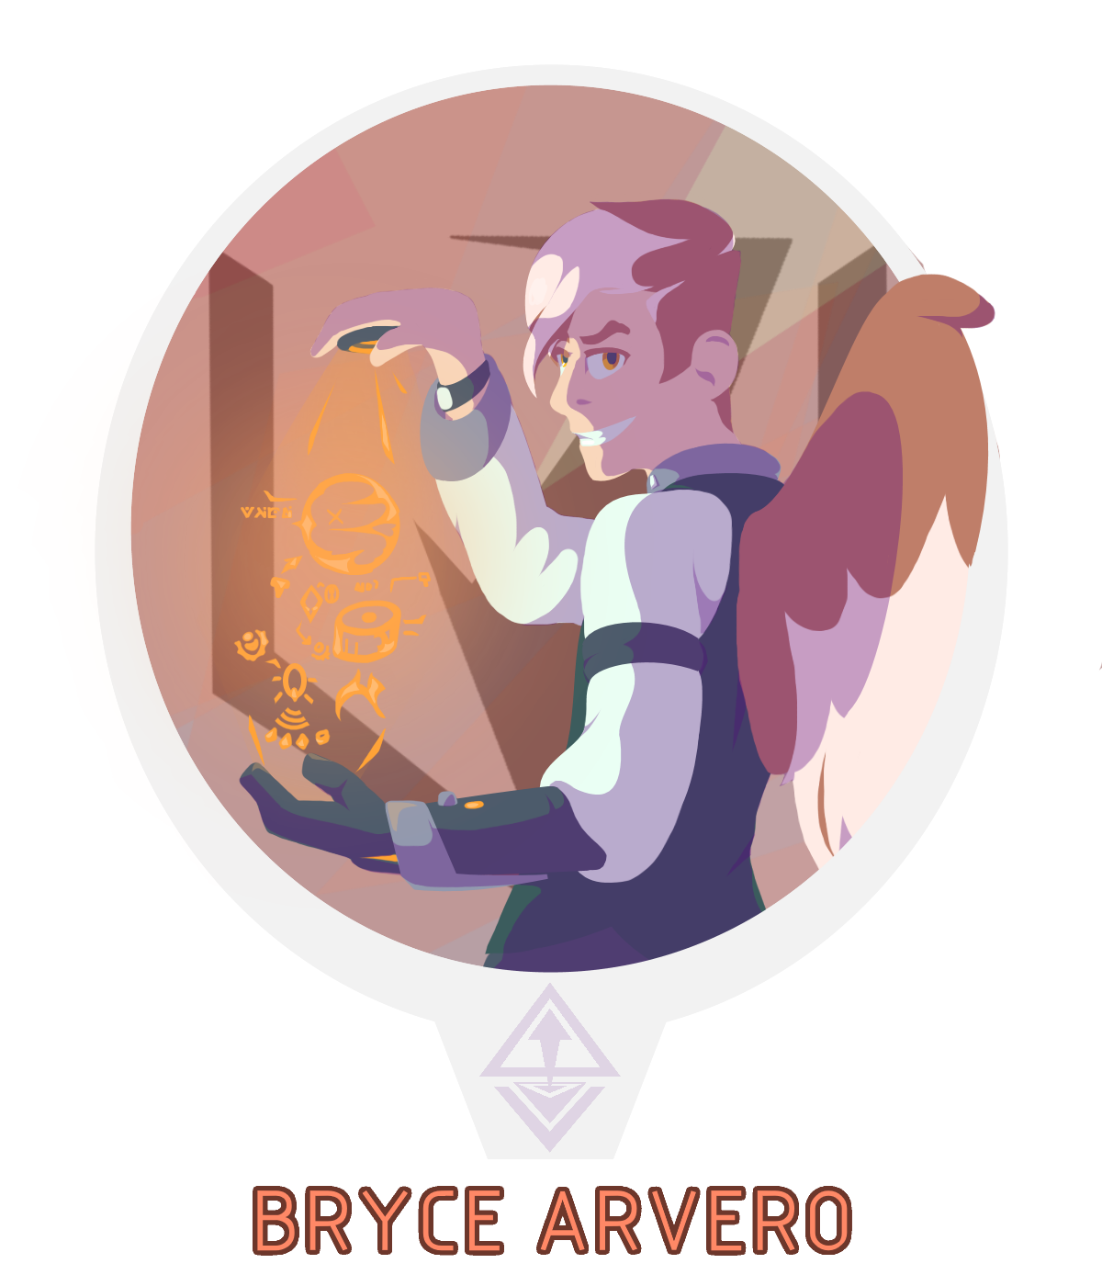
Gender | Male
Race: | Arcadian-Human Hybrid
Age: | 35 Years Active (Unknown Inactive)
Faction: | Arcandum Union
Occupation: | Librarian, Leader, Minor Political Figure
Rank: | Captain

Physical Appearance
Bryce Arvero is a tall (6' 5“) Arcadian-Human hybrid, one of a considered long-extinct species. His skin is a pale olive tone, with tawny-patterned hair that has been neatly cut with hard parts and a lanky bang that tends to fall over the head or nose. Bryce has bushy eyebrows with stark yellow eyes, a sharp nose, a triangular chin, and two large- if undergrown- wings of a same color as his hair. Bryce is lacking a left forearm, it often being replaced by a set of gauntlets or other automated prosthetics.
Bryce is often seen wearing sharp clothing, with his day job bringing a green jacket over top of a pale mint and blue undershirt with black shoes. When doing representative work with the Union, he is often seen in a larger set of black robes or overcoat and hat with matching teal accents- weather dependent. Sometimes acting as a party representative under the New Incipere Courthouse, Bryce Arvero wears a porcelain court mask depicting the tragedy-comedy duo.

Biography

Prologue
Bryce Vandela Arvero was born into the high life of Arcadian culture during the limelight of the Grand Republic of Avisten’s reign. The son of an estranged father, the young Bryce was left in sole care of a dignified ATES agent, Neena Arvero. The young Terran-Arcadian hybrid wasn’t one to brood on his life with a single mother, to him it was just daily life.
Bryce spent his youth living in a secluded apartment overlooking the streets of Avistens military district. Often left alone during the long weekdays, the boy quickly picked up a fascination with reading the many manuals and books left behind in the large shelves that surrounded his home. He was easily the creative and explorative type, always curious with what made things tick. On many occasions, Neena came home to find the house’s automated caretakers disassembled on the table.
The young Bryce was a brilliant scholar, albeit one with a stiff attitude- likely from the lack of proper socializing military familyhood brought. Even so, the boy was set on track to make it to the top of what the inner city education board could offer. He dreamt of being a creator- be it an engineer, politician, or playwright. You could say he was set from the beginning to become all three.
When the calling cards announced the reckoning of Avisten, the end of the War of the Races didn’t dwell on the naive Bryce nearly as much as it did for other citizens. He had lived watching over the Arcadian military from high above, and he didn’t even know such an institution could fail- nor was he ever aware of the conflict.
It wasn’t until the fateful raid on central Avisten did everything come crashing down. With the unnatural, unrelenting force stored beneath the heart of Avisten released, Bryce’s whole world was ripped and melted to shreds around him- slung into the disaster that was the Schism. The boy's last memory from the old world was the protective embrace of his mother as the two were engulfed in the fires of creation- what seemed to be the end.
But the Schism was never known to be clean with it’s work. The boy and his mother were spewed out into an unknown world and time, still in embrace after what seemed like an eon of sensory deprivation. The world they landed in carried an eerie familiarity, but was not welcoming to their arrival. The warmly-lit canals and wharfs of New Incipere was no proper home for the two, with Neena being quick to learn that the best option was to hide. The people barely shared their visage, and spoke in tongues that only sounded familiar on the wrong side of the battlefield.
The two lived quietly as they tried to form their bearings on both location and time, but poor Bryce never did have the chance to understand the situation. His last memory of his mother was a letter written in proper ATES code- a language long forgotten and forbidden by the modern world. His mother was gone, taken away to a court he didn’t know how to stand up to. He had seen the end of the world and knew its wrath, but no one would listen.
Bryce was left alone in an unfamiliar and unkind world with nothing but an ancient school uniform on his back and the last words of his mother, wandering the streets of New Incipere in search of a home. Wherever he went, however, trouble soon followed. He was a hybrid born in a time of tyranny not yet forgotten by the townsfolk. Wherever he wandered, his fledgeling wings were an omen. The only shelter he could muster were the halls of the local library, spending his life sorting what little books they had. He read them over and over, picking up bits and pieces of the fallen plot as he started to understand the reality of his new home.
New Incipere, the safe haven built on the ashes of Arcadia.
As Bryce grew on his own, he was left without the proper training for his growing powers- the mental control of echyllis. As the boy grew into a young man, he started to realize his work no longer came with pay- and more as a mere attraction to the townsfolk. In one altercation, Bryce Arvero got in a fight that ended with his left arm being completely amputated and a rushed trip to the hospital. Fraught with anger, the young man swore to correct the injustice he faced, and one day return to the courts of New Incipere from above. Following the letter left by his mother, Bryce used his power to head far away.
As it turns out, his mother left him a little more than some ink on paper. She left him the location of one of the last bastions of ATES networked resources, long deserted and desecrated by the time the Bryce found it. However, the raw material and information held by the forgotten center was more than enough for an proper playground. As a last will of his mother, he was left a parting gift- one half of an Arcadian military AI known only as Satori.
Time passed as the last remaining Arvero tinkered, socialized and learned, drawing out a master plan of his own design. The adult Bryce Arvero quietly returned to New Incipere, looking for a loophole to enter the chaotic government of the state. Just as before, no one would take him; Hiis wings would ruin their appeal. He found his place in a downtrodden and forgotten party by the name of Arcandum Union- founded on the belief that the Baron- the hailing founder of New incipere, was fraudulent and guilty, lying about having stopped the Schism. The group hadn’t just fallen from popularity, they never saw the lights to begin with. From his time in politics, he began to correct his image how he saw fit, becoming an expert manipulator and adopting a high-profile persona to cover his rough youth.

Modern Day
With a growing stockpile of resources, access to knowledge long-forgotten, and an easily malleable platform to build upon, it wasn’t long before Arvero set his master plan into action. He not only knew of the stories of the Baron and their infallible servants, but he knew they were real and most certainly falibale. To him, they were not deities or legends- they were opportunities. He set out to put into production one grand play of his own- one that would bring his justice to the courts of New Incipere- and possibly save the world in the process.
Arvero took the Arcandum Union and turned it into an expedition effort, restoring 'heritage sites' using rare technology that allowed his cult to travel beyond the bounds of the Arcadian Border- the long-lasting vice of Arcadia that left New Incipere divided from other cultures. This expedition was however a cover for his own resource exploitation efforts, often rewriting the history found at such locations to benefit his own goals while working out his next move. Some time into his expedition efforts, he came across another Arcadian hybrid that had been left ravaged by the Schism who had no name nor memory and was left scarred and plagued by the event. The only name they could give her was from the burnt remnants of an ATES ID card: A- -li- -oth. While Alioth lacked memory of the event, she could foresee it happening again- confirming Bryce's and the Arcandum Union's founding motives. Together with someone with similar experiences at last, the two became working partners in crime. Bryce handled the big picture planning and theatrics, while Alioth worked out leads and helped improve the Union's automated 'personnel' to be more cheaply producible and effective. It was around this time that he found his first leads on the legendary servants he so desired to meet.
Bryce's first interactions with the ISS Downrider expedition happened at the Alipier Observatory, a monument and surrounding chunk of land stripped from Nepheros and merged with the local planetoid Bivona during the Schism. Alioth had warned him of the group prior, stating they were going to be the ones to unbottle the Schism once more, but Bryce refused to believe it could be true. His initial reactions were confusion and agitation, pushing the group away and threatening them with violence. In the end, he was able to pry BTC-03, better known as Ferrus from the group- one of the many legends he had heard of and the husband of a certain associate. Bryce later met a scouting patrol from the Biechelon Collective at the same location, coming from a fresh defeat at the hands of the same Downrider Expedition. After initial hostilities, Bryce used his manipulative nature to strike a deal with the patrol and collective at large. A tight knot of information and resources of the local area to help his goals.
After further run-ins with the Downrider Expedition such as one at the Kerolyne Defile, Bryce tried to reason with the group. He figured that revealing their possible fate as the destroyer of all would be enough to dissuade them from pursuing their goals- an incorrect assumption. After this failed attempt, he revealed his knowledge of Tara, known as OSC-01 to the group, to drive a wedge between Tara and Dahlia in hopes it would destabilize their relationship and eventual mission.

Personality
Bryce Arvero is a smug, self-absorbed individual who has a very theatrical and bombastic personality. While he can be quite friendly, particularly with those he must frequent with, he is known to be a very manipulative and questionably moral individual. He is a very talkative individual, often dumping his troubles on others without their consent- or care. As the possible leader of the Arcandum Union, he holds his ego and his work highly, citing the importance of his mission loudly. While not hard to aggravate, Bryce tends to show his aggression through taunts, smartassery, and passive-aggressiveness- almost playing with his enemies as if they were friends.
Despite his self-absorbed and possibly psychotic personality, there are things in the world Bryce cares deeply about. He cares for his lost mother, and seeks retribution for the injustice done against him. He also believes that the return of the Schism is coming to finish the job, and is doing everything in his power to put himself in a position to stop it. Whether he is doing this more for altruistic purposes, or for his personal gain and vengeance is up for debate. He believes the denizens of the ISS Downrider to be the ones who will unleash destruction upon the world, falling from Alioth's visions of the apocalypse. .

Abilities

Echyllis Manipulation
Despite being an Arcadian, Bryce Arvero's ability to manipulate echyllis is fairly weak. Still, he is uncommonly capable of forming solid and primitive shapes within a confined radius around them, taking the form of orange crystals. The weakness of this ability is only further shown in comparison to their partner in crime.

Theater Key
Following their unionization of a scouting patrol of the Biechelon Collective, Bryce has gained an in with the organization and obtained a driver- a device capable of channeling echyllis in specific formats. The Theater-type key he uses grants the ability to create illusions ranging from crude sock puppets and props to full life-like visages of people who aren't there and mirrors of those who are.
It may also be able to conjure spotlights.

Items
- Several outfits.
- A ceramic and metal mask depicting the comedy-tragedy duo.
- A compact ATES HSR-5L Revolver loaded with .410-equivelant shells.
- A modular metal gauntlet loaded with communication equipment.
- A modified driver with the Theater key.
- The Arcandum Union

Trivia
- Of all the NPCs and plot elements in Arcadia Complex, Bryce Arvero has changed the least since their initial inception.

OOC Notes
This page was originally created by Pancakei on Wed 25-08-21.

