Alioth
Alioth is an NPC played by Pancakei within Arcadia Complex, serving as the antagonist deuteragonist of the plot.
Alioth
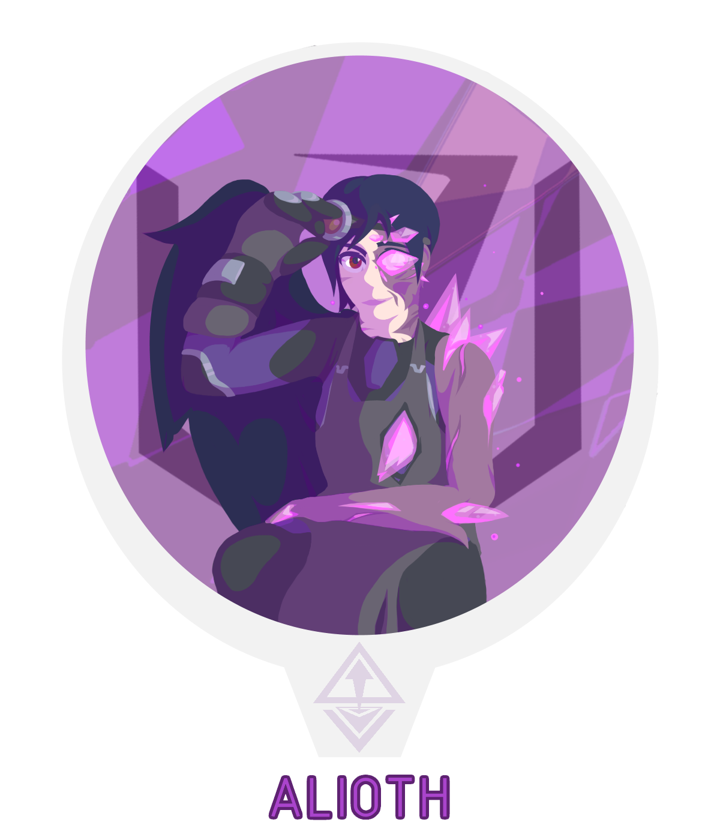
Gender | Female
Race: | Arcadian-Human Hybrid
Age: | 37 Years Active (Unknown Inactive)
Faction: | Arcandum Union
Occupation: | Field Operative, Artificer

Physical Appearance
Alioth is a tall (6') and relatively thin Terran-Arcadian hybrid whose figure has become plagued and deformed from echyllis exposure in the form of a disease known as glassvein. They have pale white skin, with much of their left side being stained purple and partially decayed from the disease. Half their face has been consumed in pink crystals, paralyzing the left side of their face and leaving that eye incapable of regular sight. Their hair is a dark cobalt with a short cut, becoming more curly and matted the closer it is to their disease spread. Their only remaining wing is equally cobalt and equally misshapen, with their left wing being missing entirely. Instead, a large pink crystal pierces her abdomen around where the wing was, with some exposed bone visibly encased in the echyllis formation. Her left arm is exceptionally withered, effectively being fossilized flesh held together by echyllis crystal and metal brackets.
Alioth is frequently seen wearing an ATES Syllic bodysuit as a base layer, with layers of utilitarian clothing overtop. Such attire consists of work boots, welding gloves, overalls, aprons, belts, goggles, and scarves. Despite their withered appearance, Alioth is exceptionally strong both physically and through willpower. When they speak, reverberating crystals in her windpipe give her voice an almost resonant quality.

Biography

Prologue
The woman who became known as Alioth was born quite some time ago during the reign of the Grand Republic of Avisten. They have little to no memory of this past life, other than they were sent into The Great Nothing by the Schism, leaving them to rest in sensory deprivation for eons. It is highly likely the roots of glassvein had already plagued the woman before the incident, with her emerging after many years of delayed spread.

Modern Day
The woman exited The Great Nothing into the destroyed remains of Avisten, which had been long abandoned by the time she had resurfaced. Overtaken by plague and left confused with nothing but an ATES Uniform and a scorched ID card, she wandered the ruins of the city struggling to remember anything but ever-distant memories of the location's signifigance. Left without memory, language, or a name, it wasn't until she came across the Arcandum Union and the adult Bryce Arvero that she found some sense in the world. Given a name based on what remained of her ID, A- -li- -oth, Alioth began to follow the group around and began familiarizing themselves with their culture. Over time, Alioth regained an understanding of speech and the world around her. She learned of Arcadia, the land she had previously called home. She then learned of the destruction of it, the Schism, and the foundation of New Incipere. Alioth became an invaluable member of the team when she was able to relay the contents of her clairvoyant visions, stating that the Schism was not finished.
Over time, Alioth has regained some aspects that may be of a prior life, particularly knowledge of mechanics and some of ATES inner workings. Using these skills, she became an artificer and field agent for the Arcandum Union, scouting out potential locations lost in distant memory and using them to generate leads. Alioth still knows very little of their own past, though it wasn't much of a concern until more recent events. Alioth's first foray into the field came after Bryce Arvero ran the Downrider Expedition off of Bivona, where she quickly dispatched a scouting patrol of the Biechelon Collective through Syllic power. Alioth's first interaction with the Downrider Expedition was in the Kerolyne Defile, an Arcadian mining and prison complex she was scouting for valuable resources. She did not exhibit outright hostility to the crew despite her negative views of them at Arvero's request, though she does go as far as to bait Juryrig into a trap to destroy his own parasite, a maneuver which failed and would not come to fruition until after the crews escape.

Personality
Alioth has a mostly flat, careless personality. Due to her heavy amnesia, she lacks most social skills and can easily miss nuances and misunderstands figures-of-speech frequently, much to her cohorts frustration. While not completely anti-social, she prefers to keep her exchanges concise- though she does occasionally slip into delirious tangents. Her ability to speak English and similar languages is in development, leading to occasional stuttering and misinterpretations. She does not care for the theatrical side of the Arcandum Union, instead leaving that to Bryce.
Alioth's mental and even living state is far from concrete due to the plague overtaken her body and mind, exhibiting mild instability (to their refusal) and a somewhat detached and sadistic enjoyment of combat. Her humor is also extremely dry, although Bryce tries to warm her to comedic value. Alioth is an exceptionally strong Syllic, only made stronger by their condition, with forms of telepathy, clairovoyance, and physical manipulation of the material exhibited in strong amounts. Because of this, she claims to have seen the future, and sees that the Schism is going to come again (more than likely, at the hands of the ISS Downrider).

Abilities

Echyllis Manipulation
Alioth is an exceptionally strong Syllic, in fact once being a part of the ATES division that coined the term. She has exhibited forms of telepahic communication, mild telekinesis, clairvoyance, and extremely strong manipulation of echyllis. She is capable of growing crystals out of every pore in her body, forming a hardened sheet of crystalline armor that is stronger over her deformed side. Her power is strong enough to tear open rifts by hand, allowing for easy travel to and from locations within a certain range, and she has shown to be able to drain (or give back) power from echyllis-powered devices such as fuses and drivers.
Despite her strength, Alioth seems unable to cure their own disease, likely due to the complete removal of Echyllis from their body being a fatal move at this level of corruption. She is also unable to control Folly, though she has become adept at recognizing and dealing with it.

Items
- ATES ID Card (Syllic Division, highly disfigured but still functional).
- ATES Type 50 Bodysuit (Syllic Division, Echyllis Resistant).
- A myriad of echyllis-powered fuses and devices.
- Welding gear.

Trivia
- Now I know what you're thinking; keep thoughts like that to yourself.
- Alioth started out as a purely visual concept, before being adapted to fit the plot by reusing some older cut elements alongside new ones.
  - Her role as a deuteragonist with an opposing-personality type to Bryce Arvero was initally going to be used by a Downrider-sympathizer figurehead named Baxter. Baxter was cut out around the time Episode Two started.
- It's arguable if Alioth is actually alive, undead, or possessed. With the condition of her plague, it could be any combination of them.

OOC Notes
This page was originally created by Pancakei on Fri 27-08-21.

