Primitive Polygon
Perpendicular Pogostick is a user who started daubling in the Ayenee RPG forums on January 12, 2018, though they have been a member of the sister site SARP for as far back as 2009 (On and off).
They are a UK crustacean with a love of retro gaming, old obscure mecha anime, robots, sci-fi, cyberpunk… The usual crap you'd expect to find on here, really. Always a fan of super weird and/or humorous character ideas.
Also a hobby artist and 3D modeller but nothing mega. Don't do commissions, but good RP always makes them want to draw the characters of friends. ;I

Characters
- Michiru Ise
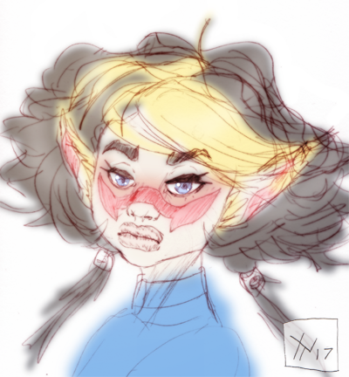
(A roboticist working for the Star Army of Yamatai forces in the sector, currently located on Nightwalker Station. They are an older model Nekovalkyrja bio-weapon with a murky past of self-doubt, and an all-consuming neurotic desire to create silicon life forms 'superior' to her own organic body.)

Projects
- Junkmaster
- Isomer City

Will
:star2: Primitive Polygon's creations (including both characters and fictional technologies) may not be changed or adopted without explicit permission. This includes the artwork contained on such pages, as it will always be by them unless specifically noted otherwise… Honestly, just ask ICly, though. Primo loves doing weird in-character deals, it's way more interesting than giving things away for free!

OOC Notes
This page was originally created by Curtis on Wed 17-01-18.

