The Blackbird Tavern & Inn
The Blackbird Tavern & Inn is owned by Veta_Norr, and managed by Alliana_Kamal. The original Blackbird Tavern was found in the general wilds of Ayenee. A second Blackbird Tavern and Inn was established in the Town.1). Which is also owned by Veta Norr.
The second Blackbird Tavern Inn & Resturant is located across the street from the Market Place, in that little trangle plot, and just behind the building of the Blackbird is Veta's cottage home.
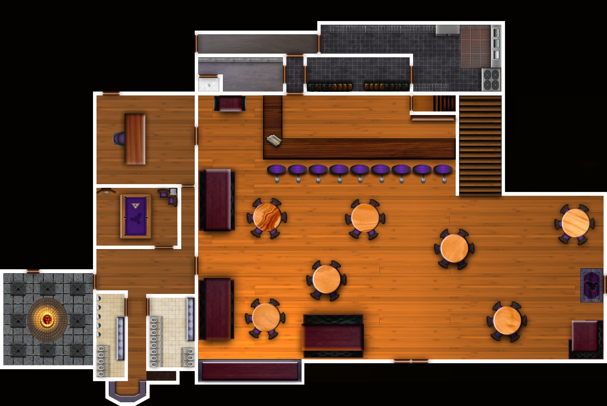
The Blackbird Taverns Main floor layout.

Tavern Description in RP
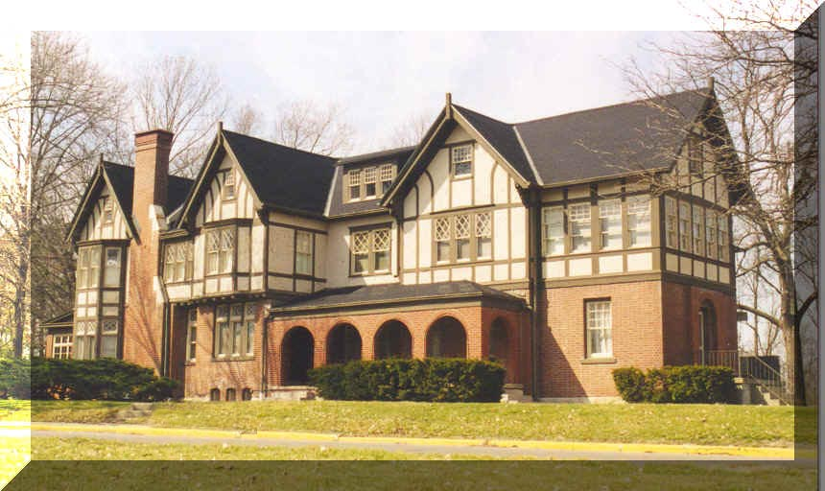
Passing down a long winding road that leads away from the city, a road that takes you past a crystal clear lake and a fragrant wild flower filled meadow..Just as you turn along the lush green tree lined bend,trees with branches of emerald leaves forming a natural canopy over the road…there as the forest crouches back as on your right a building seems to rise from the midst of the expansive forest, a tudor style building seems to rise from the midst of the expansive forest..A building with many windows letting light creep out from the interior…as you pull into the gravel parking lot you can hear faint sounds of music,laughter and talking from the patrons..as you make your way up the cobblestoned walkway towards the entrance, you see that upon the doors rests a darkly etched impression of a blackbird upon the heavy oaken doors
The exterior of the Blackbird is of Tudor style, with beautifully landscaped sculptured shrubs and blossoming small trees, such as crape myrthles, tulip and confederate rose. Along the sides of the large tudor building is clinging ivy and purple and white wisteria.
Veta thought, approaching her establishment should be a pleasant experience with the floral scents as well as appearance. Inside, the tavern is with wooden polished floors, heirloom tapestries hanging from the walls, rustic but quaint wooden tables and chairs as well as booths..each table has a cloth draped over and accented with a candle, over to one side of the tavern area is a wooden bar with a glossy surface, behind a large wall mirror, with a platform underneath the mirror that displays the rows of bottled alcohol.
In the restaurant area as you would enter is right away a sense of good atmosphere settings of a small waterfall to one corner, the soothing sounds of water cascading over sculptured stone formations..All around is plenty of table seating to accommodate every group. .and for those who seeks a little privacy there are booths on the other end. A huge fireplace not only accents the decor but provides warmth to fill the room on those cold fall and wintry days.
Upstairs is the location of the variety of inn rooms, complete with small or large beds, fireplace and personal bath. To each one that stays in a room at the Inn receives a complimentary breakfast.
The kitchen is equipped with three stoves and ovens, two refrigeration units , large preparation and chopping table, a pantry and wine cellar.

1)

