Tesla City
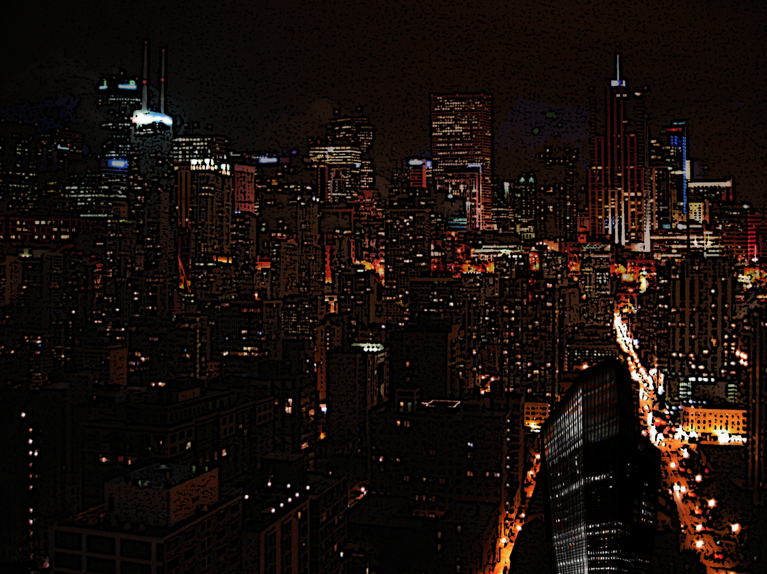
Tesla City is a large industrialized metropolis southwest of Ayenee Capital City that operates as a corporate hub city.
It is one of the locations of an Omega Operations base.

OOC Notes
This page was originally created by Wes on Sun 14-05-17.

