Isomer City
A large shanty town built on the ruins of a bombed out former capital, Isomer City is mostly ruled by a mixture of corporate security forces, mercenary groups and simple migrants. It has chilly weather and is known for possessing many underground tunnels, filled with dangerous ancient security systems.
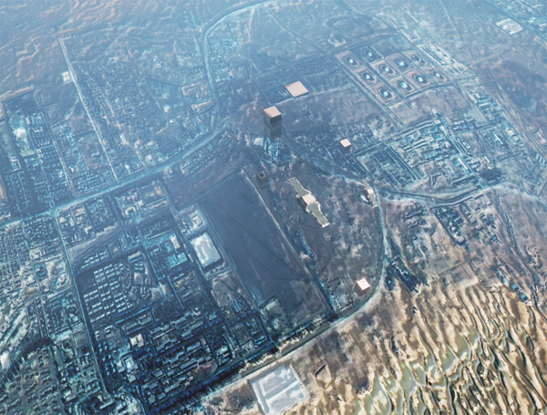
Nobody really knows who built it, as it has a poor recorded history. The original residents are long gone, and trying to stop the locals from pilfering any ancient artifacts they stumble across is a good way to get a knife in the back… That said, it has a reasonably accommodating privately owned starport, and seems to have been specifically built away from any magical ley lines. It's also quite welcome to any outsiders, as there is no one particular ruling military force, race or caste.
About the only thing valuable in sight is the miles and miles of crumbling city streets themselves, containing a wealth of recyclable metals and the odd fragment of rare composite materials.

Location
About seven hundred miles north of Fort Miller, and surrounded by cold desert and stubby cliffs prone to rock slides. There is a decent water supply coming from underground rivers, but the top soil is iron-rich and seems to have been heavily irradiated some time in the past, making it practically impossible to grow crops outdoors.

OOC Notes
This page was originally created by Primitive Polygon on Thu 18-01-18.

