Junkmaster
A self-replicating construction robot designed for independent operation, the Junkmaster is generally found inside Nepleslian and Star Army Of Yamatai factories, as well as junkyards, trash heaps, sewers and derelict space craft. It was gifted to said factions by a race of space nomads, but are independent AIs and don't necessarily follow orders unless treated like equal citizens…
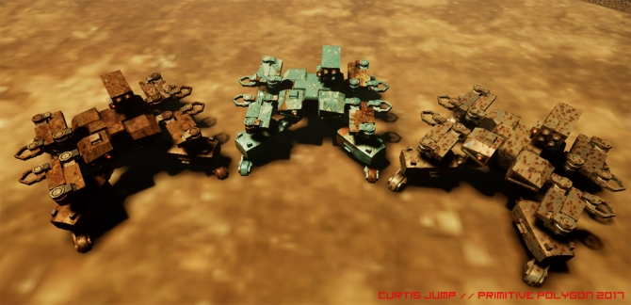

About The Machine
Controlled by a rather placid, motherly intellect, the Junkmaster is a cumbersome beast, ten foot wide and six foot tall. It has four simple two-wheeled track-pods and four crane arms, allowing for reasonable mobility and fine manipulation upon fields of garbage and scrap iron. The wheels are magnetized, but the considerable weight is such that it only really helps the unit with mobility in outer space.
The unit is designed to take care of itself and operate independently the majority of the time, often lending to a jagged rag-tag appearance of constant self-repair and parts shortages. Guns are also sometimes attached when they are found, but only as a means of self defence. Most of the time it rarely bothers with outsider organics, and would prefer to be left tinkering in peace.

Strengths
- Highly durable and capable of self repair.
- Usable either independent, or remote controlled.
- Can not only add weapons to itself on demand, but physically construct dedicated combat automata if needed.
- Relatively cheap and easily coordinated.
- Spreads a useful telecommunications signal wherever it goes.

Weaknesses
- No shields or flight systems.
- Zero ability for free navigation in space.
- Poor close defence attributes, not designed for combat.
- Can’t carry many resources itself, requiring other drones, a derelict ship or a junkyard environment to operate.

Appearance
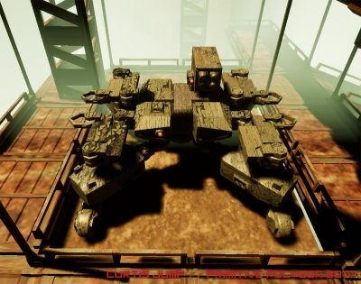
Squat and crab-like, the unit is almost radially symmetrical other than the placement of the forward camera on the right-side pod. The front right and rear left sub-divisions of the square hull have rotational hardpoints, allowing for the attachment of additional cameras and turret weapons. The finish of the hull plating depends on available resources, and if there is anyone around who cares about decorating it; Most are rusty hulks with little adornment, lending them an element of camouflage among fields of debris and trash.
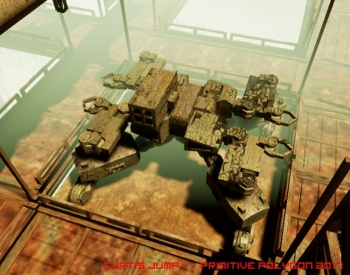

Statistics and Performance

General
Type: Large All-Environment Multi-Use Networked Construction Robot
Manufacturer: Self Reproduction

Dimensions
Junkmasters are about 6 feet tall, 10 feet wide, and 10 feet long. Some variance is possible due to availability of local materials.

Speeds and Range
The machine has an impressive climbing ability and turning speed, complete with a 360 degree visual sensor feed and reach from it’s arms. Not being designed for combat, however, means it is also rather slow, barely reaching 25mph even on flat ground. Having both a nuclear power plant and self-repair facilities on board means that its range is basically infinite, but that does depend on the availability of usable resources. A particularly healthy model with lots of spare parts (and thus redundant components) can actually be surprisingly tough to kill outright, even if it isn’t all that hard to damage the surface hardware!
Most commonly a palladium microalloy glass (“Metallic Glass”) construction with boron wire mesh substructure. Variants exist, but the need for extra layers of armour is really quite circumstantial. It does, however, have thick radiation and scalar shielding as standard.

Armament and Tools

Weapons
The exact armament is not standardized, but clusters of dumbfire rockets are popular. This is to allow the unit to ‘shock’ the enemy into cover with a large blast, before simply running away.

Electronics and Sensors
- Low-level non-volitional AI.
- Wide-range optics (Infrared, visual, UV), includes telescopic sight.
- Relay system based on quantum entanglement (Literally a pirate version of Yam and Nep communicators, if not utilising a legit model salvaged in the field.)

Power Systems
Though it depends on the exact fabricator, the Junkmaster can be equipped with one of the following:
- Nuclear Power Plant (Nearly infinite range, but stands out on sensors more. Heavy lead radiation shielding included.)
- Starlight Capacitor (Limits range to two days per recharge, but the unit now has a very low sensor profile.)

Construction Timetables
Given the relevant materials, Junkmasters can bodge together a great many things. To give an example on how long this typically takes, the following is a non-exhaustive list of things it can construct on demand.
Object | Time Required
Hand Held Rail Rifle | 26 minutes.
Mini Worker Drone | 1 hour.
Humanoid Combat Robot | 6 hours.
Another Junkmaster | 12 hours.
An Induction Furnace (For smelting local ore) | 24 hours.
Solar Power Array (Enough to sustain one Junkmaster) | 24 hours.
Battle Tank | 2 Days.
Space Shuttle | 2 Weeks.
Surface Outpost | 1 Month.
Two or more units working in concert can reduce this time by about 25% for each additional unit.

OOC Notes
This page was originally created by Curtis on Thu 18-01-18.

