Nora Shi'non'ha
Nora Shi'non'ha is a player character played by Crystal.
Nora Shi'non'ha
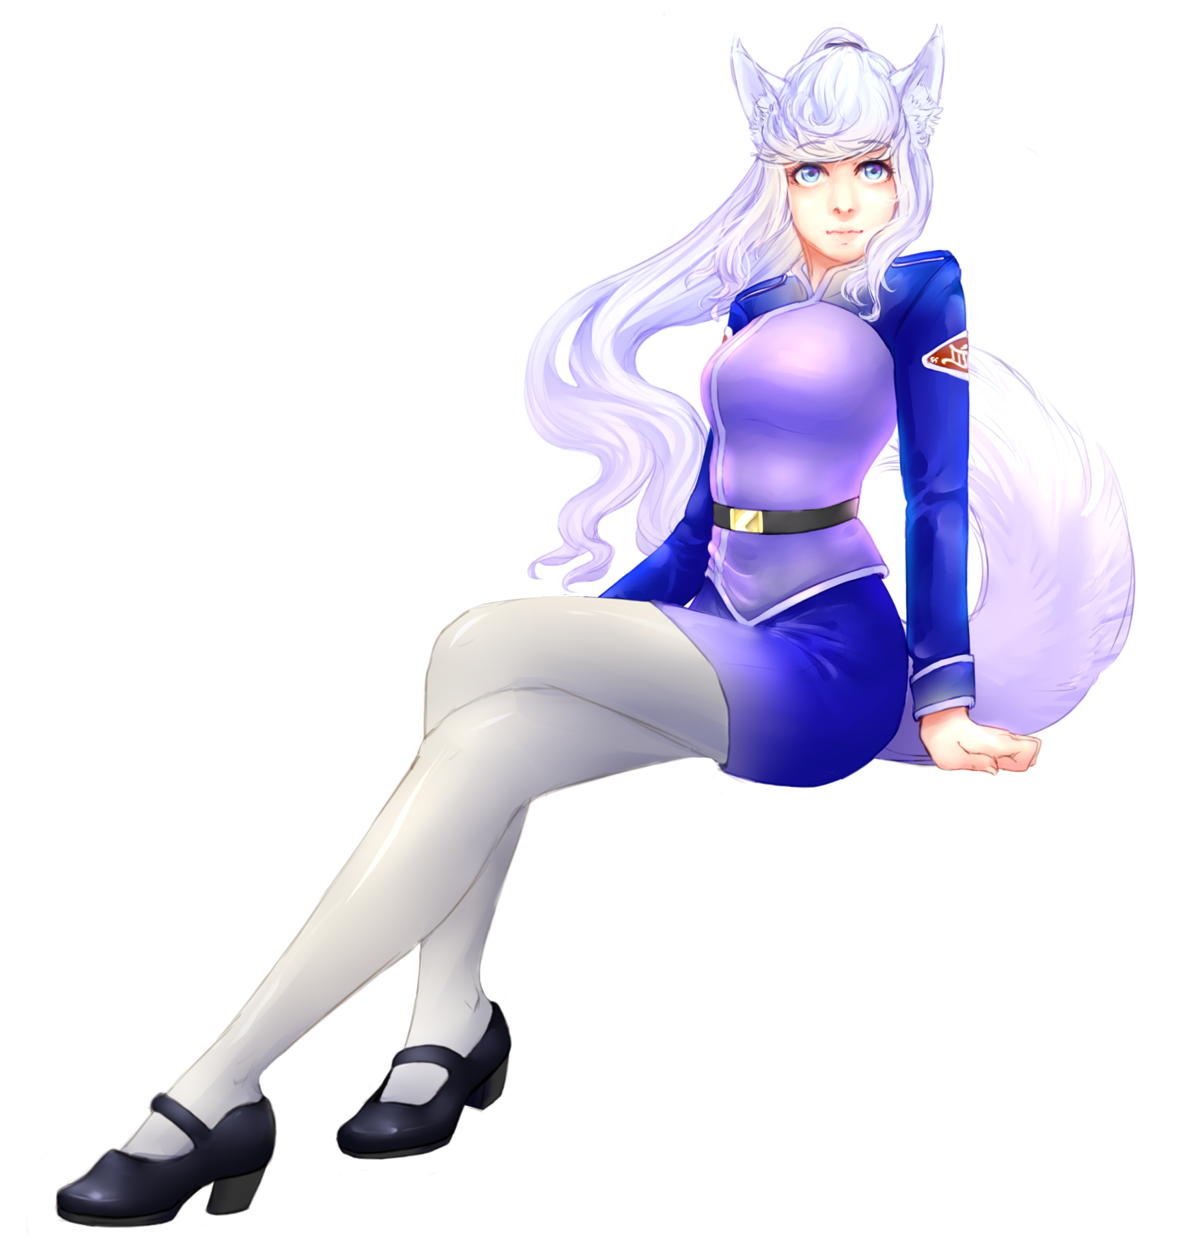
Species & Gender: | Shukaren Daur (Sub-Species) Female
Age: | 20
Eye Color: | Ice Blue
Hair Color: | White
Height: | 5'1“
Weight: | 107lb
Date of Birth: | YE 01 (Yamatain Calander)
Organization: | Star Army of Yamatai
Occupation: | Infantry
Rank: | Itto hei
Current Placement: | YSS Kaiyō II
More art of Nora here.

Physical Description
At 5'1”, Nora is taller than average for a female Daur. She has snow white skin due to the Daur's pinkish blood and has stark white hair to match. With a lean build of muscle, she isn't well endowed, common of her species as well. Her hair is long and hangs all the way down to the start of her fox-like tail when it is not held up. It is for that reason that her hair will usually be tied back in some way. The only part of her hair that will give her trouble is the swooping bangs at her forehead and the locks of hair that sprouts from just below her ears which never quite manage to stay tied back. At this point, she has given up on trying and lets the stray side bangs dangle. Her face is soft and without hard edges. Slightly higher than normal cheekbones accent her soft blue eyes.

Personality
Her Daur nature makes her very curious, and this can tend to take her in all kinds of trouble. She's a very kind person at heart, but has a short fuse and hot temper. Usually she will burn herself out before too much happens, but beware to get too close to the flame when it's burning hot. Shy at first to new people she meets, she will come off as cold with a no-nonsense attitude and eyes that pierce the thickest of armors. But if you're one of the ones that earns her trust, she will let down that guard and become one to flash the warmest of smiles and share her time, thought, and space.

History
See her page on Star Army here

The Kaiyō Incident
It was her very first mission on the Kaiyō II when she was pitted with one of the hardest decisions of her life. The mission ended with the crew of the Kaiyō II discovering a dimensional portal that they would be entering for their next string of secret missions. After consulting with some of the other crew, she decided she would get a clone of herself made that would stay behind, with it's creation known to only her and the Kaiyō II crew. She would have it requested that upon the clone's first waking minutes, she is told a lie. A lie that states she is the one and only Nora Shi'non'ha, that she had been in an accident that resulted in her death, and that she was soul transferred into a new body of near perfect replication. The clone, however, would not be told anything of the Kaiyō II and would be released to find work as the infantry soldier she was before Kaiyō II. Nora is neutral on the idea of Soul Transfer, but she cannot bear the idea of her family losing their only daughter, so she took the option that allowed her to stay in her home universe as well as carry on with the Kaiyō II ship in a way.
The Nora in this universe is the original.

Skills Learned
Nora Shi'non'ha has the following notable skills:
- Star Army Common Skills
- Fluent in Tinacen (Language), Trade (Language), and Yamataigo (邪馬台語)

Social Connections
Nora Shi'non'ha name is connected to:
- Ar'uden Shi'non'ha (Father)
- Shukara Shi'non'ha (Mother)
- Laun'el Shi'non'ha (Brother)
- The Kaiyō II Crew

Inventory & Finance
- Star Army Standard Issue Items
- Tradional Yamataian Dress
Nora Shi'non'ha currently has 3000 KS.

Nora's Mindy, "Kishi"
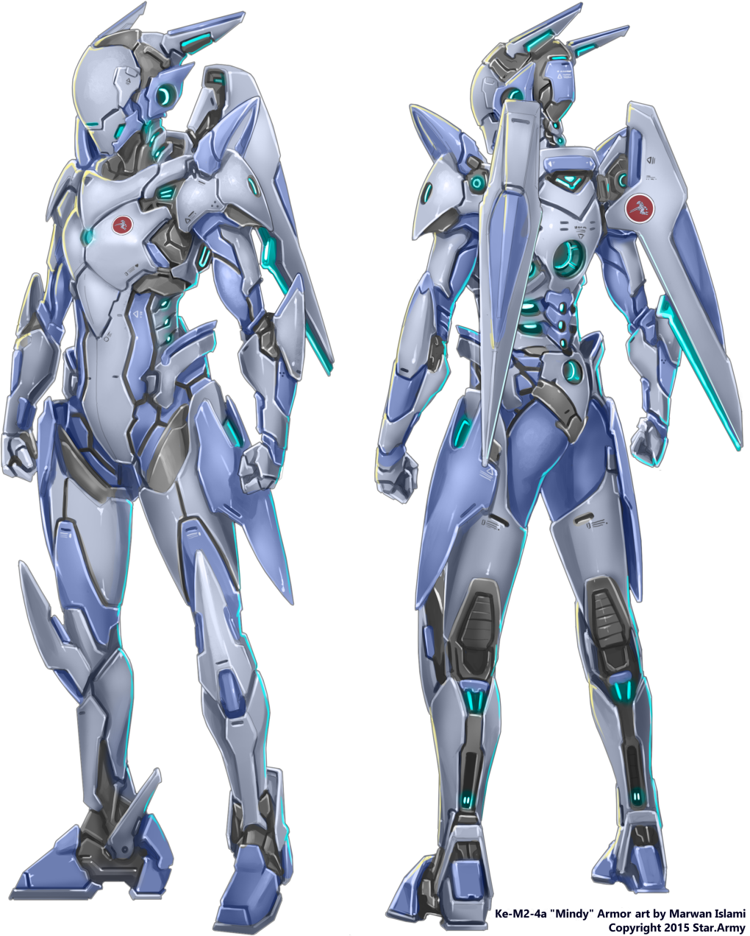
Ke-M2 Series "Mindy" Power Armor
Left Shoulder | Dorsal | Right Shoulder
Ke-M2-G3000 Shoulder Capacitor | Ke-M2-P2904 Barrier Shield Module | Ke-M2-W2906 Shoulder-Fired Missile Pod
Leg Pods | utility/cargo | Handheld
Ke-M2-W2908 Offensive Augmentation Pods | NA/NA | Ke-M2-W2913 Aether/Scalar Submachine Gun
Left Waist | Wings / Tail | Right Waist
Star Army Cluster Grenade, Type 29 | no / yes | SiZi Model 38 Special Duty Revolver
The name Kishi came from her mindy's ability to protect herself as well as others from heavy fire. The left forearm has been been replaced with an Ellipsoid Shield
Kishi translates in Japanese to “knight”

OOC Information
In the case crystal becomes inactive:
- Can this character be used as an NPC by a GM or FM? YES
- Can this character be adopted after I've been gone for a year? NO

